

# HS 1.007 Defence Learning Ecosystems Final Report and Roadmap

THE INVESTIGATION WHICH IS THE SUBJECT OF THIS REPORT WAS INITIATED BY THE PROGRAMME AND DELIVERY DIRECTORATE DSTL AND WAS CARRIED OUT UNDER TERMS OF CONTRACT NO. DSTL/AGR/01035/01.

Reference O-HSSRC-1.007-031/033

Version 2

Date 25 March 2021

OFFICIAL

|  |  |
| --- | --- |
| Customer Information | |
| Customer Contact: | Anita Hay |
| Domain or Dept: | Dstl |
| Milestone Number: | O-HSSRC-1.007-031/033 |
| Contract Number: | DSTL/AGR/01035/01 |
| Project Start Date: | 18/11/2019 |
| Project End Date: | 31/03/2021 |
| Due Date: | 11/12/2020 |

|  |  |  |  |
| --- | --- | --- | --- |
| Authors | Organisation | Tel | Email |
| Megan Pleva | LiMETOOLS Ltd | 01202 022 449 | [Megan@limetools.biz](mailto:Megan@limetools.biz) |
| John Dale | LiMETOOLS Ltd | 01202 022 449 | [John@limetools.biz](mailto:John@limetools.biz) |
| Niall Castelli | LiMETOOLS Ltd | 01202 022 449 | [Niall@limetools.biz](mailto:Niall@limetools.biz) |
| John Medhurst | Larrainzar Consulting | 01725 513705 | [John@larrainzar.co.uk](mailto:John@larrainzar.co.uk) |
| Nick Hare | Aleph Insights | 07939 159 324 | [Nick@alephinsights.com](mailto:Nick@alephinsights.com) |
| John McAlaney | Bournemouth University | 01202 964930 | [Jmcalaney@bournemouth.ac.uk](mailto:Jmcalaney@bournemouth.ac.uk) |

|  |  |  |  |
| --- | --- | --- | --- |
| Approvals | Organisation | Email | Signature / Date |
| Helen Cole | BAE Systems | [helen.r.cole@baesystems.com](mailto:helen.r.cole@baesystems.com) | |

|  |  |  |  |
| --- | --- | --- | --- |
| Amendments | | | |
| Version | Amendment date | Amended by | Remarks |
| 1 |  |  | Original Issue |
| 2 | 17/03/2021 | LiMETOOLS | Dstl Review Comments Incorporated |

|  |  |  |
| --- | --- | --- |
| Distribution | | |
| Name | Role | Organisation |
| Daisy Mundy | Research Theme Lead | HSSRC |
| Abby Laishley | Technical Partner | Dstl |
| Hash Hassan | Work Package Lead | Dstl |

# Contents

1. Introduction 1
   1. Background 1
   2. Summary of Approach 1
   3. Report Structure 2
2. Executive Report 3
   1. Imagining the Needs of a Defence Learning Ecosystem 3
   2. Key Evidence Findings 3
   3. Strategic Recommendation (R) Summary 4
      1. The Learning Space: Creating an Informed and Dynamic Internal Market for Learning Programme Development Capability 5
      2. The Delivery Space: Developing a Unified, Future-Ready Delivery System 6
      3. The Data Space: Improving the Level of Data-Capture and Analytics 7
      4. The Organisational Space: Authorising and Coordinating a Defence-Wide Investment of Resources 8
      5. A Systems Approach to Change Management 9
   4. Conclusion 9
3. Technical Report 11
   1. Project Overview 11
      1. The Project Timeline 11
      2. A Systems Approach 12
      3. Rich Picture 12
      4. Influence Diagram-Based Map 13
      5. The VSM 14
   2. Establishing the Initial Vision 16
      1. Defining the Scope of the Project 16
      2. Predicting the Nature and Needs of Future Learning Systems 16
      3. Imagining a Vision 18
      4. The Learning Landscape 19
      5. The Impact of COVID-19 19
      6. Identifying the Key Research Themes 19
   3. Integrating Governance and Communication 21
      1. The Challenges 22
      2. Implications for Change Management 22
   4. Recognising the Opportunities 24
      1. Analysis of the Learning Space 25
      2. Analysis of the Delivery Space 29
      3. Analysis of the Data Space 32
      4. Analysis of the Organisational Space 33
   5. Implementing Change Management 35
4. Recommendations 38
   1. Learning Space – Creating an Internal Market for Learning Programme Development

Capability 38

* + 1. R1: Strengthen and Modernise DSAT 38
    2. R2: Strengthen the Collaborative T&E System 40
    3. R3: Conduct Two Further Learning Space Research Projects 43
  1. Delivery Space – Developing a Unified, Future-Ready Delivery System 45
     1. R4: Enhance the DLE Capability 45
     2. R5: Enable Innovation in Delivering Remote Experiential Learning 46
  2. Data Space – Improving the Level of Data Capture and Analytics 48
     1. R6: Designing a Common Framework for Data Management 48
  3. Organisational Space – Authorising and Coordinating a Defence-wide Investment into Learning Resources 51
     1. R7: Improve Learning System Communication 51
     2. R8: Implement Governance of a Change Programme to Realign Learning Systems 53
  4. A Systems Approach to Change Management 56

1. Roadmap 57
   1. Conclusion 59
2. References 60

Appendix A - The Project Team 62

Appendix B - Stakeholder Engagement Plan 64

Appendix C - VSM Model 67

Appendix D - Influence Diagram-Based Map 70

Appendix E - Case Study Summaries 72

* 1. Defence Learning Environment (DLE) 72
     1. Key Findings 72
     2. Implications for Future Defence Learning Ecosystem 72
  2. Defence School of Electronic and Mechanical Engineering (DSEME) and LEARN 73
     1. LEARN 73
     2. Implications for a Defence Learning Ecosystem 74
  3. Royal Navy (RN) - Training Transformation (TT) 74
     1. Implications for a Future Defence Learning Ecosystem 75
  4. Army Recruiting and Initial Training Command (ARITC) and Target Learning Model (TLM) 76
  5. Higher Education (HE) 77
  6. Collective Training Transformation Programme (CTTP) 77
     1. Implications for a Future Defence Learning Ecosystem 78
  7. Aquila Learning and Risk Management System (ALaRMS) Data System 78
     1. Implications for a Future Defence Learning Ecosystem 79

**List of Figures**

Figure 1: Project Phase and Work Completed 1

Figure 2: Rich Picture Diagram of Current System 13

Figure 3: Roadmap Progression with Barrier Considerations 14

Figure 4: The Viable System Model (Beer, 1984) 15

Figure 5: Core Anchors to Defence Learning Mapped to Spaces 20

Figure 6: Integration of Governance and Communication 21

Figure 7: System 5 (Governance) Impact on System 3 and 4 VSM 23

Figure 8: Spaces Mapped onto Roadmap Progression 25

Figure 9: Strengthening the Dynamics of the Learning Space 26

Figure 10: Strengthening the Dynamics of the Delivery Space 30

Figure 11: Strengthening the Dynamics of the Data Space 32

Figure 12: Strengthening the Dynamics of the Organisational Space 34

Figure 13: Learning Space Recommendations: Strengthen and Modernise DSAT 39

Figure 14: Learning Space Recommendations: Strengthening the Collaborative System 42

Figure 15: Learning Space Recommendations: Conduct Two Further Learning Space Research Projects 44

Figure 16: Delivery Space Recommendations: Enhance DLE and Experiential Learning Capability 47

Figure 17: Data Space Recommendations: Common Framework for Data Management 50

Figure 18: Organisational Space Recommendations: Improved Communication 52

Figure 19: Organisation Space Recommendations: Governance of Change 55

Figure 20: A Systems Approach to Change Management 56

Figure 21: The Project Roadmap 58

Figure 22: The Viable System Model (as adapted from Beer, 1984) 67

Figure 23: Roadmap Progression with Barrier Considerations 70

# List of Tables

Table 1: The Elements of the Intellectual Edge 17

Table 2: Overcoming Barriers at Different Levels 24

Table 3: Stakeholder Engagement Plan 64

**Acronyms & Abbreviations**

|  |  |
| --- | --- |
| **Acronym** | **Definition** |
| ALaRMS | Aquila Learning and Risk Management System |
| ADAPTIVE | Available, Designed, Attributes, Profiles, Times, Immersive, Versions, Evidence Based |
| AI | Artificial Intelligence |
| ASC | Analysis Support Construct |
| AR | Augmented Reality |
| ARITC | Army Recruiting and Initial Training Command |
| BU | Bournemouth University |
| C1 | Civil Servant |
| C2 | Command and Control |
| CAPEX | Capital Expenditures |
| CO | Commanding Officer |
| CTCRM | Commando Training Centre Royal Marines |
| CTTP | Collective Training Transformation Programme |
| DCLPA | The Defence College of Logistics, Policing and Administration |
| DCTT | Defence College of Technical Training |
| DE&S | Defence Equipment and Support |
| DISC | Defence Intelligence and Security |
| DIY | Do it Yourself |
| DLE | Defence Learning Environment |
| DLMC | Defence Learning and Management Capability |
| DLoD | Defence Line of Development |
| DPLT | Defence People Leadership Team |
| DRIL | Data-Managed Real-Time Interventions in Learning |
| DSAT | Defence Systems Approach to Training |
| DSEME | Defence School of Electronic and Mechanical Engineering |
| Dstl | Defence Science and Technology Laboratory |
| DTEL | Defence Technology Enhanced Learning |
| FAA | Federal Aviation Administration |
| FCTS | Future CT System |
| FLC | Front Line Commands |
| FLIE | Fusion Learning Innovation and Excellence |
| FOST | Fleet Operational Sea Training |
| FWaHP | Future Workforce and Human Performance |
| GFI | Government Furnished Information |
| HE | Higher Education |

|  |  |
| --- | --- |
| **Acronym** | **Definition** |
| HELP | Hubs of Excellent Learning Practice |
| HMS | Her Majesty’s Ship |
| HQ | Headquarters |
| ICE | Innovative Concept Exploration |
| INFORMAT | Immersive Narrative Format |
| INSSAT | Individual Service Strategic Alignments with TRESLE |
| INVAL | Internal Validation |
| IT | Information Technology |
| JSCSC | Joint Services Command and Staff College |
| JSP | Joint Service Publication |
| KPI | Key Performance Indicators |
| LECONECT | Learning Ecosystem Network Concept |
| LMS | Learning Management System |
| LT Col | Lieutenant Colonel |
| MOD | Ministry of Defence |
| MODNET | MOD Operational Network |
| MODREC | MOD Research Ethics Committee |
| MOD:ULE | Ministry of Defence Universal Learning Ecosystem |
| MOTEM | Methods of Optimising Training Effectiveness and Measuring impact |
| MPLT | Military People Leadership Team |
| MTS | Maritime Training Strategy |
| ORBITLE | Overcoming Roadmap Barriers to Integrate a Teaching and Learning Ecosystem |
| P&T | People and Training |
| PL | Personalised Learning |
| R | Recommendation |
| R&D | Research and Development |
| RAF | Royal Air Force |
| RFA | Royal Fleet Auxiliary |
| RN | Royal Navy |
| ROCKIT | Repository of Capacity, Knowledge, Innovation and Technology |
| ROM | Rough Order Magnitude |
| SME | Subject Matter Expert |
| SO1 | Staff Officer Grade 1 (equivalent to OF4) |
| SO2 | Staff Officer Grade 2 |
| SO3 | Staff Officer Grade 3 |
| T&E | Training and Education |

|  |  |
| --- | --- |
| **Acronym** | **Definition** |
| TA | Transfer Accelerators |
| TAFMIS | Training Administration and Financial Management Information System |
| TDA | Training Delivery Authorities |
| TEL | Technology Enhanced Learning |
| TESRR | Training Education Skills Recruiting and Resettlement |
| TICKBOX | Transferring Individual Classic Knowledge into Broadly Owned Expertise |
| TLB | Top-Level Budget |
| TLM | Target Learner Model |
| TMS | Training Management System |
| TRESLE | Transferring Resources and Excellence into a Single Learning Ecosystem |
| TRL | Technology Readiness Levels |
| TT | Training Transformation |
| TTEP | Transforming Training Education and Preparation |
| UK | United Kingdom |
| US | United States |
| VLE | Virtual Learning Environment |
| VR | Virtual Reality |
| VSM | Viable System Model |
| xAPI | Experience API |

**Glossary**

|  |  |
| --- | --- |
| **Acronym** | **Definition** |
| DLMC | Defence Learning and Management Capability. The DLMC programme will deliver a Defence-wide training and education administration and information system. DLMC aims to enable more effective and efficient delivery of individual training and education through the introduction of integrated Virtual Learning Environment and Training Management Information Systems capabilities. |
| DRIL | Data Managed Real-Time Interventions in Learning (DRIL). The project team’s idea for: efficient capture and storage of data; the deployment of ‘just-in-time’ analytics to make learning personalised and relevant; and the analytics that inform Governance and Strategy work. |
| HELP | Hubs of Excellent Learning Practice. Part of the project team’s idea for an internal marketplace that could help alleviate barriers that currently prevent against sporadic outbreaks of innovation across the MOD from learning from each other. |

|  |  |
| --- | --- |
| **Acronym** | **Definition** |
| INFORMAT | Immersive Narrative Format is the project team’s idea for a system of Do it Yourself templates that knowledge owners can use to create new online learning tools that could be exploited in face-to-face teaching and collective training. |
| LECONECT | The project team’s idea for centralising and internally marketing a single communications digital network for all stakeholders to use; easy taxonomies to navigate; clear output deliverables; Service cross-over value narratives; encouragement to share knowledge and support with storing ideas centrally. |
| MODNET | MODNET is a secure military network that is used across all branches of the Armed Forces. |
| MOD:ULE | MOD Universal Learning Ecosystem (MOD:ULE) is the project team’s recommended focus on governance. The concept attempts to realign governance to bring authority to the centralisation process and behavioural practice change, commission strategy and policy development work on evidence- based outputs and analytics and ensure rigour in new product development and implementation compliance. |
| ORBITLE | The Overcoming Roadmap Barriers to Integrate a Teaching and Learning Ecosystem (ORBITLE) approach focuses on the action needed to overcome the barriers at each level within the system. The project team are currently illustrating ORBITLE in action with the example levels of Central MOD, Service and School but, in principle, the same approach is expected to be applied to other sub-systems, such as individual training courses or individual trainees, in a similar way. |
| ROCKIT | Repository of Capacity, Knowledge, Innovation and Technology. The project team’s idea for a delivery platform that will offer a powerful multi-format network, always on-demand, any place, anytime, to work in conjunction with data systems. |
| TRESLE | TRESLE would act as a bridge between the old dispersed system and the new focused new system. The illustrative design explored how the unit could act as a bridge between learning policy, pre- agreed ecosystem vision objectives and clear implementation plans. |
| xAPI | The Experience API (or xAPI) is a new specification for learning technology that makes it possible to collect data about the wide range of learning experiences a person has (online and offline). This API captures data in a consistent format about a person or group’s activities from many technologies. Very different systems are able to securely communicate by capturing and sharing this stream of activities using xAPI’s simple vocabulary. |

# 1 Introduction

## Background

This project is part of broader activity where the Defence Science and Technology Laboratory (Dstl) is investigating Methods of Optimising Training Effectiveness and Measuring impact (MOTEM), within the Transforming Training Education and Preparation (TTEP) project, itself a component of the Future Workforce and Human Performance (FWaHP) research programme. This project required the team to suggest, develop, and deliver a compelling Vision of how learning analysis, design and assurance needs to change in order to maximise the value of a modern “learning ecosystem” within Defence. The aim of this project was to develop a Vision for a new learning ecosystem for Defence that is disruptive and ready for the emerging realities of Defence learning needs. For the duration of this report, the project team will refer to Defence learning in its current state as Training and Education (T&E) and will refer to the future Vision as either the Defence Learning Ecosystem or just the Learning Ecosystem. The term ‘learning system’ is defined in this report as either a standalone or collection of learning systems that are brought together to create a learning environment and facilitate learning.

## Summary of Approach

Figure [1] shows the progression of phases and work completed.

Phase 1

Jan 2020

* The Vision Statement and Roadmap was presented to Defence stakeholders at workshop 1 in Phase 2

Phase 2 of the project, where the data and literature were analysed.

Feb 2020

* In Phase 3, the project team developed an interim stage of the Vision that focused primarily on

Phase 3

Jul 2020

combining the insights learnt from Phase 1 and Phase 2, with new insights from seven Defence-wide

and civilian case studies (see Appendix E), and international comparator research.

* In Phase 4, the project team conducted workshop 2 with a select group of Defence stakeholders and

Phase 4 delivered the results in an updated interim Vision Statement and Roadmap.

Nov 2020

Phase 5

Dec 2020

* In Phase 5, which is the reporting phase, the project team present a vision for change that informs

policy development and provides strategic guidance and practical advice to stakeholders that will help build, grow and nurture a successful learning ecosystem in the future.

* The project team produced a Phase 1 Vision Statement and Roadmap that included an analysis of stakeholder interviews, Government Furnished Information (GFX) and relevant global literature.

**Figure 1: Project Phase and Work Completed**

In order to fulfil the core project aims of developing a compelling Vision for a modern Defence Learning Ecosystem, the team worked hard to avoid duplication of previous research work by reviewing the relevant available Defence literature (see Appendix [A] for information on the project team). New evidence was gathered by investigating current best practice from Defence and non-defence sectors and regularly collaborating, through interviews and workshops, with stakeholders who were selected based on their experience working with different areas of Training and Learning Defence-wide (see Appendix [B] for a detailed Stakeholder Engagement Plan). This Final Report sets out how the evidence gathered in this project feeds into the outlined Vision Statement and Roadmap and provides strategic guidance for stakeholders.

This report in its entirety summarises the totality of the research conducted to date and outlines strategic guidance and formal recommendations on how to maximise the value of a Defence Learning Ecosystem. It shows this by building on existing good practice, decreasing duplication and implementing carefully calculated realignments within the current Defence T&E infrastructure. The recommendations detail strategic guidance and implementation options along a fixed timeline. This guidance is displayed in the

Roadmap that demonstrates the potential of bringing together key stakeholders with common understanding of what needs to be done in order to move from the current system to a future Defence Learning Ecosystem that can deliver benefits for Defence as a whole. The project identified a set of interlinked learning capability spaces within the current T&E system, and this report describes how these fit into the Vision Statement, outlines their purpose, and identifies key ways that proposed interventions could be disseminated Defence-wide.

## Report Structure

The report is split into five main sections:

###### The Introduction.

**Executive Report.** The Executive Report provides a brief, standalone summary of the project recommendations.

**Technical Report.** The Technical Report is designed as a modular research reference resource and is intended to be used as an evidence base for the recommendations. It contains an evaluation of the T&E system, and draws on the representative interview, workshop and case study data the team analysed, which covers the domains of Joint, Land, Air and Maritime.

**Recommendations.** The recommendations section provides a more detailed set of robust recommendations with summaries of the supporting evidence from stakeholders, the nature of related interdependencies, funding implications and an assessment of the likely outcomes if nothing is changed. This section offers guidelines on focusing and better defining various aspects of the Defence Learning Ecosystem and its benefits.

**Roadmap.** The Roadmap provides a change programme timeline that demonstrates how changes to governance and communications within Defence could be implemented over a 0-7 year plan.

The report also contains five Appendices which provide supporting information, primarily to the Technical Report:

Appendix A: The Project Team Description. Appendix B: Stakeholder Engagement Plan. Appendix C: Viable System Model (VSM).

Appendix D: Influence Diagram-Based Map. Appendix E: Case Study Summaries.

This document has navigation options at the end of each section to allow readers to move around the content to suit their own needs. The Executive Report, the Technical Report and the Recommendations were designed to either be read independently or in chronological order. As such, the navigation at the end of each section will provide a link:

* Back to the contents page;
* To the next chronological report; and,
* To a subsequent report.

**Take me straight to the** **Technical Report****. Take me straight to the** **Recommendations.**

# 2 Executive Report

## Imagining the Needs of a Defence Learning Ecosystem

In seeking to develop the Vision for a new Defence Learning Ecosystem that is ready for the emerging realities of Defence learning needs, the project team captured a range of visions that experts within the Ministry of Defence (MOD) ‘wished for’ but currently felt powerless to deliver. A brief summary of the resulting Vision Statement is extracted below:

*“In 2030, we will be proud that knowledge owners talk openly with knowledge acquirers, with some of the most respected operational leaders becoming the most extraordinary teachers, supported by new delivery technologies and managed by one of the most sophisticated centralised data management systems in the world. Our understanding of the future of global Defence will enable us to promote psychologically profound behaviour change across Defence. We will know that for every unit of resource and investment we put into this living and dynamically responsive Defence Learning Ecosystem, it delivers at least twice the unit value back and we will be able to prove that on a daily basis. Finally, we will be proud that this revolutionary Ecosystem emerged from existing legacies of good practice that are now sought throughout the world, thereby enhancing our reputation as a highly innovative Defence organisation, as well as developing new revenue streams to reinvest into a compelling Learning Ecosystem that can justify its claim to be ‘future- proof’”.*

## Key Evidence Findings

Ten months of intensive research were focused specifically on the seven core anchors of T&E that had previously been subject to intense analysis, namely People, Culture, Strategy, Content, Technology, Communication, and Governance. The team began to see a pattern emerging in each of these areas. Each had been primarily examined in isolation and yet the early evidence coming back to the investigation showed that many development and system barriers were active in four areas of crossover, or Spaces, between these anchors. It was clear that these Spaces are the most dynamic parts of the system, but they are suffering considerable operational stress. These are:

* + - the Learning Space – the crossover area between People and Content;
    - the Delivery Space – the crossover area between Technology and Culture;
    - the Data Space – the crossover area between Strategy and Technology; and,
    - the Organisational Space – the crossover area between Culture, People and Strategy.

What was happening in these Spaces clearly showed evidence of where realignments and modifications of capabilities could bring about radical enhancement and also indicated the potential for significant savings. It was also evident that these realignments of capability could be achieved without any wholesale ‘start-again’ disruption or any sweeping policy changes to deliver a major overhaul of the learning system. The alignments were likely to be most effective if they were to be carefully targeted interventions that would lower barriers and nurture a wider innovative learning culture.

Investigation of the Learning Space provided evidence that:

* + - The Defence Systems Approach to Training (DSAT) is not an optimal guide for learning programme developers now charged with teaching a workforce of young, already digitally experienced learners;
    - Given Defence’s high dependency on learning, there is a surprisingly small professional practice in the MOD with expertise in modern learning design techniques;
    - Whilst training in processes and equipment use remains strong, there is a timidity in approaching the psychological and behavioural aspects of capability development, like encouraging communication and organisation management. Whilst the MOD remains a leader in delivering skillset capabilities, emerging deployment needs suggest that mindsets and heartsets, or mental resilience and emotional intelligence training will be in greater demand;
    - There is a large amount of duplication, particularly in the number of units who use the same approaches to the deployment of new technologies in learning; and
    - Overall, there is a clear business case for more Defence-wide collaborative pathways and resource incentives that encourage coordinated Defence Enterprise co-creation in content and learning application.

The Delivery Space provided evidence that:

* + - There are signs that the technical delivery platforms that the MOD uses to reach its learners are growing in number. This is already causing interoperability issues for learning designers and there is a risk of further fragmentation, with evidence that resources are being spread too thinly on too many learning delivery technical platform solutions;
    - There is a need for consolidation and more investment in creating a single Defence-wide learning delivery infrastructure that is technically advanced and interoperable across all Service platforms;
    - Learner frustration with a ‘one-size-fits-all’ approach to the learning design of mandatory courses is leading to personalised learning (PL) techniques being developed and adopted by the educators. This requires the delivery of learning to be more flexible in its functionality and work with personalised data in a more comprehensive and integrated way.

The Data Space provided evidence that:

* + - The MOD has problems with data being held in isolated silos, and in different formats and frameworks. Much of the discussion about future T&E is focused on how to overcome these barriers between silos;
    - Most stakeholders agreed on the main challenge objectives: more data inputs for aggregation; more efficient aggregation and analysis; easy access storage; personalised learning data-driven services;
    - There was a need to extract far more value out of more subject-specific and ‘trend’ data analytics that can inform policy and doctrine; and,
    - There needs to be more of a recognition that data *for* learning (to inform decision making) is wider than just data *about* learning; it needs to be integrated with wider data about people in order to generate actionable insights and enable a truly responsive Defence Learning Ecosystem.

The Organisational Space provided evidence that:

* + - Bringing about even the smallest of changes currently requires the learning community in the MOD to interact with a business case process that is slow and financial evaluators who do not always understand or accommodate the specifics of the world of learning;
    - There is a lack of authority and reluctance to be brave in undertaking change management projects; there is evidence that shows that this can often stifle learning innovation after the early flourishing of exceptional experimentation requires a higher level of support;
    - There is currently poor communication between the centres of excellence across Defence T&E. This results in duplication, missed opportunities, and little celebration of extraordinary innovation.
    - Overall, evidence points to the need for a period of change management and realignment, authorised from an appropriate level and carried out by a team of innovation accelerators, who can be subsequently disbanded after their work is done.

## Strategic Recommendation (R) Summary

Across the four Spaces, the project team identified opportunities for the realignment of existing capabilities within T&E:

* + - In the Learning Space – creating an informed and dynamic internal market for learning programme development capability;
    - In the Delivery Space – developing a unified, future-ready delivery system;
    - In the Data Space – improving the level of data-capture and analytics; and,
    - In the Organisational Space – authorising and coordinating a Defence-wide investment of resources.

This led to eight main recommendations that would support these capability realignments, driving T&E to become a more effective and less wasteful Defence Learning Ecosystem. These recommendations are presented in this section, supported in some cases by new concepts developed during the research.

### The Learning Space: Creating an Informed and Dynamic Internal Market for Learning Programme Development Capability

#### R1: Strengthen and Modernise DSAT

It is recommended that the current DSAT model is strengthened and modernised through some realignment interventions, in order to ensure that learning practice remains fresh and fit for purpose across Defence. Whilst Joint Service Publication (JSP) 822 and the DSAT model has proved to be a strong framework to guide learning design, this now requires a much more in-depth ‘root and branch’ analysis and upgrade, in order to better support developers to meet the modern learner’s expectations of immersive and memorable learning, using new technologies. This recommendation introduces a conceptual framework called Available, Designed, Attributes, Profiles, Times, Immersive, Versions, Evidence Based (ADAPTIVE), developed during this research, that would help to bring DSAT more fundamentally into the highly complex digital learning era.

#### R2: Strengthen the Collaborative T&E System

It is recommended that the MOD creates a stronger, more collaborative learning innovation network. This should mitigate against the current prevalence of independent Service silos for learning research and experimentation, encouraging a more shared approach to research and development (R&D) with additional resources and rewards. The recommendation is to create an internal market of collaborative research units who are specifically involved in the post-theoretical, ‘near future’ research stage, Technology Readiness Levels (TRL) 3 - 61, and therefore now in the rapid prototyping stage. Elements of this focused marketplace will be pioneered by individual Services, or through collaborative practice and co-creation, but the whole of the MOD can use this specialist market know-how, on-demand, thereby saving significant sums and contributing to the collective knowledge base. The project team recommend that this can achieved by carrying out three main tasks. Initially there needs to be a detailed Learning R&D Scoping Review. Whilst it may be obvious at first sight who is responsible in each Service for R&D innovation related to learning, this project has highlighted the fact that some of the most innovative developments are happening ‘very quietly’. This is often driven behind-the-scenes by a single individual’s passion for a very specific challenge to deliver what they believe is ‘just a localised application’. However, the insights they are gaining locally can be profound and should be shared with those who are more formally involved in R&D. Once the Learning Space R&D has been fully scoped, the second task is to cluster these activities into logically defined, operational hubs. Currently, some of these are recognised as work groups that have titles like ‘War Gaming’ or ‘Augmented Reality (AR) & Virtual Realities (VR) Technologies’. Other areas of learning research are classified in more generic terms as ‘Personalised’ or ‘Synthetic’. The MOD needs to clarify operational areas of excellence and the project team have identified an approach called HELP, Hubs of Excellent Learning Practice (HELP hubs) that, if adopted, would ensure that a comprehensive research network stays fresh, active and up to date. All MOD learning R&D should intensify its focus on the ultimate objective of ensuring progress in teaching and learning competency is managed through robust research and experimentation.

#### R3: Conduct Two Further Learning Space Research Projects

It is recommended that two pieces of research are carried out to inform the enhancement of the Learning Space. The scale of the project team’s brief prevented them from having the time and resources to follow- up all the strong research leads that emerged in this Space. In prioritising what could make a disproportionately high impact with a relatively small investment of time, two areas of further research emerged.

1 **Technology readiness levels** (**TRLs**) are a method for estimating the maturity of technologies – Level 3 Proof of Concept to Level 6 System Adequacy Validated in Simulated Environment.

##### Project 1: Experiential Large Landscape Learning Research Report

It is recommended that Defence commission a research report that examines the concept that the Defence Learning Environment (DLE) and Defence Learning and Management Capability (DLMC) might be able to offer MOD learner designers a Do it Yourself (DIY) template-based approach that can be deployed by designers to create their own immersive online learning tools. In the longer term, this concept could save the MOD very large amounts of money being spent on ambitious, synthetic, scenario-based one-off projects, often procured from external sources. This integrated ‘large landscape’ learning approach is effective in a wide area of the teaching and learning curriculum that all Services now have a need to deploy, for example, in teaching aspects of leadership qualities and trust; the development of mental resilience or cognitive elasticity, or ‘how to think outside the box’. Finally, this mix of techniques could be very powerfully adopted in the delivery of life-long learning as talent moves around the MOD community. This research will take some of these themes and demonstrate how this approach might be harnessed to deliver high impact learning in the near future.

##### Project 2: Connecting Knowledge Owners and Knowledge Acquirers Research Report

It is recommended that a research report is commissioned that revisits the very basic relationship between the knowledge owners, or operational experts and their ability to ‘bottle’ their knowledge for the benefit of others. Joining up knowledge owners / Subject Matter Experts (SMEs) with knowledge acquirers (trainees or learners) is a significant challenge. Extremely busy ‘Knowledge Owners’ are faced with the need to upgrade their teaching skills, as experts are not necessarily gifted teachers, and then make their diaries more aligned with timetables, resource capacities and needs of the ‘Knowledge Acquirers’. This is driving a necessary reliance on old Power Point decks and documentation being hastily upgraded by non-experts.

The research team have developed a concept called Transferring Individual Classic Knowledge into Broadly Owned Expertise (TICKBOX). This proposes a template that the experienced owners of ‘classic knowledge’, gained over years, can be guided by, even if they have no teaching skills themselves, so that new programme developers have an authorised basis on which to build an innovative teaching programme that is not dependent on time/place access to the expert. This research report would examine how this template would be designed to benefit both the ‘owner’ and ‘the ‘learner’.

### The Delivery Space: Developing a Unified, Future-Ready Delivery System

#### R4: Enhance the DLE Capability

It is recommended that an upgrade programme for the DLE is designed and implemented so that it can service all MOD Service needs as a single delivery platform. Research indicates that there are seven technical and advisory capability enhancements that can be achieved at a relatively low cost and quite quickly (see section [4.2.1]. Three of the seven capability realignments relate to technical upgrades that incorporate wider functional capability and enable more efficient interoperability between all learning systems and platforms. Three of the realignments relate to the editorial aspects of delivery: upgrading existing user materials to maximise the learning delivery systems capabilities; the use of data and the management of security during learning; and the standardisation of learning outputs and methodologies that will significantly strengthen the range and depth of the editorial and technical learning advisory services available to learning developers and Front Line Commands (FLC), including stronger links to the currently separated Service knowledge stores. The final realignment relates to the need for accessible ‘flight-case’ equipment that has the software to support the development of advanced transmedia learning formats.

There are signs that if the DLE is not enhanced to be genuinely interoperable with other Defence and non- Defence systems, then the Training and Education (T&E) will split into deploying various proprietary learning systems (e.g. LEARN2), with the consequence that learners face a confusing selection of separate and incompatible platforms. The opportunity to benefit from economies of scale and establish common

2 LEARN is a local network and VLE designed to support other systems, but also to provide access to the internet and intranet. It is currently being used by multiple technical training schools like Lyneham and Cosford. There is some crossover between LEARN and the DLE, as some of the service capability is being duplicated.

standards will be missed and the MOD will experience the frustration of system fragmentation with the subsequent duplication of software licensing and dependencies on too many suppliers.

#### R5: Enable Innovation in Delivering Remote Experiential Learning

It is recommended that the isolated explorations of large-scale experiential learning and the exploration of collaborative learning carried out remotely should be further coordinated to evaluate the likely future demands on a single MOD learning delivery system. This research and analysis should be delivered in an initial Delivery Technology Report. In January 2020, the lead organisation in this project team delivered an Innovative Concept Exploration (ICE) 1.007 project (Pleva et al., 2021), Talya 20253, that explored the most advanced uses of a delivery platform in delivering remote collaborative learning with individuals from different Services who did not know each other. The demonstrator output was further researched in a MOD Research Ethics Committee (MODREC) compliant trial, using the DLE as a platform. The trial conducted had two phases that analysed the training effectiveness and applicability of this style of training across two distinct Defence groups: learning experts, and staff with recent experience of a military course. The experience informed the project team that, with more enhancement, the delivery process could be refined to manage a complex, multiplatform experiential learning that uses immersive scenario gaming. A particular area of capability would be to increase the level of learner personalisation in the current exercise and fully explore this response to the challenge of how to deploy analytics to make learning personalised and relevant. The team recommend that the concept illustration they offered, called Data Managed Real-Time Interventions in Learning (DRIL), should be considered more fully in this development project.

It is recommended that Defence invest in innovative large landscape training in order to provide a more immersive, remote ‘safe to fail’ learning environment. This work should inform the creation of a ‘living lab’4 online facility for learning developers to safely carry out trials of new techniques within a firewalled area of DLE and then share the outcomes across the MOD. One of the important features of modern learning delivery systems is that they show positive returns to scale. More is usually both better and cheaper, whether in generating data to inform decisions and direct learning, or in providing standards for content and data interchange. If the MOD invested confidently in a single, compelling learning delivery system like the DLE, it would impact not only on the bottom line, but offer significant value to its experienced and new learners.

### The Data Space: Improving the Level of Data-Capture and Analytics

It is recommended that data-driven learning is prioritised to be an enabler of personalised learning in a future Defence Learning Ecosystem. The more ambitious elements of the project team’s ecosystem Vision are founded on a robust, Defence-wide data architecture, enabling the through-career impacts of learning interventions to be understood, the learning needs of individuals to be identified in real time, and applying machine learning techniques to craft a truly personal learning experience across Defence. At the moment, the enterprise is a long way from achieving this, but its foundations can be laid at relatively little cost.

#### R6: Designing a Common Framework for Data Management

It is recommended that a data management mapping survey is conducted. The first problem to be tackled in the data and analytics space is the disparate nature of Defence’s data holdings pertaining to learning, which are scattered across different Services and individual units, and lack a common structure or approach. The team recommend that Defence conducts a comprehensive data mapping survey, to identify the scale of data held, its owners, and its structures, so that a common framework can be developed. The following stages will involve moving towards data integration by putting in place sharing architectures and conducting exploratory analytical studies.

It is recommended that this work is utilised efficiently by ensuring the outputs are known and incorporated, where appropriate, to the corresponding research projects within Defence that are currently investigating data management.

3 Talya 2025 is the name of a fictional game scenario created for this project.

4 A ‘Living Lab’ describes a group of respondents who have agreed to test and trial a range of products and provide feedback in a templated format.

### The Organisational Space: Authorising and Coordinating a Defence-Wide Investment of Resources

There has been clear evidence throughout the project that the fundamental problems with establishing a dynamic Defence Learning Ecosystem are to do with governance and communication. Because most resources are provided at the Service and school level there is a lack of coordination between different programmes and a shortfall in overall direction and the ability to set standards for Defence learning as a whole. This is not to say that a centralised learning system is what is needed – the individual Services and schools are in charge of training because they have the clearest understanding of the requirement and the responsibility for delivering the military capability. The solution therefore needs to be one that respects the balance between centralisation and autonomy, and provides efficient pathways for cross-Service collaboration.

The team is recommending a systems approach to change management. Many of the difficulties of creating a Defence Learning Ecosystem derive from the systemic nature of the problem – changing individual elements has only a limited effect; it is only in combination that the full potential of the system becomes apparent. Because of this, the project team are proposing several different approaches to upgrading current systems to become an effective Defence Learning Ecosystem. The project team used the four Spaces and the corresponding capability realignments recommended in this report as the basis of a workplan for the change management group to oversee. The recommendations in the Organisational Space all are made to ensure the change management process is transparent, carries with it authority and communicates to an inclusive workforce effectively.

#### R7: Improve Learning System Communication

To improve Defence Learning Ecosystem communications, it is recommended that DLMC (directed by the Directorate of Training, Education, Skills, Recruiting and Resettlement (TESRR) create a communications group of representatives, assembled to develop a theoretical model of how a modern learning Defence-wide communication network will help learning developers, learners and knowledge owners collaborate and increase the understanding throughout the MOD of the range and value of learning approaches. This model would address the quickest ways to realign current sharing systems and evaluate some of the new concepts put forward by this team, including case study templates, an online television-style branded portal for exchange, and annual award programmes and incentive schemes.

The work of the group and the business case should be followed by a pilot demonstrator, designed with a Defence-wide feedback loop. The effectiveness of this recommendation can then be reviewed formally, prior to creating a full launch implementation plan.

#### R8: Implement Governance of a Change Programme to Realign Learning Systems

It is recommended that, initially, the area of Governance of a change management process for the whole learning community in the MOD is defined. It is suggested that, within a 7-year period, realignments and efficiencies can be made and opportunities and new alliances can be developed that would deliver robust and consistent managerial level guidance and monitoring. The clear need for greater communication that nurtures quality collaboration will also be addressed. The project team illustrate their response to the governance concerns with two concepts (see sub-sections [2.3.4.2.1] and [2.3.4.2.2]) that they recommend should be developed.

##### Concept 1: Specify the structure and authority of a MOD Universal Learning Ecosystem (MOD:ULE) Project Management Authority

It is recommended that the MOD, through TESRR, develops the project team’s concept called MOD:ULE. This work would develop the concept of a temporary, devolved governance of a systems capability realignment project across the T&E. It would show how this authority could offer an immediate and coordinated access to learning centres throughout Defence, deploying small change acceleration units. The devolved authority would oversee a 5-7 year realignment of some legacy governance structures that relate to the management of learning to ensure that all learning innovation is thoroughly exploited Defence-wide. Implementing access to more focused resources will help to adapt and improve existing successful structures while also coordinating a more inclusive professional practice of learning design.

##### Concept 2: Specify the structure and organisational remit of a new implementation unit called ‘Transferring Resources and Excellence into a Single Learning Ecosystem’ (TRESLE)

TRESLE outlines the method of how to organise and communicate the governance realignment authorised and monitored by MOD:ULE. TRESLE is the project management unit acting as a bridge between T&E and the evolving Defence Learning Ecosystem. This unit would be charged by MOD:ULE to support the delivery of the realignment through smooth project management and monitoring of the impacts. The project team make some broad recommendations as to how the unit might be set up:

Appointment of three Work Programme Capability Alignment Managers who oversee and report back on Research / Application Development / External Exploitation; and

Development of a small investment fund that can be applied to using cross-Service criteria, with three funds related to a) upgrading existing content b) originating new content and c) exploring emerging learning opportunities.

Appointment of four coordination and monitoring managers or TAs, who are linked to DLE’s Category Managers and the Hubs. This recommendation would deliver a high level of efficiencies and a dramatic reduction in duplication through knowledge sharing and collaborative project coordination.

### A Systems Approach to Change Management

The team is proposing a systems approach to change management. Many of the difficulties of creating a Defence Learning Ecosystem derive from the systemic nature of the problem – changing individual elements has only a limited effect; it is only in combination that the full potential of the system becomes apparent. By their nature, system problems are hard to address both because they are difficult to understand and because all of the problems are inter-connected; change in one area leads to knock-on effects in other areas, solving problems in one area leads to more problems that need solving. Only by looking at the whole and pursuing an integrated and systemic programme of change can the full benefits of the system be realised. It is the web of inter-connection that makes the Defence Learning Ecosystem such a powerful concept and such a powerful tool; but establishing and reinforcing that web requires concerted and consistent action along multiple avenues of change.

The realignments the team recommend in this report are designed to ensure that some of the MOD’s much larger issues of organisational and financial efficiency, future-proofing capability, talent recruitment and retention are more powerfully supported by a constantly iterative Vision of exactly what a dynamic Defence Learning Ecosystem will be like. The team believe that their investigation signals many of the compelling opportunities that are waiting to be embraced, as the Vision continues to evolve.

## 2.4 Conclusion

The team wish to demonstrate the potential uses of this research, in four main impressions that have emerged during the year’s work. The first is that the current T&E system is in many ways excellent at supporting what is, in comparison with many learning systems, a community of extraordinary talent and it should celebrate this more openly and often, as ultimately the highest criteria of any learning community is the more fundamental quality of its people, not just its skills and processes.

Secondly, the recommended changes are focused on protecting good practice, whilst enhancing a shared collaboration through the development of new, dynamic crossover pathways, not providing evidence that can be absorbed by a single Service to finesse its own current strategy.

Third, the team are not advocating vast paradigm shifts in either the business case or the level of overall funding for learning activities, but the evidence could not be clearer that a devolved set of learning communities, responding in their own way to a digitally challenging world, can easily waste investment and ironically slow the growth of learning innovation.

Finally, the power of enabling knowledge owners to work more seamlessly with the vast number of enthusiastic knowledge acquirers cannot be achieved with ‘just-in-time’ course updates or a reliance on old notions of training methodologies, or even expensive hi-tech explorations of a new piece of kit arriving in the industrial market. A modern Defence force is built by people and they require inspiration and behavioural guidance just as much as process-related skills development or embracing commercial software solutions.

The realignments the team recommend in this report are designed to ensure that some of the MOD’s much larger issues of organisational and financial efficiency, future-proofing capability, talent recruitment and retention are more powerfully supported by a constantly iterative Vision of exactly what a dynamic Defence Learning Ecosystem will be like. The team believe that their investigation signals many of the compelling opportunities that are waiting to be embraced, as the Vision continues to evolve. The three videos that accompany this research activity can be viewed by following [this link to the Defence Learning Environment](https://dle.ice.mod.gov.uk/course/view.php?id=22728).

**Take me back to the** **Contents Page.**

**Take me straight to the** **Technical Report****.**

**Take me straight to** **Roadmap.**

# 3 Technical Report

The Technical Report contains an evaluation of Training and Education (T&E) across Front Line Commands (FLCs), and outside Defence, and draws on data from representative interviews, both workshops and case studies that the team gathered and analysed across the domains of Joint, Land, Air and Maritime throughout the duration of this project. The Technical Report is designed as a modular, research evidence base and is intended to be used as validation for the recommendations highlighted in section [4.0]. It defines the enablers and barriers in realising a Defence Learning Ecosystem and notes the international learning themes and approaches in a Defence context. The Technical Report progresses sequentially through the following chapters:

* Project Overview (section [3.1])
* Establishing the Initial Vision (section [3.2])
* Integrating Governance and Communication (section [3.3])
* Recognising the Opportunities (section [3.4])
* Implementing Change Management (section [3.5])

## Project Overview

This section covers the project timeline, a brief description of the work completed so far, a brief summary of methodologies used, and follows a sequential progression of the Rich Picture and Roadmap contribution diagrams. References to the previous project reports are linked throughout. Data were collected through use of interviews, Defence-wide case studies, and analysis of discussions that took place at two stakeholder workshops. Based on the project team’s initial research and knowledge of T&E, it was apparent that context and the relationships between actors would be highly relevant to this project.

Semi-structured interview schedules were used to ensure consistency in data collection, whilst still allowing for pertinent topics to be further explored in individual interviews when needed. Interviews provide understanding of participants’ experience, opinions and knowledge, giving insights as to why people behave in a certain way, and how this is influenced by their perspective of a situation (Rosenthal, 2016). Group discussions of the type that took place in both workshop sessions provided an opportunity for perspectives and opinions to be shared between key stakeholders, which helped identify areas of conflict and synergy. This was again highly relevant to the research team’s understanding of T&E and the Defence Learning Ecosystem.

### The Project Timeline

The project has run over a year-long period between December 2019 and December 2020. Key project milestones and outputs included:

#### Initial Vision Statement and Roadmap: 24/01/20 (Pleva et al., 2020a)

This initial Vision statement was generated based on preliminary exploratory analysis of Defence T&E, Government Furnished Information (GFI) Analysis, literature review, interviews, preliminary mapping and team brainstorming. The Vision was delivered in a narrative style that described the technical and functional components of what a future Defence Learning Ecosystem may look like, including a landscape of T&E. The project team delivered a video with the report that helped describe the Vision of the ‘attainable future’. The video described a ‘shining city on a hill’ that outlined the proposed areas for efficiency and success in a future Defence Learning Ecosystem. Follow [this link](https://dle.ice.mod.gov.uk/course/view.php?id=22728) to view the first video. The team also delivered a first stage progression Roadmap that defined the scope of T&E and prompted the team to think about how to introduce a new Vision.

#### Workshop 1 and Short Report: 05/02/20 (Pleva et al., 2020b)

The initial one-day workshop was conducted face-to-face at Bournemouth University (BU). The video was extremely well received by stakeholders and they expressed the benefit of showing the video to all levels of training management, delivery, and senior strategic leadership to inspire buy-in. The aim of workshop 1 was

to ensure the project team had the correct understanding of T&E and that there was an overall agreement on change barriers. Following the event, the project team delivered a short report that described the outputs of the workshop.

#### Interim Statement of Analysis and Updated Roadmap: 07/07/20 (Pleva et al., 2020c)

The second iteration of the Vision Statement covered three distinct chapters. Firstly, the team reported on seven case studies that were undertaken as part of this research (see Appendix [E] for case study summaries). The team conducted a review of relevant research into international comparators and evaluated T&E in light of the analysis from the case studies. The team considered how the barriers identified could be overcome and how they affected the Roadmap progression. The team delivered an updated progression diagram of the developing Roadmap as a high-level illustration that helped articulate and ground the strategic thinking behind the concepts.

#### Workshop 2, Interim Statement of Analysis and Updated Roadmap 2: 27/11/20 (Pleva et al., 2020d)

Workshop 2 was delivered online. It captured stakeholder thoughts related to the key overall themes and high level questions. Workshop 2 helped the project team authenticate the research to date, investigate how to apply the capabilities of the Vision into a practical Vision for Defence learning and helped the project team understand how the conceptual capabilities presented in the Vision could be configured accordingly Defence-wide.

#### Final Report: 11/12/20

This Final Report details the totality of the research conducted to date and provides strategic guidance on how to leverage the utility of a Defence Learning Ecosystem for training and learning by building on existing good practice and implementing changes. This report provides a disruptive Vision for change that informs policy development and provides strategic guidance and practical advice to stakeholders that will help build, grow and nurture a successful Defence Learning Ecosystem.

### A Systems Approach

The team has made use of a number of formal systems methodologies and frameworks to support the project, including the use of Rich Pictures (Checkland and Scholes, 1999), the Viable System Model [VSM] (Beer, 1984), and an influence diagram-based map. The influence diagram shows the changes required to move from T&E currently, as shown in the Rich Picture, to the desired future Defence Learning Ecosystem as identified in the Vision. Many of the difficulties of creating a Defence Learning Ecosystem derive from the systemic nature of the problem – changing individual elements has only a limited effect; it is only in combination that the full potential of the system becomes apparent.

### Rich Picture

The Rich Picture was developed at the start of the project and has been continuously refined and developed as data and feedback have been collected. One of the first steps in analysing a system is to understand the components of the system and in broad terms how they are related. This was accomplished using a Rich Picture which has been refined with the help of stakeholders to show, first, the complexity of the problem and, second, the many individual programmes that have the potential to change the system. The team acknowledges current innovation in the Rich Picture but also uses the space to define the system constraints and opportunities efficiently (see Figure [2]).

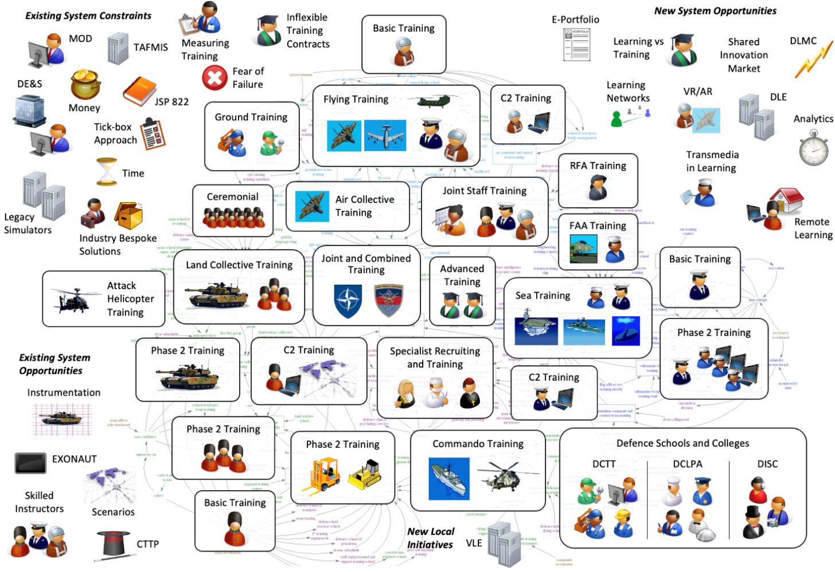

**Figure 2: Rich Picture Diagram of Current System**

The Rich Picture is based around a depiction of the different kinds of training currently carried out in T&E, which are shown in the centre of the diagram. Around these central elements are a set of icons depicting different elements of T&E that are relevant to developing a future Defence Learning Ecosystem.

The first set of icons, which are shown in the top right-hand corner, represent constraints imposed by T&E. These are characteristics that will potentially make it more difficult to manage successful change. There are also a number of new opportunities for development that are shown in the top left-hand corner and which are derived from enablers such as the Defence Learning Environment (DLE). These are elements of the desired Defence Learning Ecosystem that are already being explored Defence-wide and which can be developed into a basis for a future learning.

There are also a number of existing opportunities shown in the bottom left hand corner. These include programmes and projects not explicitly linked to a future Defence Learning Ecosystem, but which have potential to make a significant contribution, through providing either data or content for a new approach. The icons in the bottom right hand corner refer to the Defence Schools and Colleges that are often isolated and implement their own solutions to T&E issues. This shows that there are local initiatives that have the potential to contribute.

### Influence Diagram-Based Map

Throughout the duration of this project, the team have added to the diagram as shown in Figure [3]. This diagram has previously been referred to as the project Roadmap, which started as an analysis of the Rich Picture. It was originally developed to show the kind of changes that need to take place to move from T&E, as shown by the **red block** in the bottom left hand corner, to the Defence Learning Ecosystem shown in the **green block** on the top right. Figure [3] was created during Workshop 1 (Pleva et al., 2020b) and refined in the consequent reports (Pleva et al., 2020d); sections of the diagram are shown in colour to represent the kind of changes involved and have been identified by titles based upon the broad area of improvement that is illustrated (see Appendix [D] for a more detailed description of the interlinking elements of this diagram). The project team believe that this diagram shows two elements of the end-goal Roadmap. It defines and illustrates the goals and desired outcomes of introducing a Defence Learning Ecosystem. These goals are demonstrated by the boxes on the edge of Figure [3]. It acts as a high-level illustration that articulates the

strategic thinking behind the concept of the Defence Learning Ecosystem. In the final Roadmap (section [5.0]), the team have combined the high level thinking in this diagram with major steps and milestones that are needed in order to reach these outcomes.

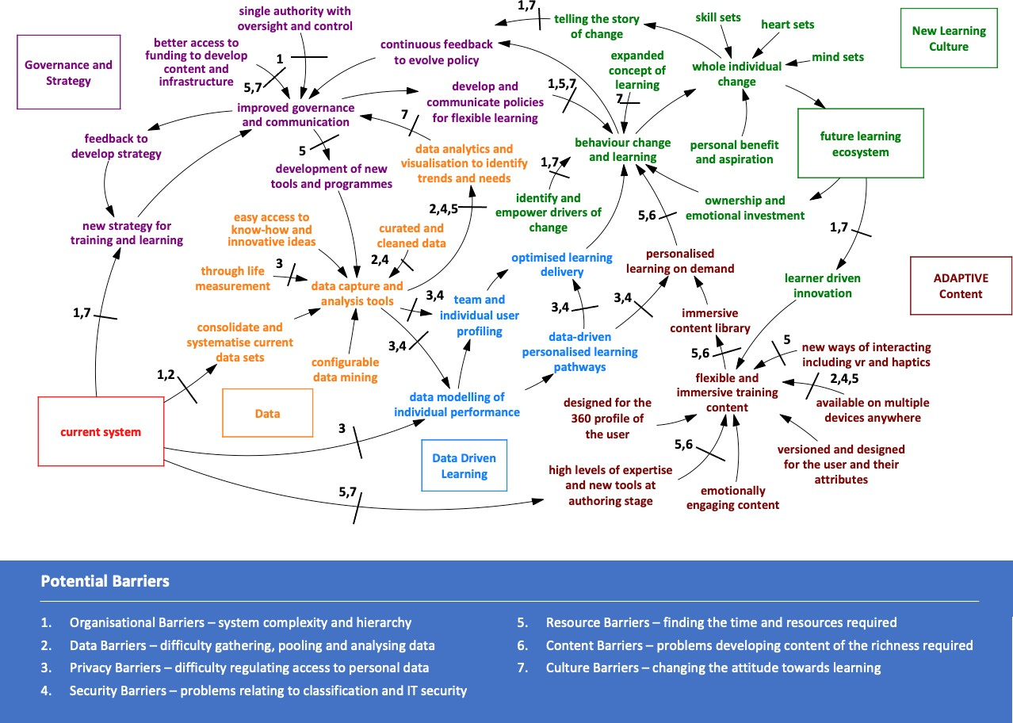

**Figure 3: Roadmap Progression with Barrier Considerations**

### The VSM

The VSM (Beer, 1984) is an approach to understanding problems of control in complex systems. In this context, the project team use the model as an influencer not a guideline format. Beer’s model was heavily influenced by biological models, including the human nervous system, and comprised a set of interlinking systems that worked together to maintain a ‘viable system’, by which is meant a system capable of successfully responding and adapting to changes in its environment. The biological analogies that lie at the heart of the VSM make it a neat fit for the problem of designing a Defence Learning Ecosystem. The recursive nature of the model also makes it applicable to the structure of the Ministry of Defence (MOD) T&E system, where significant authority is vested in individual Services and schools to deliver training according to specific needs. An overview of the VSM is shown at Figure [4].

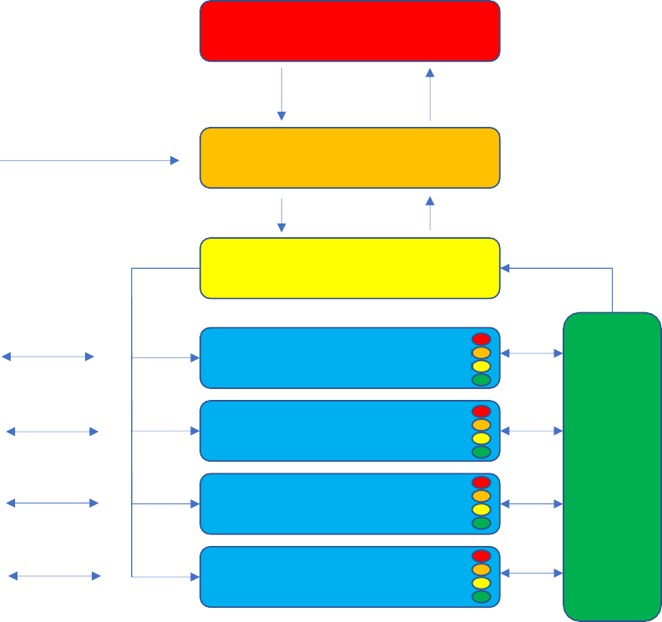System 5 (Governance)

Set Priorities Gather Information

Environment

Allocate Resources, Give Instructions, Request Information

System 4 (Outside, Future)

System 3 (Inside, Now)

Flag Issues

Plan, Generate Scenarios

Information Up

Outcomes

Outcomes

Outcomes

Outcomes

5

System 1 (Activities) 4

3

2

System 2

(Coordination and Communication)

5

System 1 (Activities) 4

3

2

5

System 1 (Activities) 4

3

2

5

System 1 (Activities) 4

3

2

**Systems are Recursive -**

**All System 1s have their own internal Systems 1/2/3/4/5**

**Figure 4: The Viable System Model (Beer, 1984)**

The VSM model comprises five systems. First, a System 1 where the activities in the system are carried out (which could, for example, be factories, departments or teams). There is then a System 2 that communicates and coordinates activity in the System 1s and passes information up to System 3, which acts as a controller for the system, allocating resources and passing instructions down to the System 1s so as to optimise their overall output. Above the System 3 is a System 4 that is more concerned with assessing the environment and looking ahead to see how the system will need to be re-balanced to meet the needs of the environment. An important role of System 4 is flagging up situations where the priorities set for the system will no longer serve to maintain its viability. All of this is carried out according to a set of priorities identified by System 5, the governance system.

In the context of the MOD, the System 5 comes from the Defence People Leadership Team (DPLT) with various System 3 and 4 functions being provided by TESRR, the DLMC team and the Defence People policy team. The System 1s in this system are the individual Services and their respective Service training organisations. By the principle of recursion, each System 1 has a complete set of systems within it. Within the Royal Navy (RN), for example, the 2nd Sea Lord and the Navy People Board are the top-level System 5 with the Assistant Chief of the Naval Staff (ACNS)/Fleet Operational Sea Training (FOST) organisation providing the System 3 and System 4. The RN Maritime Training Strategy (MTS) and its supporting boards are an important element of the System 4 functions of looking into the future and matching supply with demand. Finally the individual schools such as Commando Training Centre Royal Marines (CTCRM) Lympstone and Her Majesty’s Ship (HMS) Collingwood provide the System 1s. Similar arrangements apply for the other Services, though with variations to reflect their different structures and priorities.

The VSM is a diagnostic model of system behaviour and it allows problems with systems to be identified and corrected. Usually those problems are due to individual systems either not functioning at all or only performing part of the job they are required to do. See Appendix [C] for more detail on the VSM model.

## Establishing the Initial Vision

### Defining the Scope of the Project

The project brief5 was clear that the team were not being asked to consider T&E as a whole, nor did they have a mandate to explore the overall direction of Defence doctrine and policy. Whilst any learning ecosystem should be in tune with these larger objectives, it is possible to examine how all teaching activity within a collective community of learners is currently operated and supported within the MOD without “trying to boil the sea” in deconstructing the much wider and complex remit of changing a modern Defence organisation overall.

Even with that acknowledgement, the research team’s understanding of T&E is that it has grown to be extraordinarily large and complex. The analyses of Figure [2] and [3] evidenced that the investigation needed to be prioritised, targeted and informed by previous research. So, the project team understood that in order to determine a Defence Learning Ecosystem Vision, the team needed to:

* Develop a Vision that is disruptive, but grounded in tangible evidence from stakeholders, previous research and relevant global literature;
* Review the key literature, investigate best practice and produce guidance to future approaches to training;
* Collaborate with key stakeholders and add their insight to the Defence Learning Ecosystem development;
* Make recommendations that simplify, not further compound, the complexity of the T&E operating system;
* Note but avoid duplication of any current good initiatives or research projects that are already happening; and,
* Approach the work with an emphasis on ‘realignment’ and collaborative system development, not on aspirational ‘perfect’ modelling.

The following sections [3.2.2] to [3.2.4] walk through the progression of the project team’s evidence and insights from the first concept of the overall Vision to how this could be implemented.

### Predicting the Nature and Needs of Future Learning Systems

The initial literature review revealed expert agreement on several broad trends. Castaño Muñoz, Redecker and Punie (2013) predicted that personalisation, collaboration and informalisation (informal learning) will be at the core of future learning, with a particular emphasis on the importance of recognising informally acquired skills. Currently, training design tends to focus on presenting material and conveying information from trainers to learners. According to Lee et al (2013), in the future a more learner-centric focus will be key. In order to develop a well-rounded workforce, experts generally agree that military education would benefit from creating opportunities for learners to construct and build their own new knowledge acquisition journeys: *“an arena for dialogue, narratives and metaphors, to cultivate individuals whose judgement is developed and matured in a way that makes them culturally astute, agile and well-informed contextual learning and technological advancements”* (Sookermany, 2017 p.34). This is supported by evidence the team found in the changes within the Higher Education (HE) case study (Pleva et al., 2020c). Whilst this acknowledgement of the importance of self-directed learning is valid, a combination approach to learning methods should be the focus of the Defence Learning Ecosystem.

The differences between the terms ‘education’6 and ‘training’7 were consistently debated and reviewed throughout the project. In the preliminary interviews at the start of the project, stakeholders generally

5 HS 1.007 Defence Learning Ecosystem SOR v2.

6 Education was referred to using examples such as: personal development courses, career progression, non-essential learning, degrees and long-term retention of skills.

7 Training was defined using examples like phase one training, physically learning a skill on a course, physical training of a piece of kit.

believed that training was delivered relatively well across Defence. They provided reasoning that the hard skills, like learning how to operate weapons systems, can have dangerous implications if trained badly (Pleva et al., 2020a). Stakeholders commented that the military do not cover ‘soft skills’ education, e.g., social emotional skills, critical thinking and emotional intelligence, as thoroughly as other skill sets (Pleva et al., 2020a). Meanwhile, Denny (2020) found that both physical and emotional knowledge, skills and behaviours are critical for those who have to operate in a complex, international, and competitive environments (both military and civilian). To develop these critical abilities efficiently, a different approach to education is needed by Defence. The approach can be clustered into three groups:

* Knowledge elements: abilities that an individual can learn about;
* Personal elements: abilities that require an individual to develop and apply advanced and complex personal skills and behaviours; and,
* Team elements: abilities that a person requires to work with others effectively.

These elements are described in the context of improving intellectual edge8 in Defence training and learning in Table [1] (Denny, 2020 p.5).

**Table 1: The Elements of the Intellectual Edge**

|  |  |  |
| --- | --- | --- |
| **Knowledge Elements** | **Personal Elements** | **Team Elements** |
| Deeper understanding of:   * The political and military doctrine of actual and potential adversaries. * The art, science and profession of arms. * The history and traditions of warfare. * The operation and management of the United Kingdom (UK) Defence sector. * The operation of the media. * The operation of industry. * Artificial intelligence (AI) * Critical and creative thinking. | Devising and implementing creative and innovative solutions to:   * Complex/wicked problems. * Creative, critical, adaptive and diverse thinking. * Initiative and independent thinking and action. * Mental agility to enable advanced decision making at the speed of relevance in a complex and dangerous environment. * Resilience, coping with surprise, uncertainty and ambiguity and maintenance of reality. * Digital competencies and mindset (understanding and using new technologies). * Human-machine teaming. * Learning to continuously learn. * Risk taking. | Improving Defence staff:   * Knowledge of own leadership strengths and weaknesses, and ability to select and work with a team that has a balance of strengths/abilities etc. * Collaborative problem solving. * Leading, managing, empowering and developing others. * Effective communication. * Emotional intelligence including loyal challenge and self-challenge. * Deep networks and collaboration with military and non-military actors, from UK and abroad. * Cultural awareness and expression. * Ability to adapt to new ways of applying a capability; adopting new organisation structures. |

In order to achieve the identified elements of intellectual edge in an educated Defence-wide force, Denny (2020) reports that moving forward Defence must upgrade existing courses and new courses, which will have to include new content and different learning methodologies. The development of a Whole Force intellectual edge will require resources that Defence Academy does not currently have (Denny, 2020). The strategic scale of the effort involved in delivering suitable Defence-wide learning core capability changes, involves making high level decisions about the management and resourcing of the initiative.

The project team progressed with this in mind, with the recurrent theme from earlier Defence reform reviews at the forefront: *“Our people sit at the heart of Defence Reform. Everyone in Defence is affected and has a*

8 Intellectual Edge is referred to in Defence terms as the collective ability to react well and out-think the enemy. It refers to developing an ‘edge’ through the investment in Defence people.

*part to play. The Secretary of State has stressed that our real, long-term challenge is to change behaviours, align incentives and shift the culture. This is the key task…”9*

### Imagining a Vision

It was important to begin the work with an open, creative exploration of what a Vision of a Defence Learning Ecosystem could look like, unfettered by any influence from anecdotal evidence or previous assumptions. The teamed listened to the ’wish list’ of many stakeholders and then summarised this exercise’s outputs as:

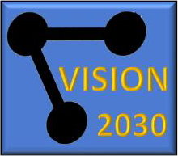*In 2030, we will be proud that knowledge owners talk openly with knowledge acquirers, with some of the most respected operational leaders becoming the most extraordinary teachers, supported by new delivery technologies and managed by one of the most sophisticated centralised data management systems in the world. Our understanding of the future of global Defence will enable us to promote psychologically profound behaviour*

*change across Defence. The learning incentives are flexible and nuanced enough to cope with whatever the emerging realities of the working environment might throw at us. We will know that for every unit of resource and investment we put into this living and dynamically responsive ecosystem, it delivers at least twice the unit value back and we will be able to prove that on a daily basis. Finally, we will be proud that this revolutionary system emerged from existing legacies of good practice that are now sought throughout the world, thereby enhancing our reputation as a highly innovative Defence organisation, as well as developing new revenue streams to reinvest into a compelling learning ecosystem that can justify its claim to be ‘future- proof’. (Pleva et al., 2020a)*

The team also wanted to understand what this Vision would ‘feel like’ to experience, as well as deliver. An imaginative and emotional benchmark was required, alongside a process-orientated Vision, to accompany them in the early stages of the investigation. This version of the early Vision emerged through the eyes of a fictional middle ranking officer in 2030:

*“I use the learning ecosystem about three times a week…surprising really. Well four actually, if you include playing some of the scenario games up there for fun! The main use is when I need to remind myself of something quickly that I learnt ages ago but has just come up in conversation with one of my team. The Defence-wide Knowledge Repository is an extraordinary reference engine for combined MOD know-how and facts and its intuitive Augmented Reality (AR) menu is so easy to use. The second is for planning my own personal development, as well as that determined by my command for current work needs. I quite often take out a quick short course to do during the weekend and the outcomes are usually to do with improving my broader life skills, like last week, getting my head around the new Excel Virtual Reality (VR) support tool. I quite often do these on my mobile as I’m usually travelling at the weekend and don’t want to take all my kit with me. With these tools, I’m usually part of an asynchronous ‘live’ learning team that includes people from the other Services, so I learn a lot more than I sometimes realise about the Defence world generally. Then there is the formal training stuff. I like the fact that this is now much more immersive than back in the early 2020s and makes me use my emotional and mental processes in line with the more practical training stuff. The last course I did was on leadership under pressure and the scenario was challenging. The clever thing about it was that the original authors of the course were reputational heroes of mine, who I had served with only a few years ago previously and they know their stuff, right up to date. At the same time, my mild dyslexia was recognised by the tool almost immediately and the progression pace automatically adapted to my comfort level. No more one size fits all these days. I was learning with a small cohort on this course, some of whom were physically in Kenya on training manoeuvres there, so new dynamics came into play as we wrestled with the collaborative exercise. The data from my previous courses in the area of people management skills shows a profile weakness of slight panicking under pressure and the tool set me a personal target in this area that I am pleased to say I exceeded. This was noticed by my immediate command who has now asked if I’d like to contribute to an R&D team, bidding for a small grant to explore the use of Augmented Reality systems in predicting urban civilian behaviours. Seems we might be working with our local Television/AR studio, a longstanding wish of mine for a few years now. Full circle back to gaming, eh?”*

9 Lord Levene, Defence Reform Review 2013, updated 2015, republished in 2016 as “New Operating Model.”

### The Learning Landscape

The insights gained from initial analysis of the available GFI10 regarding learning services across T&E, at central, Service and in some cases, at school levels are summarised here. Report observations stated that T&E has been allowed to grow as it sees fit ‘locally’ and that this has been authorised at several different levels, usually without any explicit Defence-wide coordination. Research provides evidence that this has led to inefficiency, duplication and also had the effect of burying pockets of excellent innovation and learning practice (Cullingford et al., 2019).

There needs to be some centralised control but that this would be almost impossible to achieve without very high-level intervention (Denny, 2020; Cullingford et al., 2019). Reports commented that the nature of the teaching and learning had to change to meet the emerging realties of a modern defence organisation, but that there are too many barriers and traditions to overcome and therefore localised action through agile, co- ordinated and resilient training capability was the only scale of development likely to be achievable (Denny, 2020; Maritime Training Strategy a&b).

The MTS (MOD 2018a; MOD 2018b) and case study analysis11 evidenced the Navy’s desire to provide an attractive and rewarding employment offer to new and current staff and to enable them to find their full potential. RN Training Transformation (TT) noted that in their previous T&E system there were ways of making changes, but they were costly and time consuming. These learning processes were not geared around modernising, changing or adapting. As a result, the new training transformation programme currently in effect in the RN, are using an agile management system to help consistently adapt and modernise throughout the project duration and going forward. Part of their driver for change recognised that there are opportunities to modernise education and training and implement not just the physical changes, but the changes to help staff deal with modernisation too.

There are general cultural fears about change associated with this style of change management. These fears apply to other large, international and complex organisations, as demonstrated in the HE case study (see Appendix [E]). They also noted early on that, despite these barriers, new ‘best practice’ continued to evolve and that some of the previous evidence showed that targeted support and more collaborative architecture had significantly helped to realign, rather than create a ‘start again’ new Vision from scratch.

### The Impact of COVID-19

This research was conducted during the global pandemic crisis (2020) that affected all large and complex organisations in similar ways. It was interesting for the team to absorb research conducted before the impact of the pandemic and then discuss opportunities and barriers with teams during the pandemic. The team found early anecdotal evidence that senior staff and trainees had ‘opened their eyes’ to the capabilities available, and that that technical systems and course changes were being built much quicker than normal. As an example, the prioritisation of outcomes of Defence School of Electronic and Mechanical Engineering12 (DSEME) training has changed drastically since the COVID19 pandemic. Subsequently, most stakeholders noted similar impacts and considered that, despite the immediate challenges, now is a good time to implement change in Defence-wide T&E systems.

### Identifying the Key Research Themes

Initially, the team considered the core anchors of T&E that were identified in the Analysis Support Construct (ASC) Task 0204 report (Cullingford et al., 2019). These were:

*People, Culture, Strategy, Content and Technology*.

The team explored these anchors and absorbed large amounts of analysis in each of these areas from several large reports (Cullingford et al., 2019; Deighton, 2019; Glynn et al., 2014; Pleva et al., 2020c). This led to an early realisation of how this project’s current research could be focused. T&E have not examined the crossover activities that were happening between each of these anchor points. The research tended to ‘deep

10 Medhurst et al, 2016; Cullingford et al, 2019; Deighton, 2019; MOD, 2018a&b; MOD, 2019; ARITC, 2020; Army MOD, 2020;

Glynn et al, 2014; MOD, 2020.

11 TT within People and Training (P&T) and Project Selborne (Appendix [E]).

12 DSEME is part of the Defence College of Technical Training (DCTT).

dive’ into People or Technology with only general consideration given to the crossover areas. There is an opportunity for realignment on the opportunities available in the spaces between these anchors, rather than within the anchors themselves. Workshop 1 was therefore focused on gathering evidence about these interactive spaces between the anchors. Both the barriers that were operating and the opportunities that were being harnessed were assessed. The early evidence showed that there were four areas of crossover activities that could form the basis of the more detailed case study and investigations for workshop 2. Figure

[5] shows the interaction between the core anchors and how they map to the corresponding spaces.

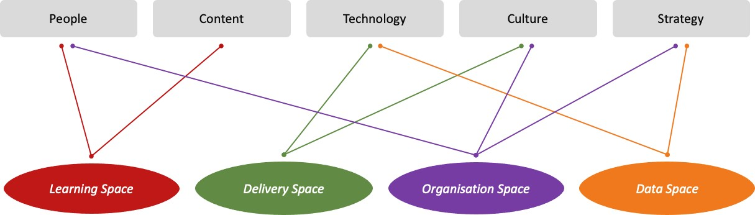

**Figure 5: Core Anchors to Defence Learning Mapped to Spaces**

In the space between **People** and **Content**, significant innovation was happening in developing and updating of current learning programmes and formats, but it was often hidden and therefore not shared. Stakeholders remarked that relatively few individuals within Defence are content creators, a result of which is that this expertise is lost when people move on. This also means that content creation has become a routinely contracted-out service or is carried out by individuals within the organisation who do not necessarily have the expertise to create optimal content. These challenges are exacerbated by the current course creation process. Currently, individuals complete a DLE training course to become a course owner, which provides them with the ability to create their own courses and deliver their own learning content. This works well in some cases when content creators have prior learning design experience. However, providing the ability for anyone to author content with minimal training means there is an increased chance of poor quality training being developed. As such, the lack of review results in course duplication and a great deal of PowerPoint style, text-heavy, eLearning course content being created. The team called this crossover area between People and Content the **Learning Space**.

In the space between **Technology** and **Culture**, evaluating the performance of the various personalised delivery systems and approaches to modernising the learning infrastructure is challenging. In particular, a lot of good work is going on in the personalisation of learning (Deighton, 2019) and how the MOD might exploit its benefits as a driver of training efficiency, operational effectiveness, learning achievement and engagement, and a positive learning culture. The approaches used to implement a Personalised Learning (PL) process include the exploitation of novel data and training delivery technologies. The team called this crossover area between Technology and Culture the **Delivery Space**.

In the space between **Culture, People** and **Strategy**, there were examples of misunderstanding about training and educating practice and some organisational legacy issues that were slowing down the pace of change (Pleva et al., 2020a). Evidence from stakeholder interviews showed that there was a significant challenge in the current system is that the teaching skills of the ‘Owners’ and their availability are in conflict with the timetables, resource capacities and needs of the ‘Acquirers’. As the workforce adapts to new types of operation, with many more ‘soft skills’ and behavioural psychology inputs required, the nature of education evolves alongside. There is evidence of innovation and significant change in some parts of the MOD, but the insights are not always shared and overall the behavioural approach to immersive learning is sporadic.

The Policy and Assurance Group that monitors all areas of learning and other single Service authorities underneath TESRR delivers good governance, but workshop 2 found evidence that the system would be enhanced if this central governing authority was more inclusive of all stakeholders, organisations and schools across different levels. Whilst the team recognise that increased physical attendees would be impractical, a

greater consideration of knowledge exchange, the meeting outcomes and a rotational strategy for representative attendees would be of benefit to cross-Service collaboration. The team called this crossover area between Culture, People and Strategy the **Organisational Space**.

In the space between **Strategy** and **Technology,** there was evidence, particularly from the first stakeholder workshop (Pleva et al., 2020b), that poor data capture and localised, unconnected analytics was failing to inform the development pathways. The MOD T&E structure comprises of a complex legacy of initiatives and often uncoordinated localised solutions. There is evidence of ‘silo’ strategies, created just-in-time to react to an issue. However, given the pressure on the service, the solution is delivered without review (Cullingford et al., 2019). In industrial and commercial environments, data analytics has become the critical factor in obtaining insights, understanding development pathways, defining strategy or doctrine and measuring impact. Unfortunately, this kind of detailed data is not easily found and can often be hiding away in small repositories (Pleva et al., 2020a). The team called this crossover area between Strategy and Technology the **Data Space.**

These four crossover areas became the lenses through which the team viewed the work going forwards into the deeper levels of research. However, there were two other anchors that were not mentioned in previous reports and were considered by the team as additional critical anchors that influenced the four spaces already now identified – these were **Communications** and **Governance**.

## Integrating Governance and Communication

A common theme throughout this research project has been the centrality of governance in determining the success of any business change programme, and particularly one that involves as many stakeholders as the Defence Learning Ecosystem. In the context of this project, by ‘governance’ the team refer to the concept of a co-ordinated policy and monitoring service, overseeing a range of authorities and compliance systems (Pleva et al., 2020a). Core to the role of any such service is communication, both ‘downwards’ (in terms of direction-setting) and ‘upwards’ (in terms of integrating information from multiple organisations and using it to inform strategy), as well as across units at each level13 (see Figure [6]). This section outlines some of the key governance and communications challenges that Defence will need to overcome to realise the ambitious Vision outlined in this document.

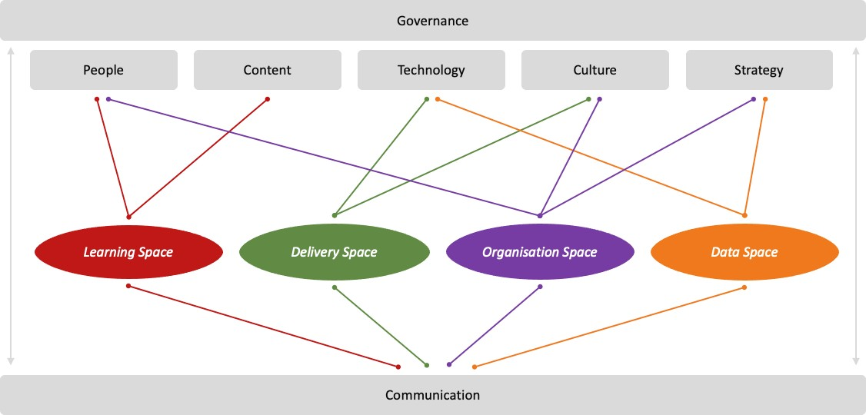

**Figure 6: Integration of Governance and Communication**

13 In terms of the Viable System Model, outlined in sub-section 3.1.5, the governance role functions as a ‘brain’, taking in requirements from policy together with the feedback loops that operate both upwards and downwards.

### The Challenges

One of the main problems that has been identified by stakeholders (Pleva et al., 2020a) is not a dearth of strategy, but, in many ways, a surfeit. In workshop 1, two attendees had recently drafted separate training and learning strategies for the MOD which were contemporary at the time of the workshop (Pleva et al., 2020b). What was missing was not the strategies, but the lack of a sufficiently high-level body with ownership over the direction of Defence-wide initiatives, and the ability to drive the Vision across the enterprise (Pleva et al., 2020a). Existing organisations that are enabled to fill this role14 would have the advantage of a track- record and existing organisational infrastructure but would face the challenge of a perception that progress so far has been too slow or too piecemeal, as well as contending with a change in brand and responsibility.

Alongside the numerous learning strategies, policy and approaches to training (MTS, 2019; Data Management Strategy 2020; MOD, 2019) that are in place across Defence, the MOD is not short of advice for how training should be executed. However, many respondents reported a sense that there was no clearly- articulated ‘Golden Thread’. Despite lots of work being undertaken, there seemed to be a lack of clear understanding of the purpose of learning to Defence as a whole, and ways in which improving learning would yield benefits to individual units, to their parent Services, Defence-wide, and ultimately to the UK by providing an increased intellectual edge and high levels of value for money. There is confidence that these benefits are real, that investment in a better Defence Learning Ecosystem would represent value-for-money

- but they need to be clearly understood and articulated: there needs to be more *why* as well as *what* and

*how*.

The relative weakness of overarching governance structures for learning across Defence also means that there is no capacity to conduct the other core communication function: that of integrating data from the Defence Learning Ecosystem’s component parts in order to understand constraints, develop priorities, or direct investment (Pleva et al., 2020b). This means that many ‘quick wins’ are being missed: areas where overtraining (or undertraining) are occurring, areas where capability is being duplicated or misallocated, pools of talent that are being underutilised, and where learning opportunities are being wasted or opportunities missed to make existing initiatives mutually compatible (Pleva et al., 2020b).

However, another clear theme that emerged throughout the project was that of the benefits of *co-ordination* rather than *centralisation*. Any initiative that entailed concatenation of existing training authorities and learning organisations would risk losing individual approaches to learning that meet specific local and single- Service needs, in the service of a Vision that had no long-term guarantee of success (Pleva et al., 2020d).

In line with the idea that Defence should be seeking to make better use of, but not to replace, the learning resources it has at its disposal, is an observation that has been made at several stages of this research project: that T&E, and its proliferation of initiatives and strategies, is the *result* of adaptation to needs, and in many cases, highly-effective ones. The project team learned throughout the project of ways in which individual Services or units had pursued technological innovation, often in response to challenging conditions. The challenge is how to exploit these beneficial adaptations, when they occur, for the benefit of the whole of the Defence enterprise.

There is every reason to think that these challenges can be surmounted. The Defence Learning Ecosystem and particularly its single-Service training establishments, are familiar with a culture of clear direction- setting, based around the articulation of a clear Vision that an organisation’s components are required to help achieve (Ground-Situation-Mission-Execution). This culture is a powerful enabler of change in the MOD, if suitably directed (Pleva et al., 2020c).

### Implications for Change Management

Governance and communication are key core enablers for all the other elements of the Defence Learning Ecosystem, as articulated in the final version of the Roadmap (section [5.0]). Without getting these right, the whole change programme stands a significantly reduced chance of success. Drawing on the findings presented in the previous section, the project team has identified a number of clear implications for the

design of the change management programme that will underpin the realisation of the Defence Learning Ecosystem Vision15.

First, there will need to be a single, appointed, organisation (either extant or newly-created), led by a suitably senior (e.g. 3-star) stakeholder, with responsibility for bringing about the Defence Learning Ecosystem Vision16 (see section [4.2.1] for more detailed information on this recommendation). The remit of this organisation should include the following:

* Ensuring that the Learning Strategy is connected to and aligned with other key pillars of MOD’s change programmes, and in particular the People Strategy;
* Defining a set of measurable change objectives, with clear responsibilities, constraints, and boundaries articulated; and,
* Clearly identifying the benefits of realising the Vision and quantifying them in value-for-money terms17.

Figure [7] demonstrates how these recommendations related to the organisational space will impact the direction between System 5 down into Systems 3 and 4 in the context of Defence within the VSM model. Making changes in this area will include:

* Ensuring the same standards in the development and delivery of training, and the collection and dissemination of information about it, are applied across MOD;
* The creation and maintenance of communications channels and networks through which information and direction can flow18;
* The establishment of central platforms for stakeholders across Defence to share information; and,
* Enacting principled processes for collecting, analysing, and exploiting information.

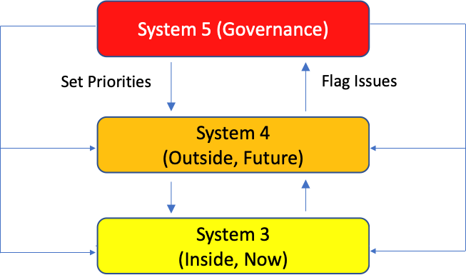

**Figure 7: System 5 (Governance) Impact on System 3 and 4 VSM**

Evidence from the interviews and literature demonstrates that communication is a weak area in T&E. As such, one of the core tasks of this governance body will be the execution of a coherent communications strategy (see section [4.4.1] for more detailed information on this recommendation). Key messages should include:

* The Vision is not about replacing or centralising existing organisations, but about making them more effective across Defence;

15 The TRESLE concept offers a more detailed Vision for what this change programme might entail.

16 The MOD Universal Learning Ecosystem Representative Board of Trustees ([MOD:ULE] TRUST) offers an example of what form this might take.

17 Pleva et al., (2020a) outlines a framework for such a value-for-money assessment is offered, pp.62-64.

18 The Learning Ecosystem Network concept (LECONECT) offers an example of such a network.

* What the benefits of realising the Vision would be for individual units, the Armed Forces, Defence as a whole, and ultimately the UK – the why, as well as the what and how; and
* What the Vision offers for every individual in Defence.

## Recognising the Opportunities

The project team reviewed the opportunity for increasing efficiency and quality and broadening the overall talent capacity in T&E using the four spaces (learning, delivery, data, and organisational). The evidence from two workshops, case studies and interviews clearly indicated that, while there are barriers to change in these spaces, there was value in articulating exactly what the opportunities are, and where possible designing potential interventions that could exploit them. The project barriers were subjectively clustered into themes by the project team and analysed at a MOD level, a Service level and a School level. This identification shows specific areas that are needed to overcome the barriers to progress (see Table [2]).

**Table 2: Overcoming Barriers at Different Levels**

|  |  |  |  |
| --- | --- | --- | --- |
| Barrier Type | MOD Level | Service Level | School Level |
| **Organisational** | Identify responsibilities of MOD, Service and School levels and provide oversight of progress across MOD | Identify a lead organisation with responsibility for driving learning transformation | Identify a lead individual with responsibility for  driving learning transformation |
| **Data** | Set pan-MOD standards for formatting and interchange of learning data | Ensure single-Service initiatives comply with the central standard and upgrade legacy systems | Ensure local initiatives conform with the central data standard and upgrade legacy systems |
| **Privacy** | Set pan-MOD standards for what personal learning data should be stored, when it should be deleted and who has access | Ensure single-Service initiatives conform with the central privacy standard and upgrade legacy systems | Ensure local initiatives conform with the central privacy standard and upgrade legacy systems |
| **Security** | Identify key security considerations for learning data and develop protocols to manage data within boundaries | Ensure single-Service initiatives take account of specific needs of high- security training systems | Ensure local initiatives take into account security issues and develop policies to manage content |
| **Resource** | Provide cross-MOD centres of excellence to support transition | Identify suitable programmes and organisations to provide lead funding | Ensure that local procurement systems reflect learning priorities |
| **Content** | Define new standards for learning content within Defence Systems Approach to Training (DSAT); and develop large scale narrative formats19 that can be configured by Service or School | Develop flexible and immersive learning content to meet Service requirements | Develop flexible and immersive learning content to meet individual and course requirements |

19 E.g. INFORMAT – see glossary.

|  |  |  |  |
| --- | --- | --- | --- |
| **Culture** | Provide leadership on cultural change and support cultural transition across all four Commands | Identify a lead organisation with responsibility for driving cultural change | Identify a lead individual with responsibility for driving cultural change |

With this consideration, the project team mapped the learning spaces onto the development of the Roadmap diagram (see Figure [8]). This helps contextualise the focus elements of the recommendations and how they map to the research undertaken. The project team refer to the Defence Learning Ecosystem barriers as Overcoming Roadmap Barriers to Integrate a Teaching and Learning Ecosystem (ORBITLE). This is a team- designed approach that focuses on the action needed to overcome the barriers at each level within the system. The project team considered the different types of barrier and the likelihood of some being concomitant to other changes in barrier status, as outlined in section [3.4]. For example, if the barrier that prevents sporadic outbreaks of innovation across the MOD from learning from each other can be alleviated by an internal market of Hubs of Excellent Learning Practice (HELP hubs), then the need for centralising the development of innovation practice could be managed as an internal market by existing services like the Defence Academy and would have therefore entirely removed a barrier. The team used the framework to deploy four types of Barrier Change Status:

Enhance (e.g. Available, Design, Attributes, Profiles, Times, Immersive, Versions, Evidence Based [ADAPTIVE] overlaid on DSAT);

Realign (e.g. DLE and LEARN receiving a Defence-wide service mandate); Remove (e.g. as example above); and,

Accept (e.g. this is agreed that in this area, each Service has greater authority over certain areas of learning than any central division).

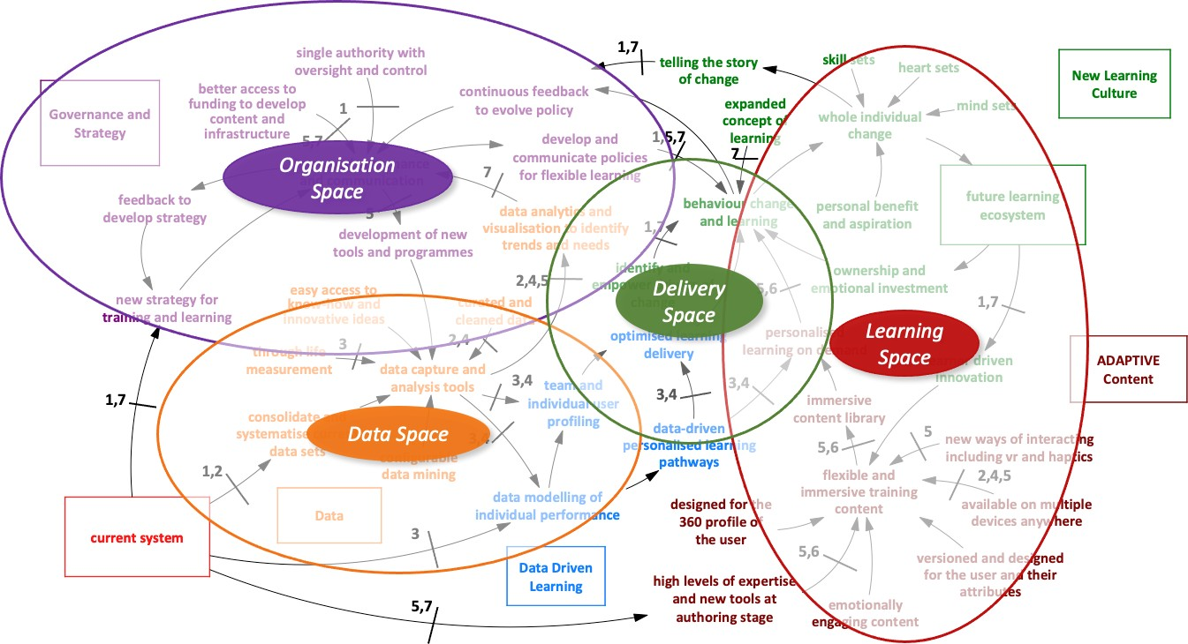

**Figure 8: Spaces Mapped onto Roadmap Progression**

### Analysis of the Learning Space

The case studies were particularly valuable in demonstrating what aspects of this space were working and what needed more support. Evidence from thematic analysis of interviews with stakeholders (Pleva et al. 2020a) indicated that a culture has grown in some areas that sees the learning system as having a single delivery objective; this is sometimes referred to as *‘training as required by the system’*. Despite the evidence

that the current one-size-fits-all approach to Defence T&E is not fit for purpose as described by a number of interview participants (Pleva et al., 2020c), there appears to the project team to be an underlying resistance to change and a misunderstanding of what a learning system, in a modern and adaptable organisation, actually needs to provide (Pleva et al., 2020c). In day-to-day practice, the reasons for not responding to these issues are often camouflaged by broad statements like ‘lack of resources’ and ‘no authority’. Nevertheless, the project team found overwhelming evidence that those who require learning and those who deliver it both appear to be wanting change. The Army Recruiting and Initial Training Command (ARITC) Case Study (see Appendix E.4) identified that successful delivery is sometimes hampered by the lack of a core development team drawing together offerings and expertise from across Defence.

Stakeholders have evidenced an enthusiasm for changing behaviours to address these issues. This can be done by strengthening both the systems approach to training and the cultural approach. Encouraging the move from traditional push training that has basic Key Performance Indicators (KPIs) to a more intuitive and self-directed knowledge exchange with 36020 assessment and capacity growth measurement is important. In order to strengthen the dynamics of the Learning Space, there must be investment not just in the types of learning, but the developers, the resources available and the measurement (see Figure [9]). Identifying the right knowledge owners will help improve methods of capturing expert knowledge, which will in turn strengthen the in-house learning development capability. Widening the application and type of learning will ensure more variety for different types of learner, and implementing data analysis and capacity measurement as a KPI will help with broader and more holistic 360 capability assessments. The success of this change is driven by sharing the positive outputs, which can be achieved through internal innovation markets.

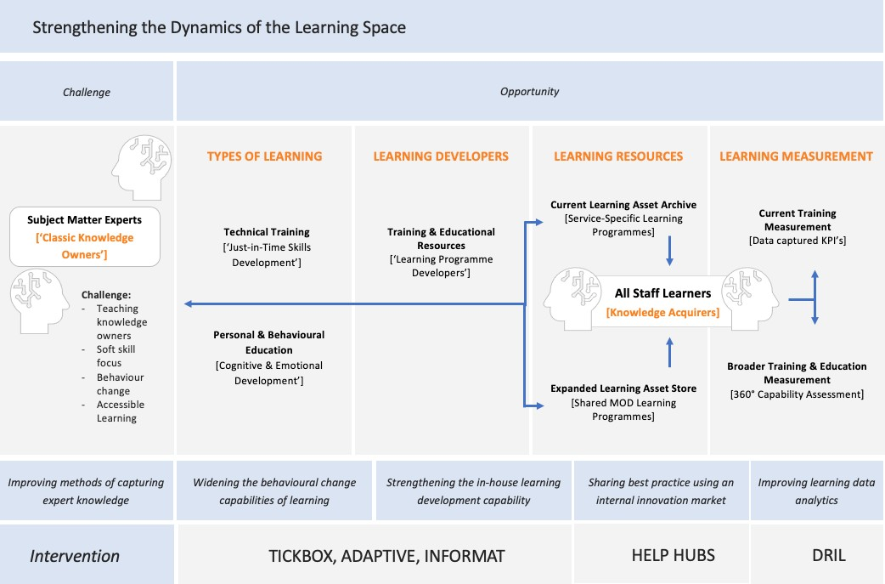

**Figure 9: Strengthening the Dynamics of the Learning Space**

In workshop 2, stakeholders agreed that there is a need for a culture in Defence that values the importance of learning and development and in particular, its content development (Pleva et al., 2020c). They argued that senior authorities do not always recognise the connection between addressing the bigger issues, like recruitment and retention, and the potential impact a Defence Learning Ecosystem could have as “a

20 A 360-degree feedback is a process through which feedback from an employee's subordinates, colleagues, and supervisor, as well as a self-evaluation by the employee themselves is gathered.

fundamental part of capacity growth and effectiveness for the workforce” (Pleva et al., 2020d p.13). The ultimate KPI of any changes to the Learning Space is to show decision-makers that an enhanced learning programme delivery system will deliver measurable impacts on high level challenges Defence-wide. The team defined their analysis into three areas:

* Specific Challenge;
* Opportunity; and
* Intervention Concept.

These areas were established based on the early research into the Learning Space where slight realignment and limited additional resource might produce high returns in a short-change programme timeline. In each of these, they originated an illustration of a possible intervention concept, in order to bring the strategy to life.

#### Building Learning Programmes Collaboratively

##### Specific Challenge

Evidence from stakeholder interviews shows that a significant challenge in T&E is that the teaching skills of the ‘Knowledge Owners’ and their availability do not align with the timetables, resource capacities and needs of the ‘Knowledge Acquirers’. There is a reliance on PowerPoint deck style teaching hosted online and text heavy courses. The DLE case study found that in particular, many courses are being updated in light of the global pandemic due to the need for more remote training; however this has caused course duplication without quality assurance (see Appendix E.1). These remote collaborative courses are not technically reviewed once they are created, aside from by the course owner, which opens up the issue of quality and course consistency. This challenge of building collaborative, expert-driven courses and programmes is important to resolve.

##### Opportunity

It would be possible to create a learning development template to assist Knowledge Owners in creating new, immersive content that engages their users collaboratively and remotely, instead of following a text-heavy design. They will be guided by this template, even if they have no teaching skills themselves, so that new programme developers have an ‘authorised’ basis for an innovative teaching programme that is not dependent on time/place access to the expert.

* + - * 1. ***Intervention Concept***

**TICKBOX** – **Transferring Individual Classic Knowledge into Broadly Owned eXpertise**: Allowing ‘time poor’ experts to support curriculum development and authorisation on a regular basis, thereby allowing greater levels of knowledge transfer between knowledge owners and knowledge acquirers. The template facilitates the expert to supply knowledge relevant to the core curriculum needs, wherever they are in the world.

#### Ensuring Programmes are Fit for Purpose

##### Specific Challenge

As the Defence workforce adapts to the emerging realities, the nature of learning and the T&E outputs related to products and services need to respond and change. There is a requirement for a focus on ‘soft skills’ development and a more accessible approach to teaching and educating. There is evidence of innovation and significant change in some parts of the MOD, but the insights are not always shared and overall. For example, there is investment into innovative technical delivery equipment; however there is far less focus on encouraging behaviour change through immersive learning. Whilst many areas of learning development do address some of these issues, interview evidence from case studies indicated that areas such as Learning Context; Mindsets (Cognitive Processes21); Heartsets (Emotional Intelligence22) and On-

21 Cognitive processes include thinking, knowing, remembering, judging, and problem-solving.

22 Emotional intelligence (otherwise known as emotional quotient or EQ) is the ability to understand, use, and manage emotions in positive ways to relieve stress, communicate effectively, empathise, overcome challenges and defuse conflict.

Demand Access to Learning are important, but the current guidance in Joint Service Publication (JSP) 822 lacks detail on how to design and deliver this modern, accessible, personalised and immersive approach to learning. Instead, DSAT focuses mainly on the delivery of task-based training objectives, and developers consequently struggle to apply the framework to less tangible learning outcomes.

##### Opportunity

Whilst DSAT continues to provide a strong framework for training delivery, the team explored how to enhance DSAT with an additional framework overlay. This would trigger important checks and balances to the current process, in order to ensure that learning design is meeting the modern learner’s expectations of immersive and memorable learning, using new technologies, whilst also ensuring that all key points are taught and assessed.

* + - * 1. ***Intervention Concept***



**ADAPTIVE** – **additional guidelines for learning programmers cover these emerging areas:**

**A**VAILABLE on a wide variety of devices and

**D**ESIGNED to be configurable for all users, their individual needs and **A**TTRIBUTES in mind; including heart-sets, mindsets and skillsets, being **P**ROFILED for each learner so they can learn at the

**T**IMES and places that are convenient for them, giving

**I**MMERSIVE and emotionally engaging learning experiences with **V**ERSIONS stored in a robust centralized storage system incorporating **E**VIDENCE BASED feedback to promote effective learning

#### Sharing Innovative Practice to Save Resources and Maximise Investment

##### Specific Challenge (A)

The project team have collected significant evidence from interviews, case studies and workshops that innovation related to T&E does exist in Defence and is, in some cases, world class (Pleva et al., 2020a; 2020b; 2020c; 2020d). However, this work is happening in silos and as it is not part of any major strategic plan, it is usually rendered timid in ambition by lack of resources. Whilst much student data is recorded and stored, Defence admittedly struggle to use the data analytics to measure student progression, inform course design and consequently improve the user experience of learning programmes. There is also evidence that this innovation is often led by the passion of an individual champion or small group, sitting slightly ‘outside’ the main learning delivery system. Therefore, the project team have been considering how to connect these ‘thousand flowers blooming’ and anchor them into a new collaborative space.

##### Opportunity (A)

Providing resources and access to technical platforms through a central MOD mandate would allow innovators to take risks and explore functionality, measurable value and, crucially, potential scalability in a safe Research and Development (R&D) environment. If this could be done, it would slow down the current tendency to duplicate effort in small-scale initiatives (Pleva et al., 2020c), whilst offering powerful new insights that can then be harnessed and configured for each specific Service need.

##### Intervention Concept (A)

**HELP – Hubs of Excellent Learning Practice**

By creating a central group of hubs, each being focused on the different spaces between the anchors (see Figure [8]), the system could begin to create an internal market of its own. Then it would become clearer as to where to put a more consolidated resource line of talent and funding, and the access routes would be offered to each Service, thereby encouraging a collaborative approach to innovation, rather than a siloed one.

* + - * 1. ***Specific Challenge (B)***

The DLE has some good structures in place that help content owners template their own course design. However, developing efficient learning tools requires creative design, speed and subject matter knowledge. Innovative learning design is not currently easily accessible in MOD technical delivery systems, which makes it difficult for developers to harness new ways of delivering training. As an example, Defence do not currently use large landscape23 experiential learning tools online or face to face. This is likely due to the perceived investment and lack of flexibility in remote learning templates. There is benefit in using learning techniques that harness transmedia24 teaching. The challenge is implementation and sharing this innovating Defence- wide.

##### Opportunity (B)

The team’s Vision seeks to expand on the excellent work in DLE by offering Do it Yourself (DIY) templates that knowledge owners can use to create new online learning tools that could be exploited in face-to-face teaching and collective training.

* + - * 1. ***Intervention Concept (B)***

**INFORMAT - Immersive Narrative Format Templates**

The use of design templates that create DIY large landscape gaming formats enabling non-experts in learning design to build innovative learning experiences that are tailored to their needs.

### Analysis of the Delivery Space

The interviews and GFI indicate that there are currently multiple online training delivery platforms being used alongside the DLE. Evidence indicated that there is frustration within some organisations who are using one main online platform like the DLE. This frustration is due to slow pace of change when large system updates occur or changes are required, and an overall sense that the current capability of the DLE does not always have all the necessary requirements for specific organisation or school needs. For some users, the DLE does not yet have the full ‘permissions’ agreements to deliver work at the higher security levels. All these factors have triggered the development of different online training platforms across Defence that have been created to respond to specific needs. The case studies highlighted that some of the issues associated with the DLE, like slow upload speed and storage, have been addressed over time. The outcome of a slow response (likely due to the lack of investment and the small internal team at DLE), has resulted in these multiple Virtual Learning Environments (VLE) using different systems that are not all interoperable with other systems and therefore cannot be easily shared. In some instances where there are very specific technical needs, a VLE or plug in to the DLE may be necessary. However developing and investing in localised VLEs is not productive to the overall aim, which should be streamlining and improving a single delivery platform for learning.

In the DLE course library, some types of training delivery, e.g., mandatory training about health and safety, reportedly can be frustrating to learners due to a lack of mobile access or Information Technology (IT) constraints, which hamper the ability to learn away from the workplace, and a large amount of course duplication with no endorsed ‘course leaders’. In sophisticated scenario gaming, the current DLE

23 Large Landscape learning – refers to epic scale fictional scenarios that immerse the learners to strengthen the experience and ensure retention of the learning outputs.

24 Transmedia – a narrative that extends beyond multiple media forms that also plays to the strength those forms; may or may not be interactive.

infrastructure cannot manage the combination of transmedia inputs, team video chat and responsive interactive collaborative analysis all being operated by each student at the same time, using remote devices.

There is a view that if nothing is done in this space, it is likely that future training developers will not be developing the highest quality training achievable (Pleva et al., 2020c&d). This means that in order for the Defence Learning Ecosystem to be effective, it must meet the needs of the modern student and the type of learning they require, alongside more efficient data outputs that help to identify the value of the learning.

Evidence indicates that there have been incentives to try and develop centres of excellence and delivery across the Services, but this ambition has been relatively unsuccessful to date as it is not being followed up with appropriate resources (see Appendix E.1). It reportedly will not happen organically and requires support and endorsement from senior authority to ensure the Delivery space is optimised Defence-wide. It is clear that some of the opportunities available within the DLE could be taken advantage of quickly if these barriers could be alleviated. There is a compelling case for exploring the small resource alignments needed to rectify the two challenges in this Delivery Space – A) infrastructure and B) personalisation. Figure [10] provides a visual overview of how the team believe the Delivery space can be strengthened. Specifically, this explores the challenges of making changes in the Delivery space, followed by opportunities that have been discovered in this project. In order to strengthen the Delivery space, it is first necessary to streamline the existing virtual systems and understand the key benefits from doing so, including: personalised learning, data-driven learning, a streamlined, interoperable system, an upgraded course library, and more efficient data feedback25.

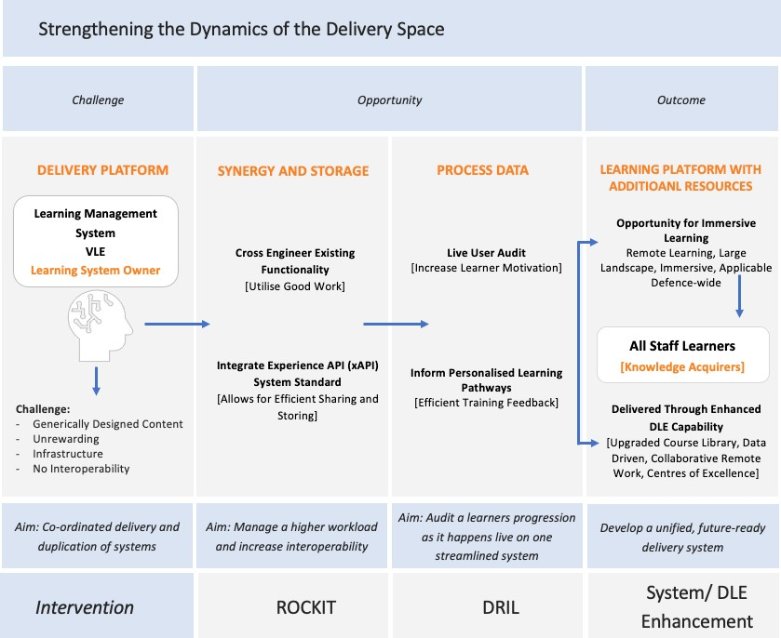

**Figure 10: Strengthening the Dynamics of the Delivery Space**

25 Current TTEP research underway in these areas is acknowledged, e.g. HS1.008 – Enabling a Data-Driven Training and Learning Capability; and HS1.021 – Personalisation of Learning.

##### Specific Challenge (A)

Comments from TESRR and DLE representatives articulated the infrastructure challenge by identifying that delivery platforms in any Learning Ecosystem have to be constantly refreshed, resourced and upgraded, as interoperability is key to Service needs and attributes. There is considerable support for the argument that a more coordinated delivery can be achieved relatively easily, with modest realignment and investment, rather than allowing several different delivery platforms to co-exist.

##### Opportunity (A)

To cross-engineer26 the functionalities that are currently enjoyed by users of DLE and other platforms, alongside strengthening MOD Operational Network (MODNET) to manage a higher workload of data transfer and interoperability. Increasing the interoperability through the incorporation of external solutions contained in software services like Microsoft 365 would quickly enhance the operational value of the whole delivery network. If all Defence learning systems started moving to a standard that allows data and systems to be shared more efficiently using, for example, the Experience API (xAPI) development standard, then programmes and other systems would be able to talk to each other and share information.

##### Intervention Concept (A)

**ROCKIT – Repository Of Capacity, Knowledge, Innovation and Technology:** Linking data service centres’ storage centrally, using a single, but integrated software programme that offers a combined ‘digital engine room’ (see Data Space later), but in the Delivery Space, ensuring resources are focused into a single learning delivery infrastructure that is well resourced and constantly upgraded.

* + - * 1. ***Specific Challenge (B)***

The delivery space is exciting, as there are regular outbursts of innovation across the MOD. The space focuses on the way that technology can deliver more personalised content. It is recognised that there are problems with generically designed, self-directed learning tools, where there are some elements the learner already knows and wants to skip, whilst others progress too quickly for some learners to fully understand. Evidence shows that this is proving to be unrewarding to many learners and leaves them feeling like they are wasting their time, summarised as *‘another load of PowerPoint time-wasting exercise’*. The challenge is how to deploy ‘just-in-time’ analytics to make learning personalised and relevant. The ARITC case study (see Appendix E.4) identified that the longer-term promise from Personalised Learning offers large benefit from efficiency gains.

##### Opportunity (B)

Learning platforms can use data to audit the user’s progression as it actually happens ‘live’, reconfiguring the learning experience to suit their specific needs. Potentially, this is a highly scalable facilitation of personalised learning. In a Defence context, personalising learning would provide a more engaged workforce which would consequently increase motivation. As it stands, Defence store a lot of user data but do not process any of it to inform personalised learning pathways. There is a development opportunity to analyse the data already being stored, to provide more targeted training which will result in better results and outcomes Defence- wide. Training feedback data is routinely collected and stored, but rarely analysed after to inform data-driven training developments.

##### Intervention Concept (B)

**DRIL – Data Managed Real-Time Interventions in Learning:** Managing and analysing data in real time will help with personalised learning and developing data driven training. Data analysis can be formatted into a templated DIY guide. The expertise in developing multi-level progression pathways can be formatted to enable those not highly skilled in learning programme development to provide personalised learning that reconfigures learning pathways ‘live’ as the learner progresses.

26 Cross engineering is a collaborative and process-oriented approach to change management.

### Analysis of the Data Space

Whilst the actual hardware of any data will naturally change as the digital product market continues relentlessly to innovate, the main concern within the space between **Technology, Culture** and **Learning Content** is data. The project team investigated the value of centralising and empowering the MOD data management, as it tries to deliver five current data-based services:

* + - * An immersive content teaching and learning library, accessible on-demand;
      * Deployment of data-driven analysis to service personalised learning pathways (see DRIL above);
      * Stronger analytical functionality using data capture and storage for individual, localised, Defence- wide knowledge capacity measurement;
      * Easy access to know-how and innovative ideas storage, combining Service knowledge repositories or hubs into a single reference area and ensuring that new knowledge or innovative ideas that often emerge from the learning community are captured and stored for future reference; and,
      * Generic data analytics to recognise trends or needs that inform policy development, learning priorities, development of new doctrine and operational planning.

The discussions with the team during the Collective Training Transformation Programme (CTTP) case study (see Appendix E.6) identified the many issues that data barriers created. The Army, as with much of the MOD, has problems with data being held in isolated silos. Much of the purpose of the Training Model component of their future systems being considered is to overcome these challenges. The project team found an opportunity in the type of research already happening and to build on current training and educational data resource. The team summarise the challenge, opportunity, intervention and outcome of the Data space in Figure [11]. Changes to infrastructure are necessary for not just improving data measurement, but for future personalisation, 360 assessment, smart architecture, and making Defence learning systems overall more interoperable and user friendly.

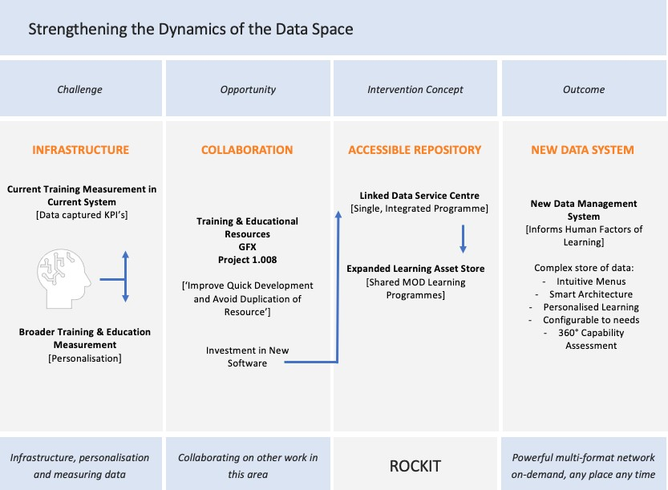

**Figure 11: Strengthening the Dynamics of the Data Space**

##### Specific Challenge

There were multiple ranging opinions from workshop 2 from participants on how to effectively aggregate data, but most stakeholders agreed on the main challenge objectives: more data inputs for aggregation; more efficient aggregation and analysis; easy access storage; personalised learning data-driven services; and more subject-specific focused analytics. In the current system, T&E is not effectively measured, analysed and personalised for a more seamless and effective learner experience.

##### Opportunity

In parallel to this research is a complimentary study (HS 1.008) that focuses on the broad concept of a data- driven training and learning capability for Defence (Bailey, 2020). The project team have linked up with the team to ensure this work is available for the major infrastructure research continuing. In a Defence Learning Ecosystem, the team's recommendations are made to inform the other research and help the individual Services to envision how data management can encourage capacity growth and then measure it, whilst ensuring overall learning progression remains ‘future – proof’.

##### Intervention Concept

**ROCKIT – Repository Of Capacity, Knowledge, Innovation and Technology:** Linking data service centres’ storage centrally, using a single, but integrated software programme that offers into a combined ‘digital engine room’, enabling data to inform the human factors of learning, whilst making all MOD innovation that emerges from learning activities accessible through navigable taxonomies. With new data management systems, this complex store of data could use intuitive menus and ‘smart’ architecture, to allow the data mining to be configured to suit a wide range of user needs.

This Vision illustrates how data management could be fully integrated and constructed to capture, store, analyse and disseminate data to increase value to other MOD stakeholders. As a delivery platform, this data centre will offer a powerful multi-format network, always on-demand, any place, anytime.

### Analysis of the Organisational Space

Specific areas of this space triggered the most debate amongst responders to questionnaires and in both workshops. The first concerned the nature of authority over the learning system development. The management structure now places decision-making at a Service level. As such, it was assumed by many that this would also work when looking specifically at the realignments of the learning provision.

Evidence quickly became available, often from the same stakeholders who thought Service authority devolution was good in principle, but that this was now not working that well. These stakeholders had regularly encountered T&E needs that would benefit from being viewed from outside an individual Service authority. Common examples cited were; how to harness new technologies, like VR and AR27; improving experiential learning in an online environment such as the one imposed by the COVID19 pandemic; and saving resources by making configurable programmes that address common themes, like leadership training. However, those with a Defence-wide remit in the learning area, like TESRR, had many examples of how difficult it was to bring about change in this decision-making environment.

When the team analysed the rapid realignment interventions within HE learning as a response to the COVID19 pandemic (see Appendix [E]) it became clear that some kind of coordinated authority is important, but that the emphasis is not on centralising that authority but rather coordinating the existing Service’s authorities more effectively.

#### Resource Management

The second area of the Organisational Space that was always referred to as a ‘barrier to change’ was resources. In both workshop 1 and in subsequent debate with TESRR representatives, it was forcefully presented to the project team that, as it stands, resources are delegated to Top Line Budgets (TLB) and this approach to resource management is expected to continue going forward. Change programmes can require a huge amount of resource and Defence-wide there are some large projects running now that must be considered in the plan moving forward, as the pre-determined supply contracts will limit any changes.

27 VR and AR immersive learning environments.

Available finances challenge the flow of change that any Head of Capability could make going forward. A recurrent theme across the research is the financial constraints associated with learning (Pleva et al., 2020a, Pleva et al., 2020b and Pleva et al., 2020c). The proposed ways to achieve change in this area, highlighted by stakeholders, include investing and presenting appropriate Defence business cases that are presented with a defined and important ‘purpose’. These must be in language that can be digested by financers who are not experts in evaluating value from learning investment, along with backing from a senior manager leading the process.

In the context of the Organisation Space, the research found that the MOD teaching and learning community think that their work is of a larger value to the overall objectives of Defence than current available data suggest (Pleva et al., 2020a). Whilst it was acknowledged that the MOD’s strategy on the general value of T&E was not in question and was recognised by all, from Government to Strategic Command, there was a missing link between some of the MOD’s major issues, like Recruitment, Retention and Service duplication, and any recognition that a powerful, well-managed Defence Learning Ecosystem can mitigate some of those larger organisational issues. The team found that these issues are persistent due to problems with governance and communication. There is currently a lack of authority over a learning system and this is widely accepted by Defence. The reasons for this vary from issues with budget, trust, time, and allocation of resource. Moving forward, it is important to provide more digestible information that defines the T&E need, to demonstrate its worth in investment terms. Figure [12] provides a visual representation of these issues, and how the identified opportunities of realignment and transfer of authority can contribute to the overall outcome which is to authorise and co-ordinate a Defence-wide investment of resources through a forum for information exchange.

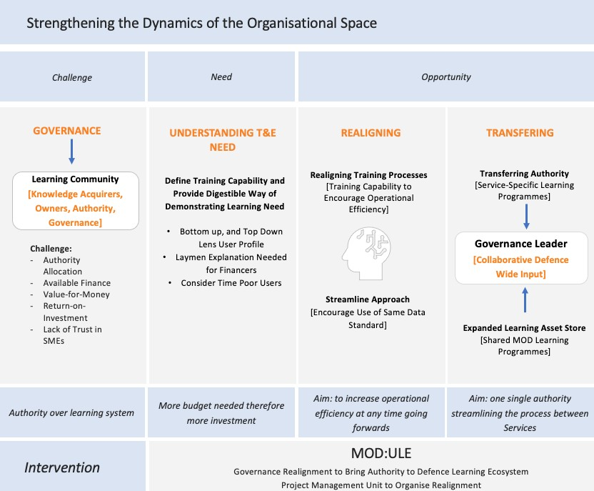

**Figure 12: Strengthening the Dynamics of the Organisational Space**

##### Specific Challenge

A representative from DSEME noted that changes were slow to be implemented due to budget restraints. Interestingly, only part of the problem is available finance. The team learned from case study interviews with stakeholders (Pleva et al., 2020c) that the financers lacked understanding of T&E needs and did not necessarily trust the advice of Subject Matter Experts (SMEs) in this. This is evidence for needing a more digestible and efficient way of describing T&E needs to financers.

In workshop 2, TESRR and DLMC representatives agreed that financial benefit can be demonstrated when Defence use internal training capability instead of outsourcing. DLMC is operating a new, internal practical delivery system. It was noted from DLE representatives that whilst it is easy to focus internally, there still needs to be an element of outside control, particularly the time it takes to procure in the current complex project management process.

The evidence presented throughout this project suggests that change needs to happen at all levels, not just the overarching level. It is difficult for individuals to understand the system as a whole, with its confused and hugely complex set of specialist centres, and therefore making effective changes requires both a bottom-up and top-down set of lenses to be used. Stakeholders reported that a lot of time is spent trying to understand the connectivity and information hierarchies. As a result, adopting small rule changes such as ensuring the same data standard is used, sharing resource and implementing changes to help understand T&E training need would make a huge difference and allow organisational process to become more efficient. To summarise, the main challenges are centred around Authority, Resources and Value-for-Money / Return-on- Investment.

##### Opportunity

The project team looked at the opportunity in two ways. The first was to focus on the gains that would come from realigning some processes to increase operational efficiency at any time going forward. The second was to consider how the early stages of any transferring of authorities, resources and process systems when moving towards the new Vision might be most carefully achieved through small interventions in the nearer- term.

* + - * 1. ***Intervention Concept***

**MOD:ULE MOD Universal Learning Ecosystem** – MOD:ULE outlines the concept of a temporary, devolved governance of a realignment project across the T&E. This would involve a collective of Defence-wide representatives who are required to oversee the collaborative nature of the overall learning ecosystem. They would be required to bring authority to the collaborative process between Services in relation to learning provision and behavioural practice change, commission strategy and policy development work on evidence-based outputs and analytics, and ensure rigour in new product development and implementation compliance.

**TRESLE**– TRESLE is the project management unit acting as a bridge between T&E and the Defence Learning Ecosystem. The illustrative design explored how the unit could act as a bridge between learning policy, pre-agreed ecosystem Vision objectives and clear implementation plans. This unit would be charged by MOD:ULE to support the delivery of the realignment through smooth project management and monitoring of the impacts.

## Implementing Change Management

The project team’s research into the MOD learning environment (Pleva et al., 2020a) identified many reasons why T&E has been allowed to grow into the huge enterprise of schools, programmes, specialist training schemes and competing technology platforms. There is general agreement from within the stakeholder community that T&E needs to be reconfigured with the core objectives of simplification, value-for-money and content development professionalism that understands how to adapt learning techniques to respond to the new emerging operational and workday realities that Defence staff are responding to. The project team considered many different approaches, already tried in both the MOD and with some analysis in large commercial multinationals and other defence systems, like that of the United States. (US). The team agreed on a core strategic objective that is prevalent in most previous research recommendations; any process that

successfully brings about change in the learning capacity of the MOD will not take the form of some kind of ‘big bang’ intervention, nor can it be one that is allowed to take 20 years to slowly creep through.

The transformation from T&E into a broader and more dynamic learning ecosystem needs to be designed to produce early results and rewards, while allowing incremental growth time for different cultural attitudes to change. It must put in place protection of innovation that is already flourishing and, finally, it needs to be clearly perceived by all stakeholders as a temporary intervention that has been designed to make everyone’s journey, including the learner, more dynamic. The change programme has to be seen to have an exit strategy built in, even before it begins its work and must not be allowed to be perceived as yet another level of bureaucracy for posterity to manage.

The stakeholders who attended both workshops agreed with the project team’s guidance that this future Vision can be brought into reality using ‘collaborative and focused governance’ (Pleva et al., 2020d), as opposed to creating some new, centralised authority. With full representation from the Services and working with a transparent change mandate from MOD high level command for training, this executive group would offer senior guidance and endorsement, as well as managing a small range of support resources. Using MOD Universal Learning Ecosystem (MOD:ULE) as an illustration of such a temporary authority remit, the team explained the idea of governance related to a single, one-off change programme. This programme is a focused, medium term solution that seeks to save resource and celebrate innovation, tackling many of the System 2 constraints (see Figure 4 and section 3.1.5). The stakeholders agreed in workshop 2 that a temporary change programme authority, possibly emerging within the current TESRR mandate, but with authority from the highest levels, might be acceptable and effective, providing it had a transparent remit and clear operating areas that it was confined to.

The project team explored both the value and the challenges of implementing this transformation process using a 5-7-year timeline and carried out by a small unit of multidisciplinary staff, working to the MOD:ULE mandate. The unit would have as its remit to:

* Offer Services immediate and focused access to previous knowledge and insight (HELP Hubs) across the whole of the MOD;
* Make available small coordination units, called Transfer Accelerators (TA), linked to DLE Category Managers, who help individual Services look across each other’s boundaries in a positive and innovative way;
* Offer focused resources for the current owners of individual learning systems in Defence to apply for innovation grants, thereby coordinating Defence-wide learning R&D and ensuring programmes are scalable and accessible;
* Design, build and supply collaborative open source tools, as previously illustrated, that support application scalability, with small funds to enable origination and adaptation or upgrading of existing programmes, whilst coordinating a more inclusive professional practice of learning design;
* Explore and coordinate the research into the delivery infrastructure needs of 5 years’ time; and,
* Ensure, where appropriate, that all learning innovation is thoroughly exploited in the commercial markets.

The project team developed an outline business case and work programme to fully understand how realistic this change programme unit could be. They called the unit:

**Transferring Resources and Excellence into a Single Learning Ecosystem (TRESLE)**. As in ‘a real world trestle’, TRESLE would act as a bridge between T&E and the Defence Learning Ecosystem. The illustrative design explored how the unit could act as a bridge between learning policy, pre-agreed Vision objectives and clear implementation plans. The unit would be charged by MOD:ULE with delivering measurable financial savings and would positively contribute to recruitment and retention issues, whilst strengthening individual Service strategy development. The project team made it clear that the emphasis of all proposed changes within this temporary programme should not be about doctrine or indeed, about carrying out orders, but it should focus on enhancing capability, whilst reducing complexity and duplication.

The team also recognised that this transformation unit would require some powerful new MOD-wide communications channels if it was to gain the ownership and support from a wide range of very busy professional stakeholders, as well as the learners themselves. This learning communications brand was initially illustrated as Learning Ecosystem Network Concept (LECONECT) which offers a means to share data frameworks and standards, learning analytics tools and expertise, and to promote an understanding of the immediate benefits of improved learning data but, after workshop 2, more work was done to refine the outputs of this small part of the TRESLE unit:

* TRESLE TV – a streamed online and mobile channel that celebrates innovation, awards, coordinates learner feedback, publicises voluntary lifelong learning opportunities and creates a learners membership community;
* The Annual TRESLE Awards – with three categories: Technical Innovation / Behavioural Learning Innovation / Skills Training Innovation; and,
* The TRESLE Accreditation Scheme – a kitemark scheme that helps small operating areas stand out and acts as an internal due diligence assessment.

As the project team outlined in workshop 2 with stakeholders, the project now had two Visions. The first was what the Defence Learning Ecosystem might look like in 5 years’ time. The second was the Vision of how the MOD might get there efficiently, through realignment and greater coordination. What follows in section [4.0] are the project team’s recommendations that present a single streamlined Vision.

# 4 Recommendations

This section delivers high level recommendations that have been derived as a result of this research project in its entirety. The following interconnected change programme areas contain robust recommendations rooted in supporting evidence from stakeholders in the Technical Report. Each section offers guidelines and focus areas across the predefined spaces that help to better define how change will look moving forward into a Defence Learning Ecosystem with the ascribed benefits. This section analyses the following four approaches to change management:

Learning Space Recommendations (section [4.1]); Delivery Space Recommendations (section [4.2]); Data Space Recommendations (section [4.3]); and,

Organisational Space Recommendations (section [4.4]).

Recommendations are presented in accordance with the four areas of capability realignment and their respective Spaces. Each section will repeat a narrative cycle that includes:

* The change recommendation itself;
* A concise summary of evidence that leads to the change recommendation;
* Funding impact;
* Implications of no action; and,
* The interdependencies operating.

## Learning Space – Creating an Internal Market for Learning Programme Development Capability

Clear evidence indicates that a culture has grown in some areas that sees the learning system as having a single delivery objective. Despite the evidence that the current T&E system is not fit for purpose, there is an underlying resistance to change and a misunderstanding of what a learning system, in a modern and adaptable organisation, actually needs to provide (Pleva et al., 2020c). In day-to-day practice, the reasons for not responding to these issues are often camouflaged by broad statements like ‘lack of resources’ and ‘no authority’. The team analysed how to encourage the move from push training to a more intuitive and self-directed knowledge exchange, with 36028 assessment and capacity growth measurement. In order to strengthen the dynamics of the Learning Space, there must be investment not just in the types of learning and collaborative T&E system as a whole, but the developers, the resources available and the measurement.

### R1: Strengthen and Modernise DSAT

It is recommended that the current DSAT model is strengthened and modernised in order to ensure that learning practice remains fresh and fit for purpose Defence-wide. DSAT, in the form of JSP 822 (MOD, 2019), Part 1 Directive and Part 2 Guidance, continues to provide strong guidelines to those involved in refreshing existing courses or developing new programmes. The review process is carried out annually, the most recent in 2020 being an update to reflect the changes to both the Modelling & Simulation and the Technology Enhanced Learning (TEL) policies. Despite this, the project team recommend a much more in-depth ‘root and branch’ analysis and upgrade.

The recommendation in achieving this objective is designed across three main propositions that help deliver an in-depth review of the DSAT guidelines, incorporate the research work from this project on the ADAPTIVE concept, and analyse this through pilot studies that help to produce modernised guidelines for training design, development and delivery.

28 A 360-degree feedback is a process through which feedback from an employee's subordinates, colleagues, and supervisor, as well as a self-evaluation by the employee themselves is gathered.

To do so, a small review group of no more than five current expert learning developers from across the Services are joined by three representatives from the learning community, who are not specialists but are enthusiasts for lifelong learning and from different ranks and demographic groups. The team, led by TESRR, will thoroughly review DSAT through a range of modern learner ‘persona’ lenses. These personas will be designed to represent realistic characteristics of specific types of learner, often working in disruptive learning environments. They will be created with the assumption that there is no such thing as an “average learner group” and these personas need to push out the boundaries of user profiling, whilst reflecting the realities of how people currently are actually asked to learn in the MOD. In parallel with this review process, the project team’s ADAPTIVE guideline research work should be incorporated (found in Pleva et al., 2020a&d). This will help ensure that the points brought up regarding improving design guidance to instil innovation in training are involved in upgrading the current guidelines. There may be a need for further application of research to be carried out, building on the core principles of the ADAPTIVE framework.

The third stage would then be for the review team to commission three small pilot projects that require a mixed ability team of learning designers and expert knowledge owners to use the new guidelines to: a) upgrade an existing programme or course; b) build a new training course plan; c) create an immersive scenario experience; a short course of perhaps 2 hours duration, to a specification design level only. After reviewing these pilot experiences, the work would be amended and resubmitted to upgrade JSP 822. Part of the new DSAT+ ADAPTIVE guidelines will have built into it a much stronger feedback demand from developers and users that can further inform the measurement of success of the Defence Learning Ecosystem. See Figure [13] for a detailed timeline of these recommendations and strategic steps.

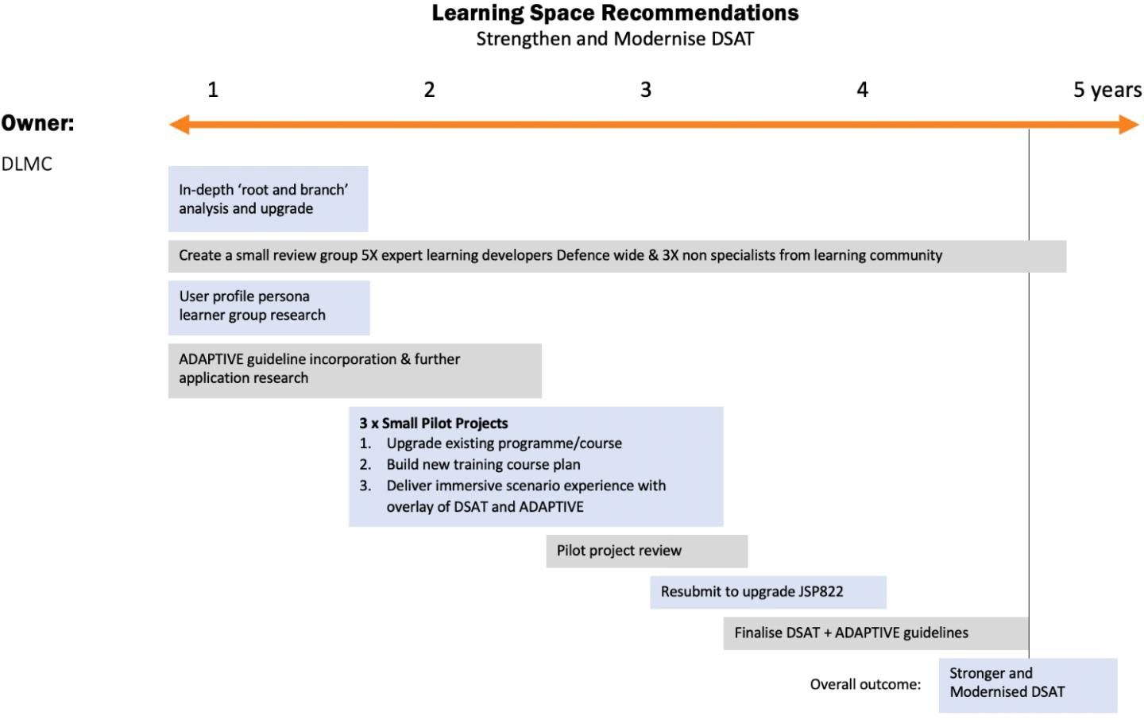

**Figure 13: Learning Space Recommendations: Strengthen and Modernise DSAT**

#### Evidence

Evidence indicates that in the emerging digital teaching and learning environment, new checks and balances need to be integrated into the current framework if it is to support the developer and meet the modern learner’s expectations of immersive and memorable learning, using new technologies.

The project team discussed their experiences in developing an ambitious collaborative and scenario-based game with other learning designers in the MOD and with DLE representatives. Overall, DSAT appeared to be largely irrelevant when preparing to manufacture an experiential learning programme or an immersive role play. It appeared to be far more focused on offering specification requirements in a procurement process than it did in trying to support internal learning designers. To an enthusiastic internal learning designer, the

guidance offered can appear fragmented and largely reactive and non-integrated upgrade process can become very challenging. Strengthening DSAT would help elicit a more user-friendly learning designer support system.

Consolidating the various JSPs and reauthoring some of the guidance to give more support to learning designers’ needs would have the combined effect of strengthening the capability and improving the existing learning products and services Defence-wide. It would also increase support to those who are developing new combinations of immersive techniques using innovative technologies under challenging conditions. The project team believe that these valuable interventions do not require new doctrines or changes of current ownership, but can be implemented to be of high impact using realignments of existing practice and strengthening support to current owners.

#### Funding Impact

The financial implications of this recommendation mostly involve staff time. It is difficult at this stage to ascertain exact staff time investment, however as reviews are already being conducted annually, to some extent costs can be offset and quoted against this. The costs and losses of allowing DSAT to continue unaltered through its primarily reactive and often ‘tweaking’ upgrades is that it may become outdated in light of new technology and changes to the operational environment and daily work life of staff, specifically when it comes to developing immersive, remote technologies. The costs of losing control over the effectiveness and quality of learning design in the MOD would be high.

#### Impact of ‘No Action’

Having a strong set of guidelines in JSP 822 has been shown to be valuable. However, as with any quality and effectiveness framework, there are times when a major, more significant overhaul is needed. There is evidence in this project that implies there is degradation of efficiency and quality happening of both internal and procured learning tools and courses. This underlying issue is evidenced in the Learning Space discussion, and interviews with stakeholders revealed that this is likely to become increasingly more evident in the next few years (Pleva et al., 2020a).

There is much frustration from passionate teams and individuals involved in learning R&D. The attractiveness of new technologies and annoyance of some old traditional course methodologies has made many learners openly express the need for a modern approach to training and learning. Increasingly, MOD learners are those who have been brought up with digital menus and a culture of ‘click to learn’ and so the more traditional programmes can appear to be from another era. The project team were concerned that the current bulk of core training will begin to be viewed as an implicit rejection of modern learning techniques and this would increasingly degenerate the retention of learning, which could become a very serious issue.

#### Interdependencies

The project team consider the Learning Space in the Defence Learning Ecosystem needs updated and modernised guidelines because this will offer a modern and flexible platform on which to build a stronger in- house learning design culture and a broader curriculum delivered, where appropriate, in a more efficient, immersive way that feels more engaging and relatable to the user. These objectives can only happen with different JSP 822 guidelines being put in place. The evidence shows that under this recommendation, there are four interventions that can be made immediately. The first two interventions suggest practical activity, the other two can also be enabled practically, but require some specific prior research to be carried out to guide the implementation. When developing a market for capability, it is necessary first to evaluate the demand, the developers and the doctrine. Next, sharing it efficiently is necessary. With any market recommendations, regular and consistent research is necessary. Potential future research projects are discussed in section [4.1.3].

### R2: Strengthen the Collaborative T&E System

It is recommended that the MOD, via TESRR, develops a stronger, more collaborative learning innovation network that enhances the current independent Service silos for learning research and encourages a more shared approach to Learning R&D with additional resources and rewards. Strengthening the collaborative T&E system will encourage sharing of innovative practice to save resources and to maximise investment.

To do so, it is proposed that Defence develop a network of collaborative research hubs. This is achieved by carrying out three main tasks. The first task would be to undertake a learning R&D scoping review. Whilst it may be obvious at first sight who is responsible in each Service for R&D innovation related to learning, this project has highlighted the fact that some of the most innovative developments are happening ‘very quietly’. This is often driven behind-the-scenes by a single individual’s passion for a very specific challenge to deliver what they believe is ‘just a localised application’. However, the insights they are gaining locally can be profound and should be shared with those who are more formally involved in R&D. The Learning R&D Scoping Review must therefore ensure that it is inclusive of not just Service groups and Defence-wide research activities within TESRR or Dstl, but that it also captures individual innovation activities, wherever they may be within the MOD’s learning community.

Once the Learning Space R&D has been mapped in detail, all parties should be asked to consider the second task of how to cluster these activities into logical, operational hubs. Currently, these are recognised as work groups that have titles like ‘Wargaming’ or ‘Augmented Reality (AR) & Virtual Realities (VR) Technologies’. Other areas of learning research are classified in more generic terms as ‘Personalised’ or ‘Synthetic’. The operational research hubs are developed first and the ‘near future’ HELP hubs are informed by the outputs. Both the HELP hub development and the collaborative research units must be iteratively analysed from creation. This is to ensure that the research and network stays fresh, active and up to date. All MOD R&D is focused on the ultimate objective of ensuring progress in teaching and learning competency is managed through robust research and experimentation. Given the complexity of the current innovation practice, there may need to be some additional research to identify the most effective way to cluster or ‘hub’ the wide range of activities.

This recommendation is not designed to change current good incentives into collaborative learning. It does advise that the MOD should create, from the newly-scoped R&D landscape map, a formal network of collaborative research units that are specifically involved in the post-theoretical, ‘near future’ research stage, Technology Readiness Level (TRL) 3 - 629 and therefore now in the rapid prototyping stage. The recommendation would be that a wide range of practical R&D groups and individuals practising in the MOD should belong to a range of hubs that each have a metaphorical sign above their door as being a member of a network of ‘HELP Hubs’. These HELP Hubs can then attract all developers, large and small, in the Services to get support, to find collaborative partners to share costs and gain reputational value by publishing and sharing practice for others to reconfigure to suit their own needs.

The project team recommend that the HELP Hubs have, in summary, access to the following resources and functionality to encourage collaboration, decrease duplication and offer a safe place to fail:

* A ’find a partner’ service that supports learning innovation team building across the MOD;
* An R&D funding grant process that multi-Service collaborative teams can apply to;
* On-demand access to a UK top industrial expert group in their area of innovation;
* An on-going support agreement with a university faculty group that can offer specialist research;
* An opportunity to apply to a new learning innovation awards scheme within the MOD; and,
* A remit to internally publish their work and allow access to their prototypes from within the MOD. See Figure [14] for a detailed timeline of these recommendations and strategic steps.

29 Technology Readiness Levels are a method for estimating the maturity of technologies – Level 3 Proof of Concept to Level 6 System Adequacy Validated in Simulated Environment.

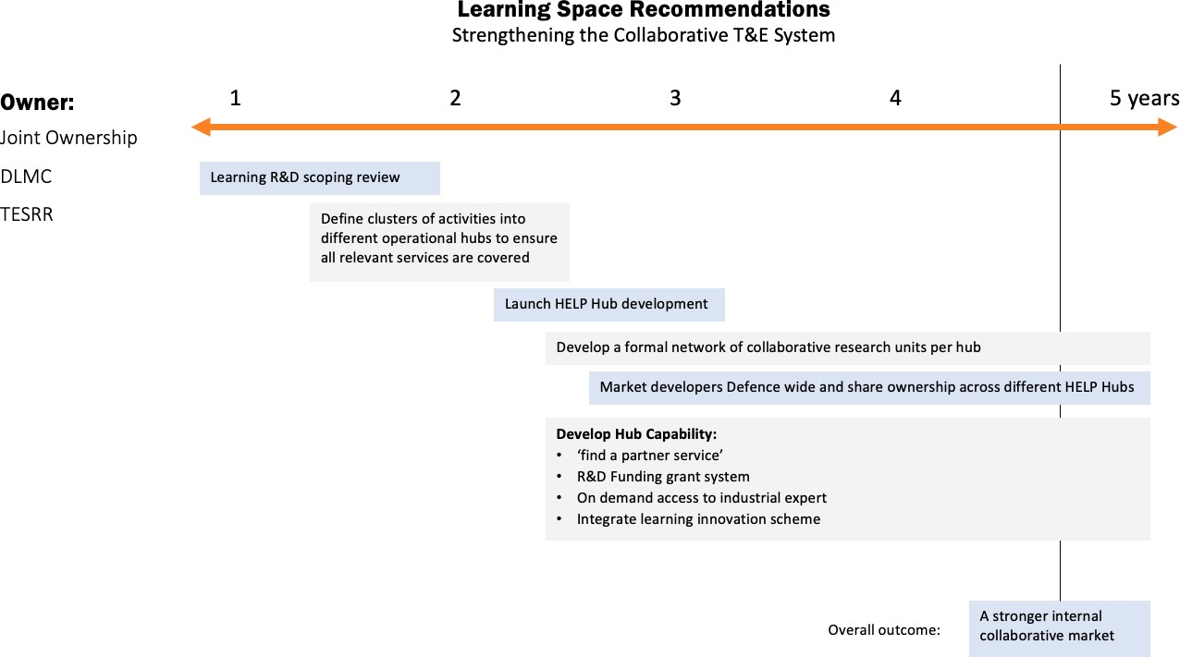

**Figure 14: Learning Space Recommendations: Strengthening the Collaborative System**

#### Evidence

As the project team’s experience in industry demonstrates, R&D budget controllers can limit wastage by sharing resources and know-how, whilst accelerating what does work into scalable applications across the whole organisation. The lessons learnt by industry of collaborative value can be applied quickly within the current excellent, but sporadic, outbursts of innovation happening across Defence, where ‘research timidity’ is usually connected with lack of resources or access to technical platforms that allow risk-taking and exploration of functionality in a safe, temporary R&D environment. It was evident, particularly in the exploitation of VR and AR technologies, various wargaming centres and approaches to learning with AI integration, that there are several groups in different Services currently having to master independently the setting up of studios or technology systems to get the basics right, even before they begin to layer in the specific environments and training outputs their specific Service needs. Simply by sharing some of this early set-up know-how and basic deployment skills, the knowledge exchange would accelerate the innovation, whilst allowing individual exploitation to still be applied at a Service level.

#### Funding Impact

The costs of the scoping process to create a more inclusive ‘activist map’ is largely in manpower time. The cost of setting up the HELP Hubs in terms of marketing and manpower of four cross-Service accelerators is also partially born by other recommendations later in this report.

#### Impact of ‘No Action’

If this recommendation is adopted, it would slow down the current tendency to duplicate in large amounts of small-scale initiatives (Pleva et al., 2020a, Pleva et al., 2020c), whilst offering powerful new Defence-wide insights that can then be harnessed and configured for each specific Service need. It was not within the project team’s remit to economically quantify the costs of current learning R&D duplication or the likely savings that could be achieved if a more collaborative approach were encouraged through a simpler integrated learning system. However, whilst recognising the need for each Service to carry out its own large- scale R&D, the project team were surprised at the scale of duplication of simple generic innovation needs like VLE data storage (Pleva et al., 2020c). Even on a ‘hunch’ basis, the savings that could be achieved through decreasing duplication and wastage going forwards is likely to be in the millions if the current separate Service strategies collaborated in these specific generic areas of need.

If nothing is done, then learner capability will suffer and the modernity being offered to MOD learning designers will be wasted, leaving behind a wasteful, sporadic and ‘just-in-time’ innovation culture.

#### Interdependencies

This recommendation seeks to strengthen the innovation culture of the learning design practice within the MOD. It supports the emergence of new methodologies in how to teach and learn; it informs those responsible, like the DLE team, of what the learning delivery system is going to need to manage in the future; and it supports the recruitment and retention of a broad range of MOD talent.

### R3: Conduct Two Further Learning Space Research Projects

It is recommended that two pieces of research are carried out to inform the enhancement of the Learning Space. The scale of the project team’s brief prevented them from having the time and resources to follow- up all the strong research leads that emerged in this Space. In prioritising what could make a disproportionately high impact with a relatively small investment of time, two areas of further research emerged.

#### Project 1: Experiential Large Landscape Research Report

It is recommended that Defence enables the expansion of use cases for experiential large landscape learning. The research team recommend two areas of research activity related to large landscape learning. The first is to respond to requests from various learning organisations within the MOD to configure the current ‘Talya 2025’ scenario game into a fully operational transmedia learning tool they can use as part of a training asset bank in the future. This requires the existing Talya 2025 demonstrator tool to be slightly reconfigured to suit specific needs, and then the underpinning software to be finally aligned with the DLE learning delivery system so that it can stand alone. This integrated ‘large landscape’ learning approach is effective in a wide area of the teaching and learning curriculum that all Services now have a need to deploy, for example, in teaching aspects of leadership qualities and trust; the development of mental resilience or cognitive elasticity, or ‘how to think outside the box’. Finally, this mix of techniques could be very powerfully adopted in the delivery of life-long learning as talent moves around the MOD community. This research will take some of these themes and demonstrate how this approach might be harnessed to deliver high impact learning in the near future.

The research will explore the design of a template-based approach to enable a more efficient, in-house learning design capability. This will support the concept that the DLE and DLMC might be able to offer MOD learner designers and knowledge owners the ability to create their own immersive online learning tools. In the longer term, this concept could save the MOD very large amounts of money being spent on ambitious, synthetic, scenario-based one-off projects.

#### Project 2: Connecting Knowledge Owners and Knowledge Acquirers Research Report

It is recommended that a research report is commissioned that revisits the very basic relationship between the knowledge owners, or operational experts, and their ability to ‘bottle’ their knowledge for the benefit of others. The research report would develop this approach and build a concept demonstration of a new tool that could then be trialled with three subject matter experts whose expertise ranges from, for example:

* + - * 1. an individual with experience developing a piece of technical know-how that is destined to become a training tool;
        2. a senior leader who has been involved in the delivery of scenario-driven decision-making skills; or
        3. an officer who is trying to support the development of an induction programme for new MOD recruits.

The experts would be automatically facilitated through a pedagogic process, being prompted to fill in their expertise at each stage of the overall subject matter progression. In effect, they will be facilitated by the concept of Transferring Individual Classic Knowledge into Broadly Owned Expertise (TICKBOX) to turn their complex and personally experienced expertise into a teaching curriculum specification.

These three packages of very different subject matter or know-how that have been shaped into outline curriculums would then be given to three learning designers who would build a learning intervention in schematic form initially without actually meeting with the subject matter expert. The designers would then

be allowed to meet with their experts and subsequently refine their designs. Figure [15] provides a detailed timeline of these recommendations and strategic steps.

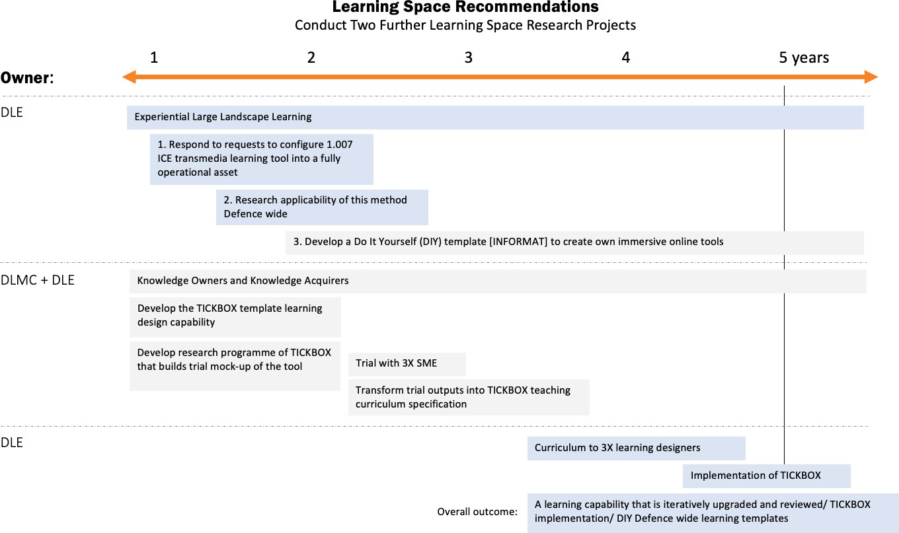

**Figure 15: Learning Space Recommendations: Conduct Two Further Learning Space Research Projects**

#### Evidence for Project 1

The project team have been running a practical project in parallel to this research, called Talya 202530, involving a two-phase trial exploring how transmedia storytelling can be developed to increase immersion and team engagement, testing the training effectiveness of a large landscape fictional online game. The project is nearing completion and the findings indicate that the current interest in synthetic and experiential learning within the MOD can be enhanced through further integration of technical applications, psychological principles and the power of fictional narratives across a wide range of MOD learners and learning experts. This research project deployed the ADAPTIVE framework overlay during development to help ensure the innovative delivery method was as highly functioning and successful as possible. The level of interest from the stakeholders Defence-wide was high. The value and effectiveness of these methods was explored in the final report, currently in publication. This provides evidence for further exploration of this area in the context of the Defence Learning Ecosystem.

#### Evidence for Project 2

This research recommendation focuses on the significant challenge that ‘Knowledge Owners’ are facing with upgrading their teaching skills, as experts are not necessarily gifted teachers, and then making their diaries more aligned with timetables, resource capacities and needs of the ‘Knowledge Acquirers’. This research has identified a concept called Transferring Individual Classic Knowledge into Broadly Owned Expertise (TICKBOX), which creates a template that experienced owners of ‘classic knowledge’, gained over years, can be guided by, even if they have no teaching skills themselves, so that new programme developers have an authorised basis on which to build an innovative teaching programme that is not dependent on time/place access to the expert. The research report would then be able to recommend the methodology and value of building TICKBOX to support the Defence Learning Ecosystem.

30 Talya 2025 exercise is part of a research Dstl’s investigation into how to optimise training effectiveness and measure impact. Talya 2025 is a fictional online scenario game delivered in a one-day remote workshop.

#### Funding Implications

The funding implications of these research projects are minimal. There is a requirement for Project 1 to be outsourced due to the complex and specialist integration of the content. To reduce budget, it is possible that Project 2 is completed in-house by learning designers and experts at the Defence Academy. Both projects could be completed within 1 year from contract award.

#### Implications of No Action

It is clear from the data that there is an immediate opportunity and need within Defence to exploit the potential of large-landscape learning methodology to improve training design, impact, accessibility and applicability. Without investment, remote training development will stagnate and the likelihood of exploiting modern design techniques within the whole Defence Learning Ecosystem will be reduced.

#### Interdependencies

This recommendation seeks to increase the MOD’s understanding in how to apply both innovative remote learning, and how to bottle the expertise of knowledge owners into engaging training for learners. Whilst Project 1 requires sufficient stakeholder interest, already acquired in the Talya 2025 project (Pleva et al., 2021), Project 2 also has a dependency on Defence for support in recruiting participants and identifying relevant stakeholders.

## Delivery Space – Developing a Unified, Future-Ready Delivery System

### R4: Enhance the DLE Capability

It is recommended that an upgrade programme for the DLE is designed and implemented so that it can service all MOD Service needs as a single delivery platform. Additional resources should be provided to enable the DLE to achieve the following enhancements within the first 2 years of the change management programme:

* + - * Technical upgrade that enables an efficient interoperability between all learning systems and platforms.
      * The incorporation of specific functionalities and permissions of other learning delivery systems like LEARN31, so that it satisfies all user needs.
      * Upgrade existing user materials in order to publish an interactive guide to using the learning delivery systems, including a clear layout of the rules of engagement, the use of data, the management of security during learning, and the standardisation of learning outputs.
      * Resources realigned from other areas of duplication to significantly strengthen the range and depth of the editorial and technical learning advisory services available to learning developers and FLCs.
      * Stronger links to knowledge stores (for example, the DLE) and data repositories in all Services, with an enhanced menu to support navigation.
      * Closer integration with learning developer community, via the proposed HELP Hubs, to enable continue development of personalised learning and the practical harnessing of other new technology platforms.
      * The development of twenty Learning Kits. These are flight cases containing laptops and specialist headsets pre-configured with the more complex multi-platform learning courses. This helps learners in operational areas with no internet access the pre-loaded courses. It helps underpin specific types of learning that use complex software platform integration.

Research indicates that these seven technical and advisory capability enhancements can be achieved at a relatively low cost and quite quickly.

31 LEARN is the current learning system used by certain schools and colleges in Defence- notably DCTT.

### R5: Enable Innovation in Delivering Remote Experiential Learning

It is recommended that the isolated explorations of large-scale experiential learning and the exploration of collaborative learning carried out remotely should be further coordinated to evaluate the likely future demands on a single MOD learning delivery system. This research and analysis should be delivered in an initial Delivery Technology Report. In January 2020, the lead organisation in this project team delivered an Innovative Concept Exploration (ICE) 1.007 project (Pleva et al., 2021), Talya 202532, that explored the most advanced uses of a delivery platform in delivering remote collaborative learning with individuals from different Services who did not know each other. The demonstrator output was further researched in a MOD Research Ethics Committee (MODREC)-compliant trial, using the DLE as a platform. The trial conducted had two phases that analysed the training effectiveness and applicability of this style of training across two distinct Defence groups: learning experts, and junior staff with recent experience of a military course. The experience informed the project team that, with more enhancement, the delivery process could be refined to manage the most complex multiplatform experiential learning that uses immersive scenario gaming. A particular area of capability would be to increase the level of learner personalisation in the current exercise and fully explore this response to the challenge of how to deploy analytics to make learning personalised and relevant. The team recommend that the concept illustration they offered called DRIL (Data Managed Real- Time Interventions in Learning} should be considered more fully in this development project.

The team also made a related recommendation that this work should inform the creation of a ‘living lab’33 online facility for learning developers to safely carry out trials of new techniques within a firewalled area of DLE and then share the outcomes across the MOD. One of the important features of modern learning delivery systems is that they show positive returns to scale. More is usually both better and cheaper, whether in generating data to inform decisions and direct learning, or in providing standards for content and data interchange. If the MOD invested confidently in a single, compelling learning delivery system like the DLE, it would impact not only on the bottom line, but offer significant value to its experienced and new learners.

It is recommended that Defence invest in innovative large landscape training in order to provide a more immersive, remote ‘safe to fail’ learning environment. The team’s experience with the Talya 2025 project (see [R3]) showed that, with more enhancement, the T&E learning delivery system could be refined to manage the most complex, multiplatform, experiential learning, scenario gaming. However, the more the learning management system is pushed by this type of technically complex learning, the more it shapes the design of the Defence Learning Ecosystem. See Figure [16] for a detailed timeline of these recommendations and strategic steps.

32 Talya 2025 is the name of a fictional game scenario created for this project.

33 A Living Lab describes a group of respondents who have agreed to test and trial a range of products and provide feedback in a templated format.

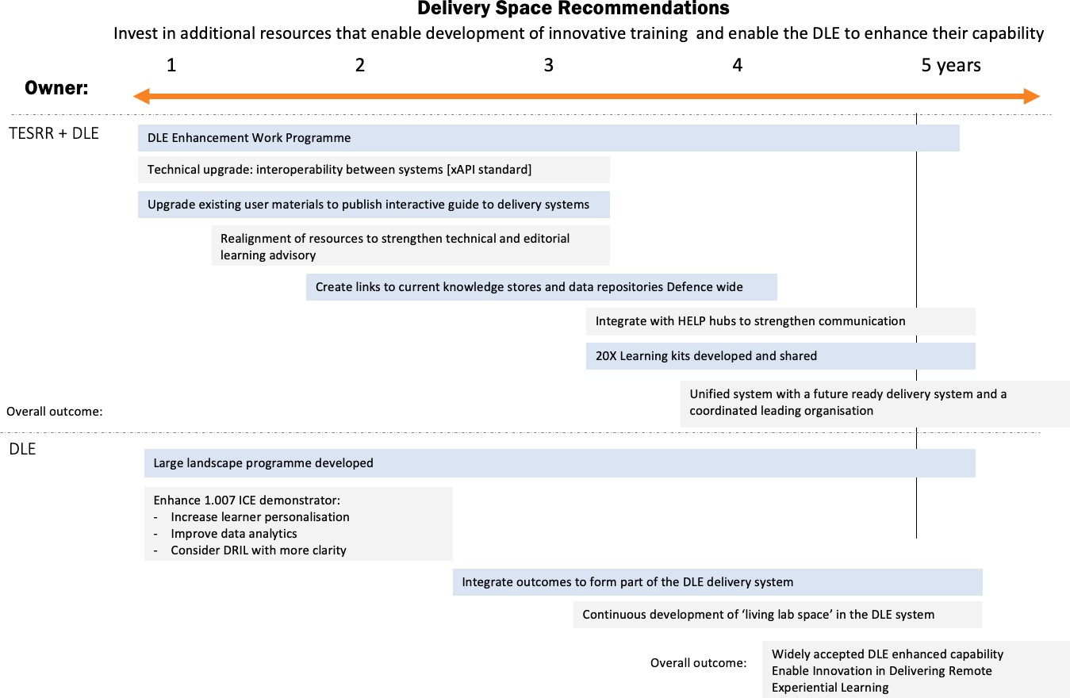

**Figure 16: Delivery Space Recommendations: Enhance DLE and Experiential Learning Capability**

#### Evidence

Comments from TESRR and DLE representatives in both workshops identified that the delivery platform in the Defence Learning Ecosystem must be constantly refreshed, resourced and upgraded, as interoperability is key to Service needs. There is considerable support for the argument that a more coordinated delivery can be achieved relatively easily, with modest realignment and investment, rather than allowing several different delivery platforms to co-exist. The objective would be to cross-engineer the functionalities that are currently enjoyed by users of DLE and other platforms, alongside strengthening MODNET to manage a higher workload of data transfer and interoperability. If systems associated with Defence learning started moving to the xAPI standard, then elements and organisations within the Defence Learning Ecosystem would be able to talk to each other and share information. The DLE needs to be able to operate with systems like Microsoft 365 and other powerful commercial solutions, as well as the internal Service platforms. It also needs its levels of operating clearance permissions to be completed, so it can work at all levels of security.

#### Funding Impact

The need for rapid redeployment of technology-driven learning delivery systems has been heightened during the readjustment activities due to COVID. The DLE and other learning systems in use have demonstrated their value in these times, but also the limitations in terms of IT constraints (Pleva et al., 2020c) when those systems are really pushed. This is entirely an issue of resources and commitment. The delivery team know what they need to do, but need to seek the commitment, in terms of time, resources and money, from others to help achieve it. The upfront costs are considered small compared with industrial learning network upgrades because a lot of work has already been done on a small scale. However, the progress has been slow, in reflection of the timidity of investment and lack of understanding that in the medium term, the returns in terms of capability and efficiency will more than outweigh the upgrade costs.

One of the important features of modern learning systems in general is that they show positive returns to scale. More is usually both better and cheaper, whether in generating data to inform decisions and direct learning, or in providing standards for content and data interchange. If the MOD invested confidently in a single, Defence learning online delivery system, it would offer significant value to its learners.

#### Impact of ‘No Action’

There are different VLEs across Defence that are splitting into various proprietary systems being used. As a consequence, learners face a confusion of learning systems that are not interoperable or easily shared. This also has implications for the continuity of learner records, data sharing, repetition of work, and a lack of recognition upon completing optional learning pathways. The opportunity to benefit from economies of scale and establish common standards will be missed and the MOD will experience the frustration of system fragmentation and learning duplication, including software licensing and dependencies on too many suppliers.

#### Interdependencies

The delivery of effective learning courses is not just about the technical platform, although that is important. It is also about the advice from the delivery managers of how best to use and manage the system in an often- frustrating digital environment. The learning delivery system, like everything else in Defence, is as much about people as it is about technology. The DLE needs to be given the right tools to achieve this, so that all the other components of the Learning Space, the Organisational Space and the Data Space can operate successfully.

## Data Space – Improving the Level of Data Capture and Analytics

There has been clear evidence throughout the project that the fundamental problems with establishing a dynamic Defence Learning Ecosystem are to do with data, storage and analysis. Resources are not being measured efficiently and learner data is not being utilised to produce a curated learner experience. As such, the more ambitious elements of the project team’s ecosystem Vision are founded on a robust, Defence-wide data architecture, enabling the through-career impacts of learning interventions to be understood, the learning needs of individuals to be identified in real time, and applying machine learning techniques to craft a truly personal learning experience across Defence.

### R6: Designing a Common Framework for Data Management

It is recommended that a data management mapping survey is conducted. Within this, a phased approach in which data integration is pursued within Single service areas should be considered. The Vision’s implications for data and analytics are ambitious. The overall outcome is to ensure data-driven learning is a successful central enabler in the future Defence Learning Ecosystem. To do so, the team recommend the following features of a Defence Learning Ecosystem34:

* + - * High-fidelity data, linked together, is collected and curated;
      * Data are analysed to identify (a) the learning needs of individuals, and (b) the impacts of interventions;
      * Outcomes are measured through-life, to identify the longer-term impacts of learning;
      * Data collected are consistent across Defence so they can be shared, and benefits compared;
      * The learning pathway that an individual follows is based on their needs and contextualised to their role, background, skills levels, and future potential; this pathway could conceivably be adaptive in real-time (e.g. based on learner behaviour while training);
      * Learning content is substantially digitised and exploits delivery technologies; and,
      * Learning delivery across Defence is seamlessly integrated from a user perspective.

The change programme to realise this Vision will need to accommodate and circumvent a number of both general and MOD-specific issues that affect data modernisation programmes. These include:

* + - * The need to integrate data frameworks with existing standards and datasets, including those used by industry;

34 These implications are drawn from the output of the workshop 1 (Pleva et al.,2020b: pp.21-22).

* + - * Compliance with MOD security and privacy policies;
      * MOD’s relatively antiquated legacy data collection processes and learning systems35;
      * The need to identify clear data owners at every level;
      * The risk of ‘dataism’ – that is focused on what is measurable rather than what is important;
      * The risk of losing the potential hidden benefits of a common, one-size-fits all, training experience36, such as the mutual trust that develops when everyone is known to have been trained to the same standard; and,
      * Too heavy a focus on data *relating to learning* rather than building interconnected datasets that help measure the *outputs* of learning (e.g. better performance)37.

This research project has identified a range of potential actions that Defence can take, which offer significant long-term improvements for relatively low financial cost (Pleva et al.,2020b). These include:

* + - * Conducting a comprehensive mapping of current training data holdings, data frameworks and structures, and owners, across the Defence Enterprise;
      * Based on this mapping exercise, designing a learning data framework that is capable of ingesting key data fields from across these areas, identifying mappings from this framework to each individual data repository, and promoting the use of this framework across the Enterprise;
      * Establishing a technical means of sharing (e.g. through xAPI) these data between data owners and any central authorities with a responsibility to analyse them;
      * Designing and implementing a data integration programme to align units with the learning data framework, first within single Services, then across Defence as a whole; and,
      * Conducting exploratory analytical studies to identify useful descriptive insights from these integrated data and developing a strategy to utilise these to a wider Defence audience.

#### Evidence

Trends indicate that the future of learning is personalised (Deighton, 2019). Digital technologies allow a fidelity of data capture and analysis that has already enabled many previously brokered, or one-to-many, transactions to become genuinely many-sided marketplaces38. Personalised learning offers the ability to identify the learning *needs* of individuals, and to match them to the learning *opportunities* offered by suppliers. This is a radically-different Vision to the pipeline-driven, one-to-many learning model that, though less applicable, is still prevalent in Defence (Pleva et al., 2020b). For the Defence Learning Ecosystem to access and promote the enormous efficiency gains that personalised learning offers, it will need a significant upgrade in the single most important enabler: the capture and analysis of data on both people and learning interventions. The specific issue of data for learning has been examined in detail by Bailey (2020), so this section covers only high-level observations. See Figure [17] for an example of how these recommendations are strategically structured in a timeline.

35 “Data is poorly captured, and learning outcomes are not measured efficiently. Some training courses poorly capture

learning outcomes and concentrate upon ‘pass-fail’ as a measure of performance. The focus is on passing exams rather than developing skills and knowledge.” (Pleva et al.,2020b).

36 Somewhat analogous to the debate about whether streaming services have ‘killed water-cooler TV’: (independent. 2020. Why TV No Longer Serves Up Watercooler Moments. [online] Available at: <https://[www.independent.ie/entertainment/tv-](http://www.independent.ie/entertainment/tv-) radio/why-tv-no-longer-serves-up-watercooler-moments-29594993.html> [Accessed 20 November 2020].) or Feeney, N., 2020. Netflix And On-Demand Aren't Killing 'Water-Cooler TV'—They're Saving It. [online] The Atlantic. Available at:

<https://[www.theatlantic.com/entertainment/archive/2013/09/netflix-and-on-demand-arent-killing-water-cooler-tv-theyre-](http://www.theatlantic.com/entertainment/archive/2013/09/netflix-and-on-demand-arent-killing-water-cooler-tv-theyre-) saving-it/280113/> [Accessed 20 November 2020].

37 Bailey (2020: p7) has summarised this issue as ‘*Data that training needs, not just training data’*.

38 High-profile examples of essentially personalised, two-sided, services that could not exist without ubiquitous personal data collection include Uber, Deliveroo, Rightmove, Waze, Netflix, and many more.

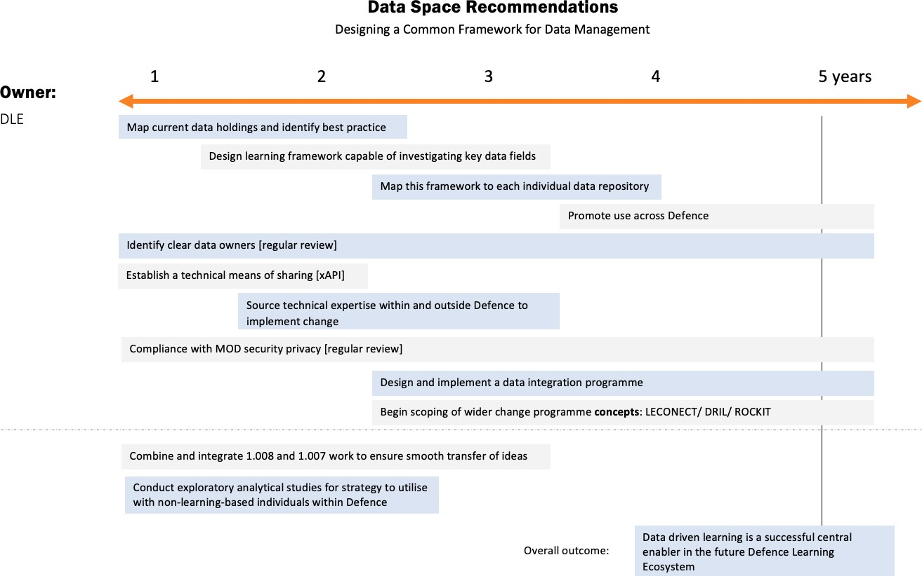

**Figure 17: Data Space Recommendations: Common Framework for Data Management**

The Vision outlined in this paper offers a range of initiatives that, if realised, collectively account for many of these proposals, while offering significant future benefits and enabling the more-ambitious elements of the Vision to be more easily realised. These are included in LECONECT, DRIL, and Repository of Capacity, Knowledge, Innovation and Technology (ROCKIT) concepts, which exemplify potential elements of the wider change programme. More specifically, these offer the following elements that will be integral to realising the data and analytics enablers of the Vision:

* + - * + LECONECT offers a means to share data frameworks and standards, learning analytics tools and expertise, and to promote an understanding of the immediate benefits of improved learning data;
        + DRIL is a platform for the deployment of a library of extensible, ever-improving learning-related data and analytics tools that match user needs to supplier services in order to make learning personalised and relevant; and,
        + ROCKIT offers a centralised data management system, making use of DRIL services, to enable Defence to make near-real time decisions about gaps in learning opportunities, to identify talent, and to guide investment.

#### Funding Impact

Improvements in data capability offer significant efficiency benefits in terms of reducing duplication, identifying low-impact interventions, informing investment choices, and delivering training that has a more significant lasting effect on capability. While the project team has not conducted a detailed appraisal of the potential costs of learning data and analytics investment within MOD, it is possible to draw on evidence from industry to infer that: (a) ‘getting data right’ is relatively low cost compared to other types of investment (e.g. in estate or people), and (b) it offers a concrete financial return. A 2019 report by the management consultancy NewVantage Partners (2020) suggested that ‘firms are realising measurable results from their Big Data and (AI) investments’, and that nearly 99% of companies report making investment in these technologies. McKinsey (2019) quoted that “companies with the greatest overall growth in revenue and earnings receive a significant proportion of that boost from data and analytics”, that “at high-performing

organisations, employees at all levels are better educated on data concepts”, and that “the deployment of a modern data architecture…is more common among high-performing companies.”

#### Impact of ‘No Action’

Data and analytics are a central enabler for nearly all the other aspects of the Defence Learning Ecosystem. Data capture and analysis enables the identification of the trends and issues that will inform the Learning Strategy. It enables the generation of personalised insights into learning needs and opportunities that will help optimise training delivery. The sharing of training content across Defence will be of limited benefit unless the data tools are there to identify to whom that content might be relevant. It is important to also understand who controls or verifies the quality of the training, especially in safety critical functions. The data and analytics tools currently available to Defence are currently inadequate to realise all of these aspects of the Vision.

#### Interdependencies

Data and analytics are highly connected to nearly all the other aspects of the Vision. Data capture and analysis tools are a direct enabler for Governance and Strategy, and for Data-Driven Learning (see Figure [11]). The ‘bridge’ between T&E and the Defence Learning Ecosystem entails, at minimum, the consolidation and systematisation of current datasets.

## Organisational Space – Authorising and Coordinating a Defence-wide Investment into Learning Resources

There has been clear evidence throughout the project that the fundamental problems with establishing a dynamic Defence Learning Ecosystem are to do with governance and communication. Because most resources are provided at the Service and school level, there is a lack of coordination between different programmes and a shortfall in overall direction and the ability to set standards for Defence learning as a whole. This is not to say that a centralised learning system is what is needed – the individual Services and schools are in charge of training because they have the clearest understanding of the requirement and the responsibility for delivering the military capability. The solution therefore needs to be one that respects the balance between centralisation and autonomy, and provides efficient pathways for cross-Service collaboration. Sections [4.4.1] and [4.4.2] describe in detail the two recommendations that will help Defence authorise and co-ordinate a Defence-wide investment of resources through a forum for information exchange.

### R7: Improve Learning System Communication

To improve Defence Learning Ecosystem communications it is recommended that TESRR create a communications group of representatives, assembled to develop a theoretical model of how a modern network can help learning developers, learners, and knowledge owners collaborate and increase the understanding throughout the MOD of the range and value of learning approaches. This model would address the quickest ways to realign current sharing systems and evaluate some of the new concepts put forward by this team. They would add or refine the initiative from the following implementation agenda:

* + - * Map the current learning-related communication channels and identify opportunities for collaboration and enhancement;
      * Create coordination and publishing templates that prepare editorial information, ‘lessons learnt’ case studies and current news, ready to be published internally between central MOD and individual Services and schools;
      * Design an information and learner feedback channel that is accessible and attractive on all devices, appearing to be an online Television-style branded portal offering a rewarding platform of exchange;
      * Estimate the types of channels and user access opportunities that could be of value to both central and external stakeholders;
      * Support the development of developer and learner incentives, including an annual award scheme, as well as being part of a branded Defence Learning Ecosystem change programme; and,
      * Scope the business model related to a small publishing learning editorial team, that is closely aligned with the wider MOD communications infrastructure and create a business case for the outputs described above.

The work of the group and the business case should be followed by a pilot demonstrator, designed with a Defence-wide feedback loop. The effectiveness of this recommendation can then be reviewed formally, prior to creating a full launch implementation plan. See Figure [18] for a detailed timeline of these recommendations and strategic steps.

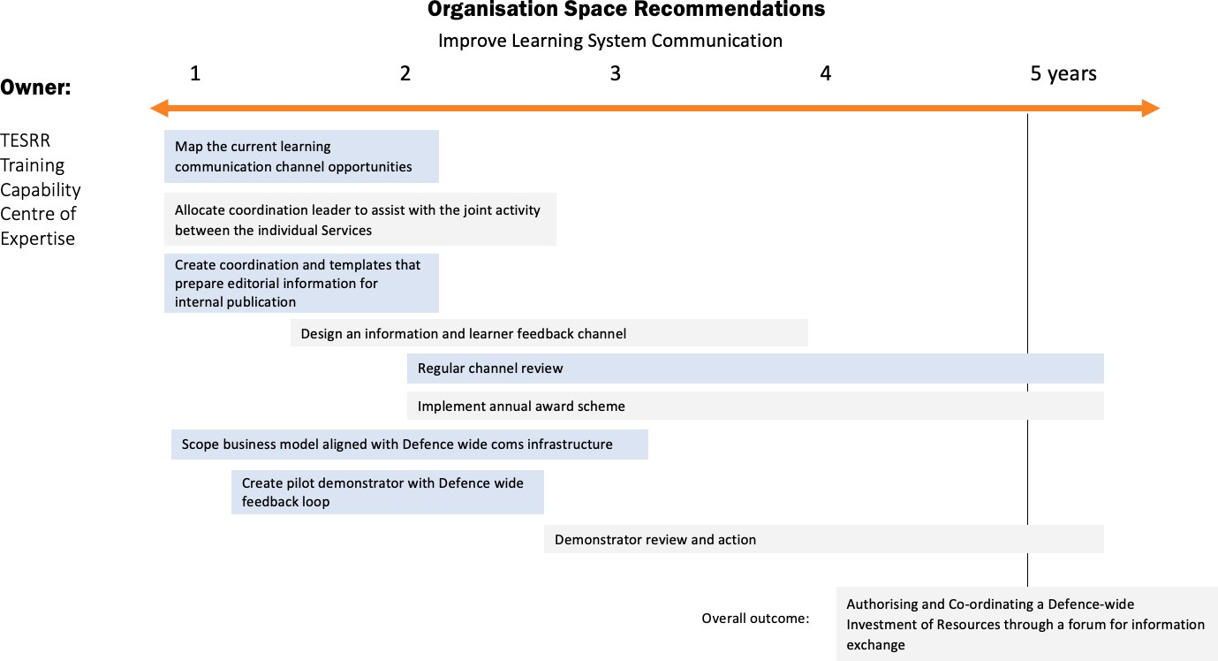

**Figure 18: Organisational Space Recommendations: Improved Communication**

#### Evidence

Evidence into the Organisational space reveals that there is currently a lack of authority and reluctance to be brave in undertaking change management. This points towards the need for realignment and coordination of innovation that is already happening Defence-wide. Improving the communication will help encourage innovation and potentially increase exposure and consequent investment. Evidence suggests that the current process for new investment is slow and financial evaluators do not always understand or accommodate the specifics of the world of learning and procurement.

#### Funding Impact

The project team have highlighted in the Learning Space (section [3.4.1]) the efficiency value of greater awareness and understanding between learner designers, deliverers and the learners themselves. A more compelling information exchange channel would help deliver these efficiencies and at the same time add an important celebratory note to the process of developing MOD capability. There is a need for resourcing both the work group and business case, including funding for the pilot demonstrator.

#### Impact of ‘No Action’

Lack of rewarding and coordinated communication will continue to be made worse through greater fragmentation of messages, and the learning community will fail to fully engage with itself. With a more participatory communications learning system, learning in the MOD will move towards being perceived as a collective endeavour, informed by itself, and not become a ‘push service’ only delivered at the last moment of need.

#### Interdependencies

This recommendation, if carried out, will directly support and enrich the delivery of all the other recommendations. It requires the agreement that there is a learning community that sits within the general communications infrastructure, but that it could be enriched in tone and strengthened in impact, if it is allowed a slightly more personalised approach to its discourse with all staff.

### R8: Implement Governance of a Change Programme to Realign Learning Systems

It is recommended that Defence authorise and coordinate a governance change management programme that helps with allocation and investment of resource through a forum for information exchange. This 5-7 year, special change management unit approach will facilitate the other project recommendations efficiently. Within this 7 year period, realignments and cost-savings can be made and opportunities and new alliances can be developed that would deliver robust and consistent managerial level guidance and monitoring. In the longer term, this coordinated governance might be refined and continue as a coordinated authority for learning, or it might be seen as having achieved its objectives and can be disbanded. Evidence shows that without an, albeit temporary, authority in place over T&E, very little will change. This organisation should also have the authority to gather information on what is happening and direct resources to fill any emerging gaps. The project team illustrate their response to the governance concerns with two concept illustrations – MOD:ULE and TRESLE. MOD:ULE outlines the concept of temporary governance of the realignment project across the learning system. TRESLE outlines the concept of how to organise that realignment and show how the communications could be improved practically.

#### Specify the structure and authority of a MOD Universal Learning Ecosystem (MOD:ULE) Project Management Authority

It is recommended that the MOD develops the project team’s concept called MOD:ULE. This work would set out the mandate and objectives of a temporary, devolved governance of a learning systems capability realignment project across T&E. It would show how this authority could offer an immediate and coordinated access to learning centres throughout Defence, deploying small change acceleration units. The devolved authority would oversee a 5-7 year realignment of some legacy governance structures that relate to the management of learning to ensure that all learning innovation is thoroughly exploited Defence-wide. Implementing access to more focused resources will help to adapt and improve existing successful structures while also coordinating a more inclusive professional practice of learning design. Initially it is important to define the operational objectives and business case for MOD:ULE to help author and monitor change in the Learning Ecosystem. Next, it is recommended that TESRR manage both of these concept developments, using the following objectives and guidelines.

In section [3.4] of this document the team defined what MOD:ULE should achieve during its period of managing change:

* + - * + To bring to the Services immediate access to previous knowledge and learning insight across the whole of the MOD;
        + To deliver measurable financial savings and positively contribute to recruitment and retention issues, whilst strengthening individual Service strategy development;
        + To offer focused resources for the current owners of individual learning systems in Defence to apply for innovation grants, thereby coordinating Defence-wide learning R&D and ensuring programmes are scalable and accessible;
        + To make available small coordination and process acceleration units that help individual Services look across each other’s boundaries in a positive and innovative way;
        + To design, build and supply collaborative open source tools that support application scalability and coordinate a more inclusive professional practice of learning design;
        + To explore and coordinate the research into the delivery infrastructure needs of 5 years’ time; and,
        + To ensure, where appropriate, that all learning innovation is thoroughly exploited in the commercial markets.

To achieve these outputs, the initial task within this recommendation is for MOD:ULE / TESRR to:

* + - * + Define the mandate from DPLT that scopes out clearly the operational areas and lines of authority;
        + Identify the Service representatives and other stakeholders who should make up MOD:ULE’s Operational Board;
        + Quantify the funding required in detail over a 3 year cycle and in scope for a further 4 years;
        + Identify talent and define post responsibilities;
        + Define the exact crossover contact points within each Service;
        + Produce a set of measurable deliverables and work packages; and,
        + Identify the KPIs of the deliverables plan.

Subject to approval, when launching MOD:ULE using the enhanced communications network (as described in section [3.4.4.1.3], it is envisaged in the early implementation that the Operational Board, as the coordinating body, will fully report back to DPLT on a regular basis.

#### Specify the structure and organisational remit of a new implementation unit called ‘Transferring Resources and Excellence into a Single Learning Ecosystem’ (TRESLE)

TRESLE outlines the method of how to organise and communicate the governance realignment authorised and monitored by MOD:ULE. TRESLE is the project management unit acting as a bridge between T&E and the currently evolving Defence Learning Ecosystem of initiatives and innovation outputs. This unit would be charged by MOD:ULE to support the delivery of the realignment through smooth project management and monitoring of the impacts. The project team make some broad recommendations as to how the unit might be set up:

* + - * + Appointment of three Learning Work Programme Alignment Managers who oversee and report back on Research / Application Development / External Exploitation;
        + Development of a small investment fund that can be applied to using cross-Service criteria, with three funds related to a) upgrading existing content b) originating new content and c) exploring emerging learning opportunities; and,
        + Appointment of four coordination and monitoring managers or TAs, who are linked to DLE’s Category Managers and the Hubs of Learning Excellence to manage individual project delivery and monitoring.

The team would also work with the communications unit outlined in section [3.4.4.1.3] to oversee the editorial input of:

* + - * + TRESLE TV – a mobile learning news and features channel;
        + The TRESLE Awards – annual in three categories: Technical Applications for Learning / Behavioural Learning / Skills for the Future
        + The TRESLE Accreditation Scheme - If a HELP HUB is given a TRESLE Accreditation, it receives:

Small grants of R&D project funding;

Extra trainers to manage requests; and,

Equipment upgrades CAPEX (Capital Expenditures) budget.

See Figure [19] for a detailed timeline of these recommendations and strategic steps.

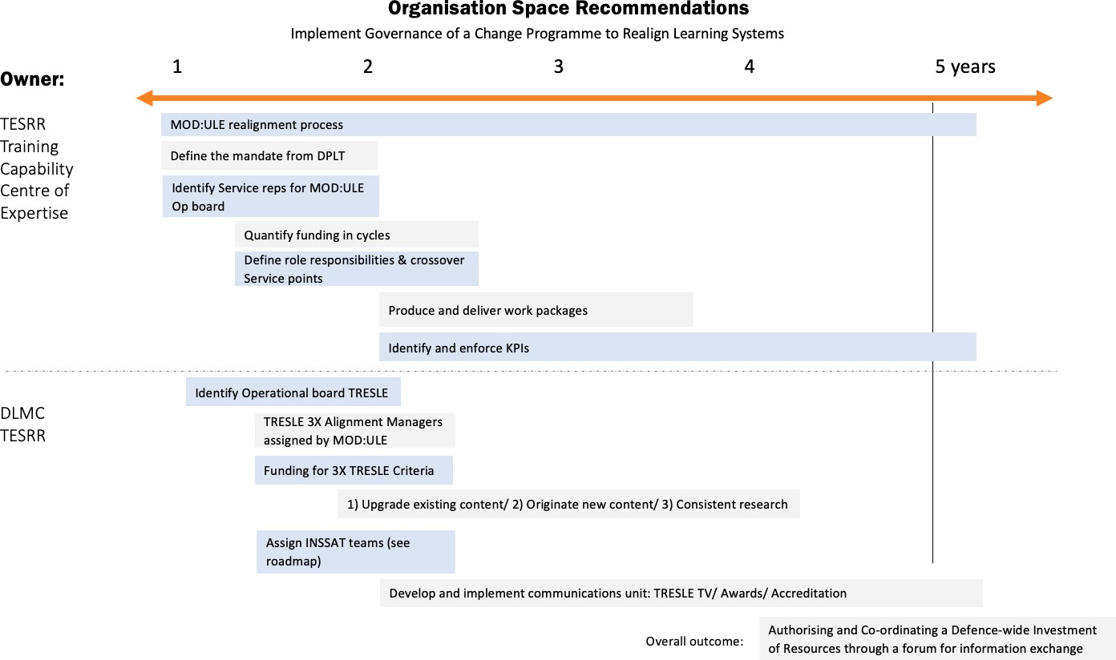

**Figure 19: Organisation Space Recommendations: Governance of Change**

#### Evidence

The problem of governance is more difficult as it is intimately tied up with the allocation of resources. There are also issues with achieving the right balance between central direction and local autonomy. At the moment, the majority of resources are controlled by individual Services and schools, which has led to a hollowing out of the centre. However, there are elements of the Defence Learning Ecosystem that would be more effectively directed from the centre, including the establishment of standards for things like security and privacy, and the development of common tools and data infrastructure.

#### Funding Impact

This governance recommendation requires investment in terms of time, manpower and budget, but the outcomes would deliver a high level of efficiencies and a dramatic reduction in duplication through knowledge sharing and collaborative project coordination.

#### Impact of ‘No Action’

If the current situation continues then there is the likelihood that development across MOD will continue to be haphazard and uncoordinated, leading to a situation with unnecessary duplication and a mass of different learning systems that do not talk to each other. This will lead to a situation where there is not a single Defence Learning Ecosystem but rather a set of islands each with their own systems.

#### Interdependencies

There are currently many different actors developing their own aspects of the Defence Learning Ecosystem and in many cases, the work is highly innovative and must be protected, but ideally then shared. Each of these formal and informal operators have their own interests, priorities and internal competitions to resolve. What is important is to provide authority, resources and a forum within which these issues can be worked out and shared.

## A Systems Approach to Change Management

The team is proposing a systems approach to change management. Many of the difficulties of creating a Defence Learning Ecosystem derive from the systemic nature of the problem – changing individual elements has only a limited effect; it is only in combination that the full potential of the system becomes apparent. By their nature system problems are hard to address both because they are difficult to understand and because all of the problems are inter-connected; change in one area leads to knock-on effects in other areas, solving problems in one area leads to more problems that need solving. Only by looking at the whole and pursuing an integrated and systemic programme of change can the full benefits of the system be realised.

Because of this, the team are proposing several different approaches to building an effective Defence Learning Ecosystem. The way in which these different approaches are interconnected is summarised in Figure [20], which shows the four spaces, the corresponding capability realignments and the different elements of MOD:ULE that contribute to each of the transformations that the team are trying to achieve. The connections are not one-to-one, but many-to-many; each of the different activity areas has the potential to make a contribution to more than one of the different capability realignments and it is in combination that the greatest effect will be seen. The team have also grouped the different components of MOD:ULE according to the broad objectives that are being sought to achieve with each set of elements and have listed the VSM System level (see Figure 4) that each group seeks to affect.

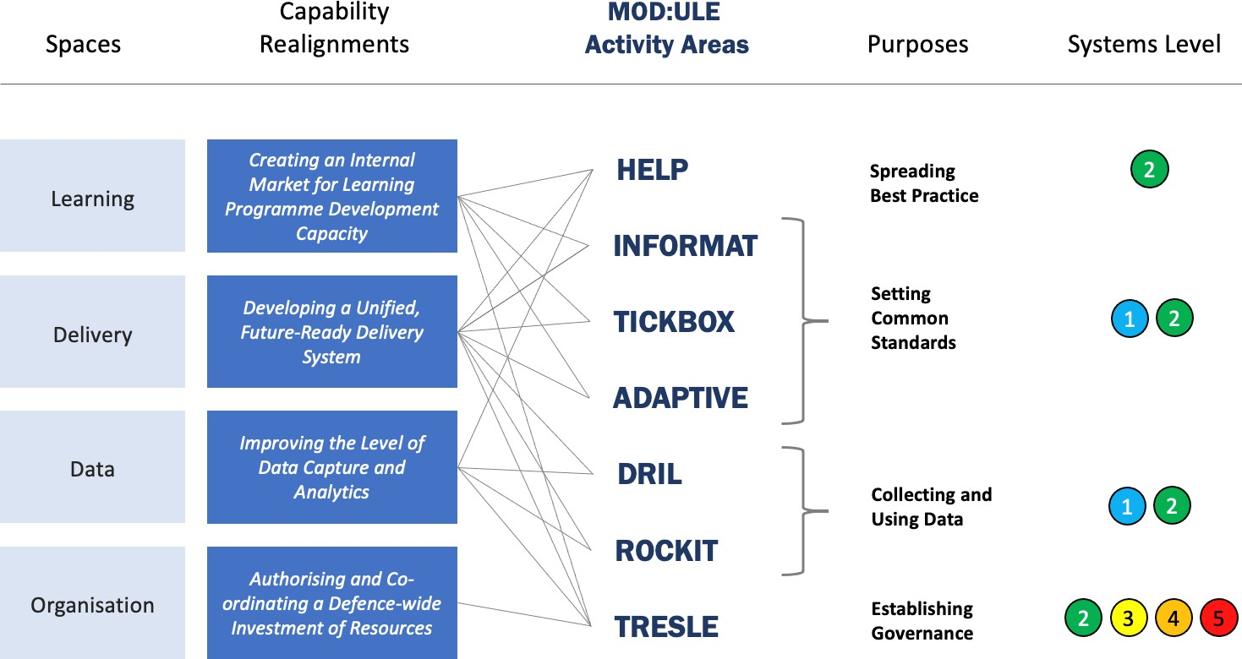

**Figure 20: A Systems Approach to Change Management**

Just as in the initial conception of the problem, in terms of the spaces in-between the anchors, the relationships are much more to do with how things are inter-connected than they are to do with what is happening in any particular part of the problem. Similarly, when the capability realignments are mapped across to the Roadmap, the relationships are overlapping and the transformations need to pull together changes that are going on in more than one area of the diagram.

It is the web of inter-connection that makes the Defence Learning Ecosystem such a powerful concept and such a powerful tool; but establishing and reinforcing that web requires concerted and consistent action along multiple avenues of change.

**Take me back to the** **Contents Page.**

# 5 Roadmap

This section covers an outline of the prioritisation of deeper research and analytics required for Defence moving forward in the context of a roadmap. The design of this programme-of-change Roadmap has been influenced by the importance of making it clear to those working with it that coordination does not necessarily mean a ‘take over’ of the current T&E systems or a change in ownership. Like any early draft implementation plan, roadmaps must initially trigger responses from all the key stakeholders before they can be further defined, and that was evidenced well in both workshops. In the case of realigning a vast and dynamic learning system to become a new, more fully aligned Defence Learning Ecosystem, there must be consideration given to the strategists and planners in each Service, for whom learning is just a part of their overall consideration.

These individual strategists need to feel comfortable that what is being offered to them is a flexibility to interpret and a recognition that certain factors might already be in place and others may take much longer to adapt from their current plans. Whilst all the Services have learning strategies in place, these plans rarely correlate with each other or explore common synergies or economic savings that can come from a collaborative, scaled approach. The project team have therefore devised a simple guideline Roadmap to trigger debate across the Services and at the same time support individual Services on identifying the challenges to their previously agreed strategies, with this more collaborative alignment, in a period over 7 years.

The recommendations are contextualised in a ‘bigger picture’ Roadmap (see Figure [25]). The Roadmap demonstrates how changes to governance (MOD:ULE) and communications and coordination (TRESLE) within Defence could be implemented over a 0 - 7 year plan. Years 0 - 5 in the Roadmap refer to the alignment phase. This is where the seven project recommendations sit. This is followed by 2 years of monitoring and finessing (years 6 -7). This brings the project total to a 7 year implementation plan.

The Roadmap demonstrates three distinct phases that occur over each green, grey and blue banner, representing the individual Services. The thickening of these coloured lines represents the phase changes over the years. It also represents the concern the project team have that this roadmap is designed to allow each Service to differ in its progress and even interpretation of the Roadmap. For example, the Army may well believe that their Learning Plan is well developed and potentially could be quickly aligned with the Roadmap, but that their Data Plan will take a long time to implement successfully. Meanwhile the Navy and RAF might feel comfortable with alignment with the Delivery Plan in the Roadmap but be less assured as to how quickly they can align with the innovation hubs in the Learning Plan.

The design emphasis built into the Roadmap allows for these periods of adjustment and eventual realignment, but at a pace that suits existing culture and resources in each Service. However, the MOD:ULE overseeing coordination and monitoring team does have the authority to ensure that everyone is progressing towards a common beneficial collaborative learning system, using some of the interrelated strategies that align with the recommendations and research findings in this project.

The Roadmap shows on its top line the three key elements to the MOD:ULE team, a Monitoring Board of Senior Stakeholders; representatives of MOD:ULE fully briefed in each Service senior decision-making body; and, connected directly into the central MOD financial services, a Resource Audit & Monitoring function for the change programme.

The Communications strand of the work is represented by the types of community outreach groups, the whole of the MOD workforce, the Service-specific communications systems, and a review function for communication requests from UK or international stakeholders

TRESLE is the change implementation unit and is made up of three teams: a Resource & Allocations team that manages grants, small innovation, and supports and guides the practical application of innovative outputs. The Accelerator Crossover team works across the Services, coordinating, inspiring and consolidating learning development; and the Exploitation team ensures that all innovation is market-tested and assessed for exploitation value.

The project team have designed an overall schematic for three change management support tools:

**Overcoming Roadmap Barriers to Integrate a Teaching & Learning Ecosystem (ORBITLE)** is a team-designed approach that focuses on the action needed to overcome the barriers at each level within the system. The project team considered the different types of barrier and the likelihood of some being concomitant to other changes in barrier status, as outlined in section [3.4]. For example, if the barrier that prevents sporadic outbreaks of innovation across the MoD from learning from each other can be alleviated by an internal market of HELP Hubs, then the need for centralising the development of innovation practice could be managed as an internal market by existing services like the Defence Academy and would have therefore entirely removed a barrier. The team used the framework to deploy four types of Barrier Change Status:

Enhance [e.g. ADAPTIVE overlaid on DSAT];

Realign [e.g. DLE incorporating LEARN functionality receiving a Defence-wide service mandate];

Remove [e.g. No requirement for LEARN and other delivery platforms, as example above]; and,

Accept [e.g. this is agreed that in this area, each Service has greater authority over certain areas of learning than any central division].

**The DSAT/ ADAPTIVE Framework** is set out in section [3.4.1.2.3] and section [4.1.1] and upgrades the support for learning designers within the MOD.

**The INFORMAT Framework** is a template tool that supports large landscape collaborative learning done remotely, that also is part of the recommendations made in the Learning Space [4.1].

Finally, the TRESLE Operational Years indicate the phases of annual progression towards a unified realignment of Tri-Service learning capability.

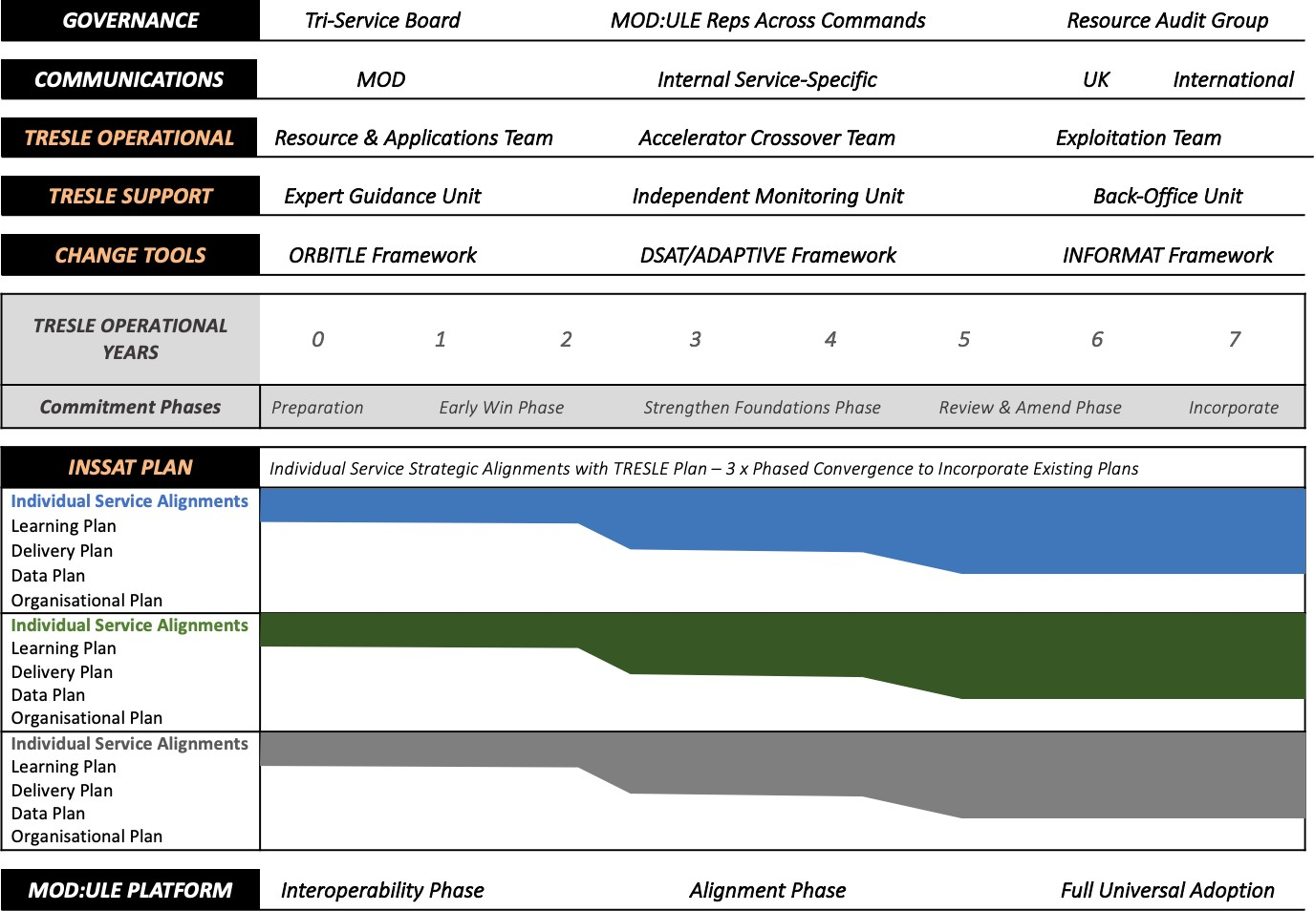

**Figure 21: The Project Roadmap**

The Individual Service Strategic Alignments with TRESLE Plan (Individual Service Strategic Alignments with TRESLE [INSSAT Plan] in the left-hand column in Figure [21]) asks the Services and their centralised learning support communities to consider the defined outcomes that have been identified by the designated operational MOD:ULE Board in four areas of enhancement and realignment: the Learning Space, the Delivery

Space, the Data Space; and the Organisational Space. Each of these areas will be populated by the TRESLE team with specific actions or projects and accompanying outline KPIs, that will deliver the specified outcomes of the overall learning change programme.

INSSAT teams (identified in year 1 under recommendation 8) would then work to identify in each Service and learning support community which recommendations and areas can be progressed quickly, and which will require a longer realignment time. The recommendations made in section [5] will be implemented Defence- wide during the first 5 years of the alignment plan. Some of the recommendations are likely to be quite quick changes that enable greater learning design collaboration and consequent incorporation, like the connecting up of existing innovation activity, whilst other more fundamental changes to learning needs will need careful investigation to identify the impacts on the ‘local’ current strategic plans and it is possible that they may span into the review and incorporation phase of the Roadmap.

## Conclusion

The project team wish to end this report with a conclusion that does not just repeat the objectives and an enthusiastic hope that stakeholders will use this research to bring about change in their own areas of the current T&E system. Instead, this conclusion aims to highlight, for the potential users of this research, four main impressions that have emerged during the year’s work.

The first is that the current T&E system is in many ways excellent at supporting what is, in comparison with many learning systems, a community of extraordinary talent and it should celebrate this more openly and often, as ultimately the highest criteria of any learning community is the more fundamental quality of its people, not just its skills and processes.

Secondly, the recommended changes are focused on protecting good practice, whilst enhancing a shared collaboration through the development of new, dynamic crossover pathways, not providing evidence that can be absorbed by a single Service to finesse its own current strategy.

Third, the team are not advocating vast paradigm shifts in either the business case or the level of overall funding for learning activities, but the evidence could not be clearer that a devolved set of learning communities, responding in their own way to a digitally challenging world, can easily waste investment and ironically slow the growth of learning innovation.

Finally, the power of enabling knowledge owners to work more seamlessly with the vast number of enthusiastic knowledge acquirers cannot be achieved with ‘just-in-time’ course updates or a reliance on old notions of training methodologies, or even expensive hi-tech explorations of a new piece of kit arriving in the industrial market. A modern Defence force is built by people and they require inspiration and behavioural guidance just as much as process related skills development or embracing commercial software solutions.

The realignments the team recommend in this report are designed to ensure that some of the MOD’s much larger issues of organisational and financial efficiency, future-proofing capability, talent recruitment and retention are more powerfully supported by a constantly iterative Vision of exactly what a dynamic Defence Learning Ecosystem will be like. The team believe that their investigation signals many of the compelling opportunities that are waiting to be embraced, as the Vision continues to evolve.

# 6 References

Army Data Sub Strategy (2019). *An Exploitable Strategic Asset*. MOD. Official.

Ashby W.R. (1958) Requisite variety and its implications for the control of complex systems, *Cybernetica* 1:2, p. 83-99

Bailey, M. (2020) *HS 1.008 Data-Driven Training and Learning for Defence Interim Vision Statement and Roadmap*. O-HSSRC-1.008-006.

Bandura, A., 2001. Social cognitive theory of mass communication. *Media psychology*, *3*(3), pp.265-299. Beer, S. (1984). The Viable System Model: Its provenance, development, methodology and pathology.

*Journal of the Operational Research Society*, *35*(1), pp.7-25.

Castaño Muñoz, J., Redecker, C., Vuorikari, R. and Punie, Y. (2013). Open Education 2030: planning the future of adult learning in Europe. Open Learning: The Journal of Open, Distance and e-Learning, 28(3), pp.171-186.

Checkland, P. and Scholes, J. (1999). *Soft systems methodology: a 30-year retrospective* (pp. 330-pages). Chichester: John Wiley.

Cullingford, E., Ralston, B., and Lumsden, G. (2019). *ASC Task 0204- Enabling Better Training and Learning.*

Publication Number: QINETIQ/19/01366, version 1, 29th March 2019. BAE Systems.

Deighton, C. (2019). *Personalisation of Learning, a Scoping Study: Final Technical Report*. Farnborough: QinetiQ.

Denny, S. (2020). Internal MOD Document. *Defining and Developing the Intellectual Edge: An interim report,* dated: Version 3- 6 October 2020. Defence Academy.

Kaarbo, J., and Beasley, R. K. (1999). A practical guide to the comparative case study method in political psychology. *Political Psychology, 20*(2), 369-391.

Lee, E. A. L., Wong, K. W. and Fung, C. C. (2013). Virtual Reality: An Emerging Technology for Learning.

Glynn, M. D., Goode, M., Ralston, B., Kelly, C., James, L., and Caird-Daley. (2014). A New Employment Model (NEM): Evaluating the Effectiveness of Phase 0 Training Final Report. TIN 2.023, UC- DHCSTC_I2_T_T2_023/012, dated 12 March 2014.

McKinsey. (2019). Catch them if you can: How leaders in data and analytics have pulled ahead [online] Available at: [https://www.mckinsey.com/~/media/McKinsey/Business%20Functions/McKinsey%20Analytics/Our%20Insi](https://www.mckinsey.com/~/media/McKinsey/Business%20Functions/McKinsey%20Analytics/Our%20Insights/Catch%20them%20if%20you%20can%20How%20leaders%20in%20data%20and%20analytics%20have%20pulled%20ahead/Catch-them-if-you-can-How-leaders-in-data-and-analytics-have-pulled-ahead.ashx) [ghts/Catch%20them%20if%20you%20can%20How%20leaders%20in%20data%20and%20analytics%20have](https://www.mckinsey.com/~/media/McKinsey/Business%20Functions/McKinsey%20Analytics/Our%20Insights/Catch%20them%20if%20you%20can%20How%20leaders%20in%20data%20and%20analytics%20have%20pulled%20ahead/Catch-them-if-you-can-How-leaders-in-data-and-analytics-have-pulled-ahead.ashx)

[%20pulled%20ahead/Catch-them-if-you-can-How-leaders-in-data-and-analytics-have-pulled-ahead.ashx](https://www.mckinsey.com/~/media/McKinsey/Business%20Functions/McKinsey%20Analytics/Our%20Insights/Catch%20them%20if%20you%20can%20How%20leaders%20in%20data%20and%20analytics%20have%20pulled%20ahead/Catch-them-if-you-can-How-leaders-in-data-and-analytics-have-pulled-ahead.ashx) [Accessed 20 November 2020].

Medhurst, J., Kelly, C., McIntyre, H., Crabbe, R. and Black, S. (2016). *Final Report - TIN 3.130 Maritime Training Interoperability Development of a Maritime Training Interoperability Framework and Scorecard – Research Module 1*, DHCSTC O-DHCSTC_I392840_TH_T3_130/006, dated 15 January 2016.

MOD. (2018a). *Maritime Training Strategy: Part 1 - Evolving training to meet the challenge of future maritime operations*. Internal MOD document.

MOD. (2018b). *Maritime Training Strategy: Part 2 - Meeting the training challenges of Maritime Strategy 2035.* Internal MOD document.

MOD. (2019). *Joint Service Publication (JSP) 822: Defence Direction and Guidance for Training and Education: Part 2 – Guidance*. Internal MOD document.

MOD. (2020). *Joint Service Publication (JSP) 939: Defence Policy for Modelling and Simulation: Part 2 – Guidance.* Internal MOD document.

Newvantage.com. (2020). Big Data and AI Executive Survey 2019 [online]. Available at: https://[www.businesswire.com/news/home/20200106005280/en/NewVantage-Partners-Releases-2020-](http://www.businesswire.com/news/home/20200106005280/en/NewVantage-Partners-Releases-2020-) Big-Data-and-AI-Executive-Survey [Accessed 20 November 2020].

Pleva, M., Dale, J., Medhurst, J., McAlaney, J., Hare, N. and Castelli, N. (2020a). *HS 1.007 Defence Learning Ecosystems Interim Research, Vision and Roadmap Report*. HSSRC Report O-HSSRC-1.007-015 dated 24 January.

Pleva, M., Dale, J., Medhurst, J., McAlaney, J., Hare, N. and Castelli, N. (2020b). *HS 1.007 Short Report and Updated Roadmap*. HSSRC Report O-HSSRC-1.007-021 dated 22 April.

Pleva, M., Dale, J., Medhurst, J., McAlaney, J., Hare, N. and Castelli, N. (2020c). *HS 1.007 Interim Statement of Analysis*. HSSRC Report O-HSSRC-1.007-024 dated 10 September.

Pleva, M., Dale, J., Medhurst, J., McAlaney, J., Hare, N. and Castelli, N. (2020d). *HS 1.007 Interim Statement of Analysis with Updated Roadmap*. HSSRC Report O-HSSRC-1.007-029 dated 27 November.

Pleva, M., Dale, J. and Castelli, N. (2021). *HS 1.007-I-008. Talya 2025 Final Report.* HSSRC Report O-HSSRC- 1.007-I-008 dated 22nd January 2021.

Rashid, Y., Rashid, A., Warraich, M. A., Sabir, S. S., & Waseem, A. (2019). Case study method: A step-by-step guide for business researchers. *International Journal of Qualitative Methods, 18*. doi:10.1177/1609406919862424.

Rosenthal, M. (2016). Qualitative research methods: Why, when, and how to conduct interviews and focus groups in pharmacy research. *Currents in Pharmacy Teaching and Learning, 8*(4), 509-516. doi: <https://doi.org/10.1016/j.cptl.2016.03.021>.

Sookermany, A. M. (2017). Military education reconsidered: A postmodern update. *Journal of Philosophy of Education*, 51(1), pp. 310-330.

# Appendix A - The Project Team

The team bring together a wide range of experience and skills into a **balanced multidisciplinary** team.

* LiMETOOLS brought **a clear Vision of a potential future Defence learning ecosystem**. They are experts in combining broadcast and feature-film storytelling with interactive user or group- controlled learning using a robust and proven psychological approach to training. Their platform, currently being used by 97 banks around the world, uses Social Cognitive Learning Theory (Bandura, 2001) to facilitate behaviour change in large organisations.
* Larrainzar Consulting provided **experience of the problems of Defence training** and complex requirements, including previous work for Dstl. They brought experience using facilitation, mapping, and soft Operational Research techniques to achieve change in complex socio-technical systems.
* Aleph Insights provided expertise in the **collection, structuring and analysis of the hard and soft data** that, throughout the project, was used to underpin the Roadmap design. This included information generated during the scoping and implementation workshops, and the case studies.
* Bournemouth University (BU) provided **scientific expertise** to the Interim Report, data generated from the case studies and the Final Report.

Together, they provided an **independent research capability** that drew upon new thinking when developing a Defence Learning Ecosystem.

###### LiMETOOLS Ltd (John Dale – Lead Investigator)

John has led organisations for over 30 years in media production, including senior creative and managerial roles in the BBC, including heading up the Innovation Group in BBC Strategy. He was a senior executive producer of drama at the UK’s main commercial channel, ITV. In the educational arena, he was the co-creator of BBC Knowledge and Director of Communication Studies at the pioneering training college Ravensbourne. He spent some time in the Cabinet Office as an advisor on the UK digital rollout. During this project, John brought his expertise in production, education and storytelling and was the pioneer in developing a Vision for change in Defence T&E that is both disruptive and practical.

###### LiMETOOLS Ltd (Megan Pleva – Project Manager and Chief Investigator)

Megan is a cyber security and human-factors professional working as a Business Executive for the cyber division at LiMETOOLS. Megan was the project lead on the Dstl ASC Task 131 Future Insights and has a background in managing and developing the cyber content for LiMETOOLS products, managing large bespoke commissions, co-ordinating the development of new training tools, managing client relationships and researching existing trends in Cyber. Megan was the project manager and chief investigator on this project.

###### LiMETOOLS Ltd (Niall Castelli – Proof-reader)

Niall worked as a monitoring scientist for the Environment Agency before joining LiMETOOLS as a project manager. Throughout the duration of this project Niall worked as a proof-reader and helped with admin management.

###### LiMETOOLS Ltd (Ashley Garner - Scenario Production Executive)

Ashley is the Head of Production at LiMETOOLS, managing the development and manufacture of feature film assets and assembling gaming tools for clients as diverse as Pricewaterhouse Coopers World Bank, Siemens and HMG Foreign & Commonwealth Office. For the duration of this project Ashley provided production support, filming, editing and delivery of immersive films.

###### Larrainzar Consulting Solutions Ltd (John Medhurst – Facilitator)

John is an analyst with 35 years of experience in Operational Research. He has been involved in studies of training and training effects for the last ten years. He has carried out work on mapping the training system, simulating training effectiveness and showing the cost effectiveness of training. He has also worked on the ASC Project GHOST, developing real-time modelling of expected performance for personnel under training. He has also had been the subject of training as part of a Corps headquarters. John is an accredited

Fellow of the Operational Research Society (FORS). During this project John provided experience of the problems of defence training and complex requirements, including previous work for DHCSTC. He facilitated both workshops and helped map Operational Research techniques to achieving change in complex socio- technical systems.

###### Aleph Insights (Nick Hare – Data Consultancy)

Aleph Insights is a London-based analytical consultancy and data science company. Nick Hare founded Aleph Insights in 2014. Since then, he has led a wide range of analytical projects for customers in government and industry. These have included an analysis of cyber risk in defence procurement, the generation of scenarios for future space traffic, a probabilistic assessment of explanations for flight MH370's disappearance, and the development of dashboards to visualise the UK's preparedness to deal with major hazards. His role in the project included providing expertise in the collection, structuring and analysis of the hard and soft data that, throughout the project, was used to underpin the Roadmap design. This included information generated during Workshop 1 and Workshop 2 and the case studies.

###### Bournemouth University (John McAlaney- Behavioural Psychologist).

Head of Education and Associate Professor, John McAlaney is a member of Bournemouth University Cybersecurity Research Group and works in interdisciplinary research between the Departments of Psychology and Computing. He led the British Psychological Society’s position paper on the role of psychology and human factors role in cybersecurity, and the Society’s response to Government whitepapers on cybersecurity challenges. He has received research funding from Dstl and the US Army and has delivered invited talks to a range of stakeholders, including the National Cyber Crime Centre and the MOD. During this project, John advised on the T&E in HE, conducted literature analysis and advised on the behavioural robustness of the recommendations.

# Appendix B - Stakeholder Engagement Plan

**Table 3: Stakeholder Engagement Plan**

|  |  |  |
| --- | --- | --- |
| **Stakeholder Engagement Plan** | | |
| **Stakeholder Organisation** | Role | Type of Engagement |
| **Defence School of Electronic and Mechanical Engineering (DSEME)** | Civil Servant (C1) - Head of Learning Technology |  |
| **Training, Education, Skills, Recruitment and Resettlement (TESRR)** | Lieutenant Colonel (Lt Col) Staff Officer Grade 1 (SO1) |  |
| **Capability Training in Army HQ** | B2 Civil Servant |  |
| **Battlespace Technology Course (BTC)** | 2X Maj BTC 13 Students | Interview |
| **Defence Education Pathway Team** | Lt Col SO1 |  |
| **Defence Academy** | Lt Col SO1 |  |
| **DLMC** | Civilian consultant representing DLMC project. |  |
| **Defence Education Pathway Team** | Lt Col SO1  Deputy Team Lead |  |
| **Joint Services Command and Staff College (JSCSC)** | Staff Officer Grade 2 (SO2) |  |
| **DSEME** | Civil Servant - Band C1 |  |
|  |  | Workshop 1 |
| **Learning Technology - Land Warfare**  **Centre (LWC)** | Staff Officer Grade 3 (SO3) |  |
| **Defence Academy - Defence Learning Environment (DLE)** | Lt Col SO1 |  |
| **Assistant Chief of Naval Staff Training Head Quarters (HQ)** | Staff Officer for Training Transformation |  |
| **Commanding Officer (CO) (North), Regional Command** | Lt Col |  |
| **Defence Academy - Defence Technology Enhanced Learning (DTEL)** | DLE SO2 Development Faculty |  |
| **TESRR** | Lt Col SO1 |  |
| **DLE** | 2X Interviews with DLE service owner |  |
| **DSEME and LEARN** | 1X interview with Head of Learning Technologies and 1X interview with Head of Assurance | Case Studies  *all case studies researched using open and exploratory analysis sourced using GFI, online resources  and interviews. |
| **RNTTCT MA - Training Transformation (TT)** | 2X interviews with SO3 Training Transformation from RN Fleet HQ |

|  |  |  |
| --- | --- | --- |
| **Stakeholder Organisation** | **Role** | **Type of Engagement** |
| **Army Recruiting and Initial Training Command (ARITC) and Target Learning Model (TLM)** | 2X interviews with ARITC staff |  |
| **HE** | 4X interviews with Higher Education staff from Bournemouth University including:  1X Head of Centre for Fusion Learning Innovation and Excellence, Bournemouth University;  1X Associate Dean Student Experience, Faculty of Science and Technology, Bournemouth University;  1X Head of Department of Psychology, Faculty of Science and Technology, Bournemouth University; and,  1XDeputy Dean Education & Professional Practice, Faculty of Media and Communication, UK. |  |
|  | Case Studies |
| **Collective Training Transformation Programme (CTTP)** | 2X Interviews with SO2 Training Capability Development at Army HQ |  |
| **Aquila Learning and Risk Management System (ALaRMS) Data System** | 2X Interviews with ALaRMS service owner  1X interview with SO1 at Defence College Technical Training (DCTT) responsible for LEARN who uses ALaRMS system |  |
| **Defence Academy** | 7X representatives  Learning Development Advisor |  |
| **RN TT** | 1X SO1 Training Transformation |  |
| **DSEME HQ** | 1X representative |  |
| **Aquila Learning** | 1X representative |  |
| **DLMC** | 1X representative  1X RN technical lead for DLMC | Workshop 2 |
| **Training Group Project Mercury** | 1X representative |  |
| **Defence and Security Analysis Division** | 1X SO2 TT |  |
| **HQ Air Command** | 1X Deputy Head of Personnel Strategy  1X Team Leader 1X SO1 Training |  |

|  |  |  |
| --- | --- | --- |
| **Stakeholder Organisation** | **Role** | **Type of Engagement** |
| **DCTT HQ** | 1X SO1 CIS |  |
| **Royal Naval Air Engineering and Survival Equipment School** | 1X Air Engineering Specialist Training Pillar Head | |
| **Central Training School Royal Air Force**  **(RAF)** | Officer Commanding Design and  Delivery Wing | |
|  |  | Workshop 2 |
| **RAF Training Strategy** | 1X SO1 Psychologist |  |
| **DLE** | 1X representative |  |
| **TESRR** | 1X SO1 Training Capability & Force Development | |

# Appendix C - VSM Model

The Viable System Model or VSM (Beer, 1984) is an approach to understanding problems of control in complex systems. The approach was developed by Stafford Beer (1926-2002), a pioneer in the field of systems thinking and operational research with a background in both psychology and philosophy. The approach was developed from cybernetics39, the science of control and communication within systems. Beer’s model was heavily influenced by biological models including the human nervous system and comprised a set of interlinking systems that worked together to maintain a ‘viable system’, by which is meant a system capable of successfully responding and adapting to changes in its environment. The project team developed the VSM as an ‘influencer’**.**

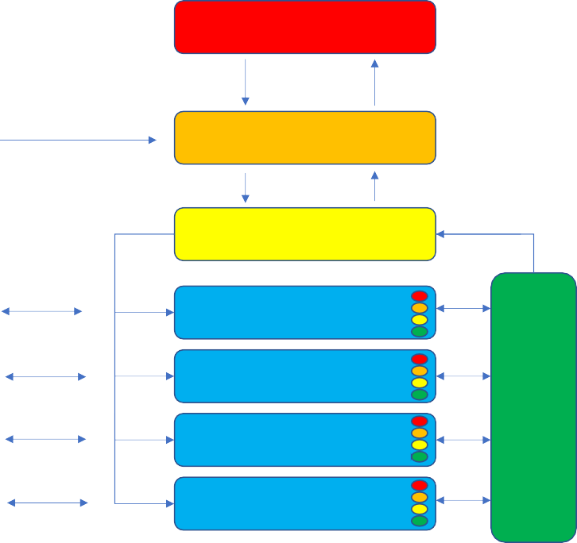System 5 (Governance)

Set Priorities Gather Information

Environment

Allocate Resources, Give Instructions, Request Information

System 4 (Outside, Future)

System 3 (Inside, Now)

Flag Issues

Plan, Generate Scenarios

Information Up

Outcomes

Outcomes

Outcomes

Outcomes

5

System 1 (Activities) 4

3

2

System 2

(Coordination and Communication)

5

System 1 (Activities) 4

3

2

5

System 1 (Activities) 4

3

2

5

System 1 (Activities) 4

3

2

**Systems are Recursive -**

**All System 1s have their own internal Systems 1/2/3/4/5**

**Figure 22: The Viable System Model (as adapted from Beer, 1984)**

An overview of the VSM is shown in Figure [22]. It comprises of five systems:

**System 1** – there can be more than one of these and they carry out the activities of the system. According to the central theorem of the VSM, each component of a viable system must itself in turn be a viable system. As a result, each System 1 also has within it independent Systems 1, 2, 3, 4 and 5 that allow the internal operations of that sub-system to be monitored and controlled.

**System 2** – this system is responsible for intercommunication between the different System 1s and also provides a conduit for the information required by System 3 – the controller at the next level up.

**System 3** – this system focuses on maintaining and adjusting the internal state of the viable system; allocating resources between System 1s, requesting information through an audit function and giving instructions to the individual lower level systems to optimise their joint output.

**System 4** – this system focuses on the external world and the future state of the system; it gathers information about the outside environment and generates scenarios to allow the system to assess the impact of different futures and allow System 3 to adjust the lower level systems to maintain the viability of the

39 From the Greek *Kybernetes* (κυβερνήτης) – steersman.

system as a whole. System 4 also provides the mechanism to flag up changes in the situation that are sufficiently significant that they require a re-assessment of the priorities that the system has been given.

**System 5** – this system provides overall governance for the system; it sets and updates priorities for the other systems and is responsible for ensuring that the behaviour of the system as a whole continues to be able to adapt and respond to the environment.

The VSM is a diagnostic model of system behaviour – it allows problems with systems to be identified and corrected. Usually those problems are due to individual systems either not functioning at all or only performing part of the job they are required to do.

Key to the VSM is the concept of variety, with the VSM being an application of Ashby’s (1958) law of requisite variety to the problem of management of systems. Variety describes the number of potential states that a system can be in. The toss of a coin has a variety of two, most real-world systems have very large levels of variety. Ashby’s law states that the degree of variety in a controller must be as least as great as the degree of variety in the possible outcomes – Ashby also stated the law as ‘variety destroys variety’. This means that an effective controller of a system in a changing environment must either be enormously complex or there must be some way of reducing that variety through a series of intermediate steps. It is this requirement that determines the balance between autonomy and centralisation in the VSM. Simple systems can afford to be highly centralised but most real-world systems are much more complex and benefit from lower-level systems that can act to reduce the amount of variety that is fed through to the higher levels.

Beer’s analogy was with the human central nervous system, where for the most part the system maintains itself without conscious thought. There does not need to be a focus on keeping on breathing or digesting, these processes happen at a ‘System 1’ level and are largely autonomous most of the time. They have their own internal systems of feedback and control and are continually feeding information up the spinal cord – the body’s System 2 – to the brain-stem. This can override the lower level systems in times of stress, shutting down the digestive system and raising the heartrate and the blood flow to the muscles through release of adrenaline for example – this is a System 3 function. Even motor actions have a substantial non-conscious element – the trajectories do not need to be considered consciously when reaching to catch a ball, but it has to be done somewhere. In Beer’s terms predicting where the ball will be is a System 4 function. Deciding to catch it in the first place is System 5.

The feedback loops shown involve what Beer described as an algedonic feedback system, in modern terms this is a kind of neural network that is designed to take a large set of inputs from the environment and turn them into a much narrower set of outputs. In terms of requisite variety these algedonic systems reduce variety.

The biological analogies that lie at the heart of the VSM make it a neat fit for the problem of designing a learning ecosystem. The recursive nature of the model also make it applicable to the structure of the MOD training and learning system, where significant authority is vested in individual Services and schools to deliver training according to specific needs.

The VSM shows us, however, that this delegated approach only works effectively when there is a channel for coordination and communication between the different elements – the System 2 of the model. It is apparent that since the devolution of much responsibility for training to the individual Services there has not been an accompanying development of a suitable channel for intercommunication to coordinate the activities of the different Services. That is particularly true in the area of learning ecosystem design, where different initiatives are being pursued by different schools and Services but where opportunities are being missed to establish common standards and benefit from best practice.

This kind of decentralised model also requires a central authority that can intervene when necessary to direct resources to the right place and establish policies that are best applied to the whole system. This higher- level control function is represented within the VSM as Systems 3, 4 and 5 and is very limited within MOD at the moment. The audit function of System 3 is particularly weak. This means that although the centre can promulgate policy through tools such as JSP 822, it has only a limited ability to ensure that this policy is being followed. There are signs that this weakness is being addressed through the new TESRR Training Capability Centre of Excellence but the allocation of most training funding to front-line commands and schools means that the System 3 function will always be constrained by a lack of direct resources.

These problems of governance and communication were also identified as part of our ‘spaces in-between’ analysis and are further developed in Appendix D, where the barriers are identified on a potential Roadmap to a future learning ecosystem.

O-HSSRC-1.007-031/033

Version 2 / 25 March 2021

OFFICIAL

# Appendix D - Influence Diagram-Based Map

This is an influence diagram-based map includes barriers that were identified in the individual case studies, key focus areas of the Vision, how these elements interact with one another and relate to the barriers.

single aut hority w it h ove rsight and cont rol

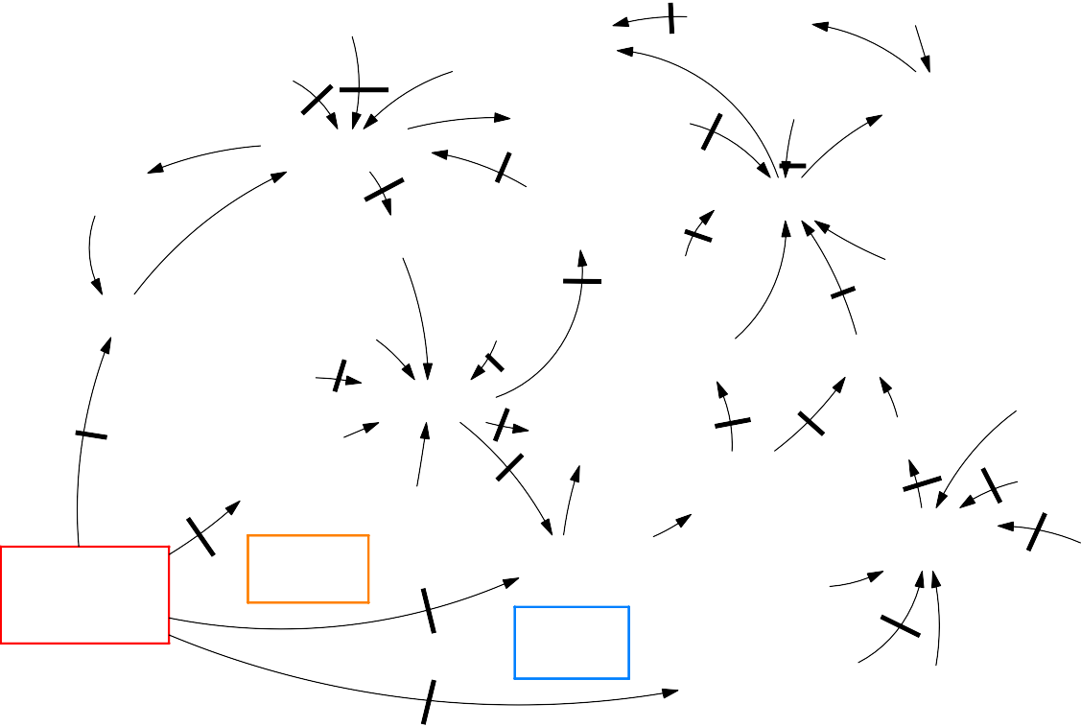

be t t e r acce ss t o

Gove rnance and St rat e gy

cont inuous fe ed ba ck

**1**

t e lling th e sto ry

of change

skill set s

he art se t s

New Le arnin g Cult ure

funding t o de ve lop

cont e nt and **1**

infrast ruct ure

**5**

t o e volve policy

de ve lop and

e xpa nd ed co nce pt of

**1** le arning

w hole individual change

m ind se t s

fe edback t o

de velop strat egy

im proved gove rn a nce and com m unicat ion

**5**

de velopm en t of n ew

t ools and program m e s

co m m u nica te po licie s fo**7**r fle xible le arning

dat a analyt ics and visualisat io n t o ide n tify

t ren ds and ne ed s

**7**

be haviou r ch ange and le arning

**1**

pe rson al b en e fit and aspirat io n

ne w st rat e gy for

t rain ing a nd learnin g

e asy acce ss t o kno w -h ow and innova t ive ide as

**3**

cu rat e d a nd cle ane d dat a

**2**

ide nt ify an d

**2** e m pow e r drive rs of

fut ure le arning e cosyst e m

chan ge

opt im ise d le arning

ow ne rship a nd

**5**e m ot ional inve st m e nt

**1**

pe rsonalise d

ADAPTIVE

Con te nt

t hrough life m e asu re m e nt

dat a cap tu re an d

t e a**3**m an d

de live ry

le arnin g on de m and

le arne r drive n inn ovat io n

**1**

consolidat e and

syst e m at ise curre nt dat a set s

**1**

a nalysis t ools

co nfigurable dat a m inin g

individual use r profiling

**3**

**3**

dat a-drive n

pe rsonalise d le arning pat hw ays

**3**

im m e rsive

cont e nt libra ry

**5**

fle xible and

ne w **5**w ays of int e ract ing including vr and ha pt ics

**2**

curre nt syst e m

Dat a

dat a m ode lling of

individual pe rform ance

**3**

de signe d for t he 360 profile o f

t he use r

im m e rsive trainin g cont e nt

a vailab le on m ult iple de vice s anyw he re

Dat a Drive n Le arning

high le ve ls of e xp ert ise and ne w t ools at

**5**

e m ot ionally

ve rsione d and de signe d for t he use r and t he ir

at t ribu t e s

**5** aut horing st age

e ngaging cont ent

**Potential Barriers**

* + 1. Organisational Barriers – system complexity and hierarchy
    2. Data Barriers – difficulty gathering, pooling and analysing data

**Figure 23: Roadmap Progression with Barrier Considerations**

1. Resource Barriers – finding the time and resources required
2. Content Barriers – problems developing content of the richness required

The **purple block** in Figure [23], in the top left shows what would need to be accomplished in the areas of governance and strategy. These changes include new strategy and policy to reflect an open and flexible system of training together and improvements in communications between policymakers, knowledge owners and knowledge acquirers. These changes would help in the development of new tools and programmes that can exploit the potential of the new ecosystem. The VSM analysis (see Appendix [C]) also highlights the importance of some of these issues in enabling beneficial change.

The **orange blocks** cover the necessary improvements in data capture, retention and storage. There are already elements of these present within the existing training system, though they are not necessarily as widely or consistently used as they might be and a key problem is that what data are held are often in isolated silos with organisational, security and resource barriers to their consolidation. The map also identifies additional resource barriers in providing suitable data analytics due to the lack of sufficient data storage capacity, and cultural barriers in the higher command to the use of data analytics to direct and monitor training.

The **light blue blocks** identify a key part of the system, the ability to use data to deliver personalised and data-driven learning. This draws together the orange and brown sections of the Roadmap and connects them to the change in learning culture and behaviour illustrated in the green section of the Roadmap. This is the most revolutionary element of the project team’s proposals but there are important security and privacy considerations that need to be addressed in drawing together information on individuals and linking it to their learning experience.

The **deep purple** bottom right hand corner deals with the content required to support this kind of learning; content that is immersive and engaging, designed with the user in mind and available where and when the user requires it.

The **green block** corner shows what the team hope to accomplish by all this, a step change in learning behaviour and a shift from a training system designed to produce square pegs to fit in square holes to a learning ecosystem able to prepare people for a lifetime of development and innovation.

Note that the diagram does not specify an order of completion or a set of priorities, these components are all mutually reinforcing, and it is likely that some components will be more developed than others in different areas. The diagram does show where elements are necessary precursors to other types of change.

The diagram also indicates where barriers may exist to achieving this kind of change, drawn from the initial literature review, the two workshops and the case studies.

These include the organisational barriers raised by many stakeholders, including the tendency to ‘silo thinking’ and bureaucratic resistance to change. Many of these organisational issues have also been shown to have an impact on the efficient sharing, pooling and analysis of data.

Privacy barriers have not been as prominent but that may be because many of the systems involved are still at an early stage of development. The requirement to ensure that personal information is properly stored is a legal one and will not go away just by ignoring it.

The importance of security considerations in preventing the inter-connection of systems has been reinforced, with the case studies raising the importance of the ability to handle training material above OFFICIAL in enabling a seamless system. This seems to be part of the reason for the split between DLE and LEARN.

Resource barriers are also repeatedly raised, with the difficulty of persuading those responsible for finance to adequately fund training equipment and infrastructure being a persistent problem. Those most able to liberate funding for training are those areas where significant sums of money are already being spent.

Content barriers have also been raised repeatedly during the case studies, with the main issue being the lack of suitably qualified and experienced individuals to generate training material of the richness and variety required, particularly where electronic material needs to be produced.

Finally, the problem of barriers due to culture seem particularly omnipresent and make some of the other barriers much more limiting than they might otherwise be, though the rapid change to the use of online resources as a consequence of the recent pandemic shows that this can be overcome if the need and the opportunity are there.

# Appendix E - Case Study Summaries

## Defence Learning Environment (DLE)

The DLE is a Moodle-based Learning Management System (LMS) and a Virtual Learning Environment (VLE). It is managed by DTEL, but the content and use is delegated to the Chain of Command. The DLE is accessible from MODNET, Defence Intranet, most Defence unit intranets and the wider internet, via a Defence Gateway login at OFFICIAL level only. It provides a mechanism for learning that encompasses:

* + - A wide range of e-learning/online courses;
    - A means of coordinating and managing learning;
    - A means for students to collaborate;
    - A means for students to record all types of learning;
    - A mechanism to analyse course progress for course owners;
    - A conduit to technology that improves learning and widens learning resources;
    - Adaptable learning courses and content as learning objectives change;
    - Learning that is accessible 24/7 from a range of devices (e.g. auto adjusts for mobiles/tablets); and,
    - Courses that range from minutes to years in length (including a means to manage learning over a whole career).

### Key Findings

Interviews with DLE stakeholders revealed that the slow progress of the DLMC programme has also affected the DLE progress. The longer it takes to migrate to the DLMC, the more the utility of the DLE will be compromised and the greater the possible increase in eventual costs. The target DLMC architecture will be created using a combination of Commercial off the Shelf components, existing components from the Training Administration and Financial Management Information System (TAFMIS) and existing DLE components. This combination will help with purposeful development of training and learning. Support for the DLMC programme is necessary to help investment in the DLE; interviews with stakeholders suggested that more funding will be required in order to deliver and expand the current capabilities to meet individual Service needs.

There are currently different online learning systems working separately across Defence that are not fully interoperable with one another. This presents a problem, as it provides a disjointed service without a single lead and means that learner data are being split across different systems. Having a shared system for learning data that can be used to personalise learning, store achievements and work with the learner through career is important and cannot be achieved across multiple, isolated learning environments. The DLE case study has highlighted that developing system interoperability and focusing on the underlying system development is key to a future Defence Learning Ecosystem. If Defence systems were xAPI compliant then Defence systems would be able to share information more effectively. A future Defence Learning Ecosystem will require both governance and high-level strategic decision making to streamline training and system interoperability.

The DLE capability is the chosen Defence LMS and therefore should be core to the future Defence Learning Ecosystem. Some of the opportunities available with the current DLE system could be exploited quite quickly if there was sufficient authority behind the changes, potentially through a change management group. Importantly, if all Defence systems adopted the xAPI standard, then Defence systems would be able to talk to each other and share information; however, currently there is a lack of funding to do so.

### Implications for Future Defence Learning Ecosystem

A number of actions should be considered in any future Defence Learning Ecosystem as necessary enhancements to the DLE’s current capabilities. The evidence from this case study shows that the following considerations would make a difference in knowledge transfer, knowledge ownership, and the service as a whole, including:

* + - * Investment in new software and API gateways to enhance the current capability;
      * Streamlining of the different VLEs to include the positive elements of each system;
      * Innovation and ideas should be shared Defence-wide;
      * Improving the technical system to accommodate for Service-specific needs;
      * The DLE services should be marketed efficiently;
      * There should be more investment in soft skill knowledge owners;
      * Course duplication should be reviewed and removed, and more ownership should be given to service owners; and,
      * There should be a focus on hiring people with the right skills rather than focusing solely on technology solutions.

## Defence School of Electronic and Mechanical Engineering (DSEME) and LEARN

*“Radical change has ignited cultural shift of how people view online learning.”*

###### Head of Assurance DSEME, Interview 1.

This case study focuses on how the DCTT and the schools that sit within it, specifically the DSEME, are delivering technical training. Like many schools across Defence, DSEME have had to respond rapidly to the new COVID-19 restrictions over the last few months and transition from a blended mix of online and offline training delivery to a predominantly online delivery mechanism. This case study evaluates the process of change within DSEME, how the VLE, LEARN, is being utilised and the impact this will have on Defence going forward. Specifically, the case study explores what barriers and successes have become apparent during the months of radical change and how DSEME believe this will impact the school’s immediate and long-term future.

The COVID-19 impact has caused huge ripple effects and rapid development in most areas of Defence training. Notably, interviews provided evidence that senior staff and trainees have become aware of the capabilities available to them, specifically because actions are happening, and things are being built more quickly than normal. The prioritisation of outcomes for DSEME training has changed drastically as a result of COVID-19 constraints. The School is revamping training plans and the way that training is provided, getting as much of it as possible online, looking to include more pre-course work, and aiming for a much shorter timescale for training that cannot be done online. The interviews revealed that since training has transitioned to online delivery in light of COVID-19, Internal Validation (INVAL) feedback from trainees has been extremely positive.

A key challenge identified was the ability to gain buy-in from those involved in authorising funding for new initiatives; this highlighted the need to ensure that funders had a greater understanding of the potential benefits but also, importantly, a level of trust in the SME. Consequently, new resource requirements needed to be presented clearly, in layman’s terms, and contextualised to show the learning benefits of introducing new initiatives.

### LEARN

LEARN is a local network and VLE designed to support RAF specific systems that the DLE reportedly does not account for, and also provides access to the internet and intranet. It is currently being used by multiple technical training schools like Lyneham and Cosford. The LEARN solutions that are delivered at separate sites are not identical, but they are based on the same high-level design and are responsive to business needs. There is some crossover between LEARN and the DLE, as some of the service capability is being duplicated. Because of School-specific limitations, DCTT was prompted to find a local VLE solution after encountering the following constraints with the DLE system:

* + - * At the time of development, the DLE was unable to carry the size of many of the DSEME technical courses as there was a limit on course upload size;
      * Many technical training courses are modular and have specific build requirements that the DLE, at the time of development, did not account for;
      * Change requests for system amendments to suit course requirements can take time to be actioned on the DLE;
      * The DLE at the time of development did not have a sandpit to allow for versioning and revision control; and,
      * The DLE can only process OFFICIAL, not OFFICIAL SENSITIVE content. This restricts what is allowed on the system.

Although designed to suit DSEME’s specific system requirements, LEARN also has some limitations, most notably:

* + - * The accessibility of MODNET and regular difficulties connecting;
      * LEARN has a Virtual Private Network login, so it is possible to directly login to any LEARN hardware; however, the financial cost of the hardware is a restriction; and,
      * LEARN is only accessible to learners who have the accompanying hardware.

### Implications for a Defence Learning Ecosystem

Interviews revealed that the two main barriers to rapid change are IT constraints and financial blockers. There is an apparent need for more internal specialist software employees, whose job it is to evaluate upcoming technology and to protect the military system without constraining it. This requires greater transparency between departments and more buy-in from finance teams, with more effort to enhance their understanding of the technical requirements and increase trust in SME guidance.

The development of local VLEs in Defence has demonstrated that, when developing online learning resources and networks, any new system or changes to current systems must be modern, interoperable and flexible. If they are limited due to IT restraints, the system is ineffective. The DLE is currently Defence’s chosen learning system and, as such, it would be illogical to recommend a transition to a local VLE like LEARN. However, it is important to consider the limitations of both systems so that, moving forward, the recommendations for change are focused and streamlined. The implication is to recommend a partial merge of LEARN and the DLE to exploit the best of both systems.

## Royal Navy (RN) - Training Transformation (TT)

*“To make the most of our maritime opportunity, our new Navy will be innovative, institutionally inquisitive, agile and efficient in both its behaviours and its exploitation of technology. But fundamental to realising our ambition is our high-quality people”.*

###### Vice Admiral Ben Key CBE, Fleet Commander (MOD, 2018a: p2)

RN training is currently undergoing rapid, organisation-wide, transformational change. The need for change was driven by the first and second Sea Lords and the Fleet Commander who have jointly developed a Vision for transformation. In order to inspire cultural change, the RN TT project is transforming all elements to sit under one umbrella - ‘People and Training’ Division.

The reported reasoning behind this shift change in the Navy is to provide an attractive and rewarding employment offer to new and current staff, and to enable them to achieve their full potential. Moving away from a system that was slow and expensive to modernise and adapt, the RN TT project aims to develop a new system that has the ability to consistently modernise. Part of the drivers for change included recognising that there are opportunities to enhance education and training, implementing not just the physical changes, but the changes to help staff deal with modernisation.

The overall aim is to use Project Selborne40 to provide a new and much more flexible structure for the delivery of RN training that can draw upon new developments in the technology of learning to improve both the effectiveness and the flexibility of the current system. The purpose of Project Selborne is to provide incremental acquisition and to integrate the maritime training programme. RN TT are concerned with a ‘whole force’ approach; the MTS (MOD, 2018a; MOD, 2018b) refers to ‘enablers’ that will ensure the success of RN TT, including:

* + - Establishing a ‘whole force by design’ people capability framework;
    - Building and maintaining collaborative relationships, especially with industry;
    - Ensuring systemic innovation in training;
    - Developing agile, coordinated and resilient training pipelines;
    - Providing flexible, learner-centric training;
    - Supporting workplace learning;
    - Exploiting immersive, technology-enabled training;
    - Exploiting synthetic collective training; and,
    - Coherently managing and exploiting information.

It must be noted that Project Selborne and the RN TT project are still at the very early stages of development, however, even at this early stage, notable barriers have been highlighted. There are negative stereotypes associated with change programmes, most notably that they take too long, and they rarely achieve the core goals. To tackle these issues head-on, the RN TT programme has allocated extremely tight time scales.

In order to ensure that the RN are adapting to rapid cultural and technology change in the near future, they have developed a data project called Project Nelson which operates from Portsmouth Naval Base and which aims to develop a centralised data store for the RN as part of a 3-year modernisation plan.

Early lessons have revealed that the agile project management part of TT has worked well so far in 3-week sprint intervals but should be regularly reviewed. For TT to happen successfully, it needs to be transformed in alignment with everything else. Having an organisation that is receptive to the ideas, approaches, concepts and practical elements of the infrastructure is key. One of the requirements of the Selborne bidders was to provide explanation for how they will deal with cultural management, in order to set the tone and create the space for this kind of transformational change and modernisation.

### Implications for a Future Defence Learning Ecosystem

The case study has revealed that in order to implement a whole force approach and ensure the success of radical change, Defence should consider the following lessons learnt during the RN TT process with regard to any future training initiatives:

* + - * An operating model should increase coherence and align behaviour;
      * There should be a collaboration service that helps communication across both commercial partnerships Defence-wide;
      * Training should be a ‘pull’ not a ‘push’; and,
      * Agile methodology allows for organisations to pick up on mistakes quickly and act on them efficiently. Iterative agile management helps provide accountability.

It is not effective to have different communications fighting against each other. The objectives and goals of each training incentive should align with the same message under the same principles. It is integral to explain why transformation is necessary and happening, and to provide context to the users, otherwise there will be

40 Project Selborne has contracted for the delivery of Naval Service Training, some of which is already outsourced, across UK establishments, modernising the approach to training design, delivery and encouraging innovative solutions. The 12-year contract will deliver all levels of Naval personnel training including operational sea training, training and simulation and Royal Marine training, whilst mobilising existing contracts to work collaboratively.

duplication and clashes. This method of communicating new strategy and ensuring that the message is streamlined should be part of the future Defence Learning Ecosystem recommendations.

Part of the DLMC incentive is to further enhance the management and governance of the maritime training system, however the routes for how DLMC and the RN TT work together are relatively undefined at this stage. The MTS (MOD, 2018a; MOD, 2018b) will act as an influencer for the DLMC programme to ensure it meets RN Service requirements; Navy Command HQ is planning on integrating interim solutions until DLMC provides the promised solution. A good Vision does not always drive practical change, which is why having a strategy like the MTS that is rooted in research and doctrine is key. It is important that the future Defence Learning Ecosystem understands dynamic competencies and how they mix together. The case study findings imply that the Navy will utilise the DLMC when it is available, if it fits their requirement; if not, they may choose to develop their own capability. This is important when considering governance for a future Defence Learning Ecosystem.

These insights align with the MTS guiding principles for behaviour, practice, learner-centric training, supporting workplace learning, technology and collective training (MOD, 2018a). Innovation will only thrive if ‘designed in’ to the management and governance of training and strong links are maintained with the teams who act as enablers of innovation. This is key, not just to Navy growth, but Defence-wide as new ideas are regularly implemented.

## Army Recruiting and Initial Training Command (ARITC) and Target Learning Model (TLM)

ARITC is one of the primary Training Delivery Authorities (TDAs) within the Army and is responsible for all recruiting and training of individuals prior to their becoming a fully qualified soldier or officer. ARITC has recently been implementing an initiative to improve the efficiency of learning delivery through the exploitation of new delivery technologies, combined with a model of Personalisation of Learning (PL) known as the Target Learning Model (TLM). As such, ARITC’s experience holds potential insights for the future Defence Learning Ecosystem, and in particular in identifying the most significant benefits and challenges that the Roadmap will need to accommodate.

The project team extracted a range of insights from the source material and interviews, and clustered them into a set of high-level themes, providing a framework for identifying implications for the future Defence Learning Ecosystem. These were:

* + - **Resources and Skills.** The longer-term promise from PL offers benefit from efficiency gains. In the short term, implementing PL will require additional resources to cover the increased workload (in terms of collection and analysis of data) and skills gap.
    - **Matching Interventions to Needs**. Digital matching services such as Uber, eBay and Netflix, provide potential models for the ROCKIT element of the Vision: a catalogue of potential learning interventions, combined with persistent personal profiles, to match needs to intervention as effectively as possible.
    - **Organisation**. At the moment, delivery of PL is hampered by the lack of an overarching development team drawing together offerings and expertise from across Defence.
    - **Data and its Integration**. To do PL properly, there would need to be significant improvements in the collection, handling, sharing and analysis of data across Defence.
    - **Avoiding Fragility**. There were concerns that, at present, the way training is done depends for its effectiveness on everything working properly, and that moving towards any system that was further centralised would introduce single points of failure that would undermine the ecosystem’s robustness.

The study team drew the following implications for the Vision and Roadmap for the future learning ecosystem:

* + - **PL is already happening** in Defence (albeit in many ways in spite of rather than because of technology). What is not as well understood, and where the challenges probably lie, is how to ‘get there from here’.
    - **Data is central to getting PL right**. There is a long way to go in Defence, and different models for data curation have different costs and benefits.
    - ARITC’s experience has demonstrated that **it is not necessary to have everything in place** to start implementing PL. The Roadmap will be informed by a consideration of what benefits can be realised throughout the journey to the future ecosystem.
    - However, until the technological infrastructure exists, **moving forward on PL might be costly**, potentially hampering progress in the short term.

## Higher Education (HE)

HE in the UK has undergone substantive changes. These changes have been driven by developments in technology and pedagogical research, regulation, funding models and, more recently, the COVID-19 pandemic. The opportunities and challenges created by these changes in HE have parallels with the issues being discussed in relation to the learning ecosystem in Defence. This case study is based on Bournemouth University, as an exemplar of a UK HE institution. Interviews were conducted with four members of staff responsible for different aspects of teaching and learning across the institution. This case study also draws upon the research experience and expertise of the Centre for Fusion Learning Innovation and Excellence (FLIE), which is based at Bournemouth University and provides best practice guidelines for HE.

Several effective practices were identified, including the use of flipped learning and blended learning. The basis of these approaches is to increase learner engagement by re-shaping the educational experience to move away from traditional, didactic teaching approaches. This creates possibilities for new forms of assessment, which can be more flexible, tailored and data-driven. However, as noted by some interview participants, there can obstacles in the implementation of these approaches along with unexpected outcomes, such as increased polarisation of learners towards either excelling on their courses or performing poorly.

Challenges were also identified. It was noted that there can be a mismatch between the expectations of learners and educators. Multiple barriers to change in the learning ecosystem were also identified which included organisational culture, differences between discipline, legacy systems, and poor communication. However, it was also noted that COVID-19 had resulted in a situation in which rapid and substantial change had to be made to learning and teaching strategies across HE. By necessity, this has required finding ways around barriers which had previously been perceived as being insurmountable.

For the Defence Learning Ecosystem, the key implications of this case study are that: i) consistency in quality of teaching and learning across disciplines is vital, but this does not equate to standardisation; ii) buy-in from both learners and educators is vital if any meaningful change in the learning ecosystem is to be sustained; and, iii) the learning ecosystem must recognise and accommodate the fact that learners enter the ecosystem with a wide range of backgrounds and with a wide range of expectations, which may be very different from the educators in system.

## Collective Training Transformation Programme (CTTP)

The CTTP is a programme designed to upgrade the Army’s capability to carry out collective training (CT) and pave the way for a Future CT System (FCTS). The FCTS will use modern training technology to optimise the mix of Live, Virtual and Constructive training and will allow data to be collected and analysed to support training and Force Development. The CTTP is being directed by the Capability Directorate Training Branch within Army HQ. Since most collective training is the responsibility of the Field Army, the objective is to develop an FCTS that can be used by the Field Army to deliver the benefits outlined above. This has involved working closely with the Field Army throughout.

The plans outlined for the CTTP will traverse the early stages of the Roadmap, including both the data elements and some elements of the customisable training experience. Some of the barriers identified in the Roadmap have already been encountered, with data barriers being a particular problem. The Army, as with much of the MOD, has problems with data being held in isolated silos. Much of the purpose of the TME component of the FCTS is to overcome these barriers.

One important element is selecting the right commercial model. At the moment, MOD procurement tends to incentivise contractors to develop systems in which their expertise in running the system becomes indispensable. This is an important factor behind the data silos that restrict existing collective training systems. The commercial model is being designed to incentivise a more open approach in which those involved in training will have much better access to data and the ability to analyse data themselves. These commercial issues are a barrier that has elements of organisation, data and culture, and are common to more than just Army CT.

Security barriers are also becoming a significant issue with CTTP, with a change case currently being put in place to upgrade the security classification of the entire system to allow material at higher classifications to be handled. This is probably inevitable in a system that is also used for experimentation.

### E.6.1 Implications for a Future Defence Learning Ecosystem

It is clear that the problems of data sharing, as outlined in the Army Data Sub-Strategy (2019) have been recognised. It is important to note that these are not just a problem within training but also within the Army as a whole and within Defence. That means that solutions for these problems are likely to be most effective if they are applied as widely as possible. This implies the need for a specification for data interchange in training and learning that is consistent with MOD-wide standards and developments as well as commercial practice.

A key objective that has emerged from the CTTP case study is the need to ‘consolidate and systematise current data sets’ and there is provision for feedback using data analytics back into the management element of the system. Like other case studies, there is an ambition to use this to ‘optimise learning delivery’ and provide ‘data-driven personalised learning pathways’ though, again, this is in a collective context rather than an individual one.

How to provide the right incentives to make sure that innovation and openness can thrive is likely to be an important part of the requirement for a future Defence Learning Ecosystem, as are the kind of frameworks that allow multiple providers and multiple systems to co-exist, interact and collaborate. Bearing in mind that many of these providers are direct competitors, this is likely to be a challenge and should be well thought through.

## Aquila Learning and Risk Management System (ALaRMS) Data System

ALaRMS is a system that attempts to make sense of complicated training systems and the governance processes that they must comply with (such as Systems Approach to Training standards). It was presented to the research team as an innovative software application that creates an effective, efficient and safe system of training management with minimal human resource. It aims to cut the effort required to design, deliver and manage complex training systems through life. ALaRMS was designed to be the ‘backbone’ of any training system that utilised system approach to training methods, such as DSAT. It effectively amalgamates a number of legacy applications into one end-to-end Training Management System (TMS). This creates efficiencies, reducing time and cost. With xAPI, ALaRMS can connect and interoperate with wider applications in the ecosystem. This ‘backbone’ concept also allows ALaRMS to offer a fully connected technology across the entire DSAT hierarchy and Training Defence Line of Development (DLoD).

ALaRMS was created and developed by an ex-senior officer and training expert in the Royal Air Force (RAF) and was built in a response to Defence need. The team wanted to build something innovative and agile that applied the DSAT and JSP 822 process, with an aim to connect Defence and the wider Defence industry. ALaRMS was designed with the idea that all of Defence would be using the same technology and it was intended to be collaborative with the end user (MOD). The system was developed to be remote working- friendly, which helps speed up the process, cut costs and reduce error. It is built so that once each bespoke end platform has been developed, the client will take control of a system that has the potential to be

accessible by other organisations across Defence, as all different versions of ALaRMS can plug in to MODNET. This solves an issue with multiple service providers, data access and service interoperability. As it stands, ALaRMS is currently in use in two parts of Defence. It is being used in a front-line aircraft programme in the RAF and during Phase 1 training within the RAF. Aquila believe that using this system at the beginning of the project lifecycle will help operational efficiency and streamline data access and analysis through development.

### E.7.1 Implications for a Future Defence Learning Ecosystem

ALaRMS was designed with the idea that all of Defence could benefit from a common technology that offered extensive collaboration with the end user (MOD). It is a good example of a system that has been developed from the ground up, with the DLMC and training requirements of Defence in mind. From the start, ALaRMS has been developed to work in collaboration with different Services, so it could be used in current and future iterations of any Defence Learning Ecosystem. The system has the potential to be accessible by other organisations across Defence, as all instances of ALaRMS can be accessed via MODNET.

The project team recommend analysis of the current ALaRMS active contracts within Defence so that the progress and implementation of the system going forward can be effectively analysed. This is pertinent as ALaRMS are implementing many of the important ‘actions’ highlighted from different case studies, including how xAPI investment can positively impact Defence systems interoperability and how a system being available both locally and organisation-wide affects Defence.

**Subject to Protective Marking, National Caveats and announcement or availability restrictions, the information provided in this form will be published outside UK government and should, where possible, be of a commercially non-sensitive nature.**

To aid completion notes can be found at the end of this form.

|  |  |  |  |  |  |  |  |  |
| --- | --- | --- | --- | --- | --- | --- | --- | --- |
| **1a.** | **Report number: \*** | O-HSSRC-1.007-031/033 | | |  | **1b.** | **Version number:** | 2 |
| **2.** | **Date of publication:** | 25 March 2021 | |  |  | **3.** | **Number of pages:** | 90 |
| **4a.** | **Report UK protective marking: \*** | | | OFFICIAL |  |  |  |  |
| **4b.** | **Report national caveats: \*** | |  | NONE |  |  |  |  |
| **4c.** | **Report descriptor: \*** |  |  | NONE |  |  |  |  |
| **5a.** | **Title: \*** |  |  |  |  |  |  |  |
|  | HS 1.007 Defence Learning Ecosystems Final Report and Roadmap | | | | |  |  |  |
| **5b.** | **Title UK protective marking: \*** | | | OFFICIAL |  |  |  |  |
| **5c.** | **Title national caveats: \*** | |  | NONE |  |  |  |  |
| **5d.** | **Title descriptor: \*** |  |  | NONE |  |  |  |  |
| **6.** | **Authors: \*** |  |  |  |  |  |  |  |
|  | Megan Pleva, John Dale, John Medhurst, John McAlaney, Nick Hare, Niall Castelli | | | | | | |  |
| **7a.** | **Abstract: \*** |  |  |  |  |  |  |  |
|  | In this project the team identified four areas of capability realignment that improved opportunities for the realignment of existing capabilities within T&E:   * In the Learning Space - creating an informed and dynamic internal market for learning programme development capability; * In the Delivery Space - developing a unified, future-ready delivery system; * In the Data Space - improving the level of data-capture and analytics; and, * In the Organisational Space - authorising and coordinating a Defence-wide investment of resources.   What was happening in these areas clearly showed where realignments and modifications could bring about radical enhancement and indicated significant savings. This led to eight main recommendations that would support these capability realignments, driving T&E to become a more effective Defence Learning Ecosystem, including;   1. Strengthening and Modernising the Defence Systems Approach to Training (DSAT); 2. Strengthening the Collaborative Training and Education (T&E) System; 3. Conducting Two Additional Further Research Projects into the Learning Space; 4. Enhancing the DLE Capability; 5. Enabling Innovation in Delivering Remote Experiential Learning; 6. Designing a Common Framework for Data Management; 7. Improving Learning System Communication; and, 8. Implementing Governance of a Change Programme to Realign Learning Spaces. | | | | | | | |
| **7b.** | **Abstract UK protective marking: \*** | | | OFFICIAL |  |  |  |  |
| **7c.** | **Abstract national caveats: \*** | |  | NONE |  |  |  |  |
| **7d.** | **Abstract descriptor: \*** | |  | NONE |  |  |  |  |
| **8.** | **Keywords:** |  |  |  |  |  |  |  |
|  | Learning Ecosystem, Training, Education, Vision, Roadmap, Governance, People, Culture, Communication, Strategy, Technology, Data, Learning, Defence, Emerging Technology, Building Blocks, Barriers, Hubs of Excellence. | | | | | | | |
| **9.** | **Name and address of publisher: \*** | | |  | **10.** |  | **Name and address of funding source:** | |
|  | HSSRC  BAE Systems Alvington Yeovil Somerset BA22 8UZ |  |  |  |  |  | Hash Hassan Dstl Porton Down Salisbury Wiltshire  SP4 0JQ |  |
| **11.** | **Funding source contract:** | | DSTL/AGR/01035/01 | |  |  |  |  |

|  |  |  |  |  |  |  |
| --- | --- | --- | --- | --- | --- | --- |
| **12.** | **Dstl project number:** | | HS 1.007 |  |  |  |
| **13.** | **Programme:** | | HSSRC |  |  |  |
| **14.** | **Other report numbers:** | | HSSRC-1.007-015 and HSSRC-1.007-021, HSSRC-1.007-024 and HSSRC- 1.007-029 | | | |
| **15** | **Contract start date:** | | 18/11/2019 | **15a.** | **Contract end date:** | 31/03/2021 |
| **16.** | **IP conditions for report: \*** | | DEFCON 705 FULL RIGHTS |  |  |  |
| **17a.** | | **Patents:** | No |  |  |  |
| **17b.** | | **Application number:** |  |  |  |  |
| **18.** |  | **Release authority role:** | DSTL HSSRC PROJECT MANAGER | |  |  |